# Restarting RedBack

If you are restarting the service because of a crash of unknown origin, it is important to manage the RedBack log files so that a developer can determine the cause of the crash.

1. Connect to the live server (00SRV01) via Remote Desktop
   1. Start Remote Desktop Connection
   2. Connect to 00SRV01 and login

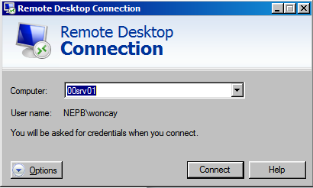

* 1. Log in with your credentials (NOTE that you must have a valid login account on this server in order to log in.

1. Once logged in to 00SRV01
   1. Start Control Panel
   2. Click on Administrative Tools
   3. Click on Services
   4. The services should be listed alphabetically. Scroll down to find “RedBack Scheduler 4.4.3.1555 for UniData” The version number may be different, but this is the service that should be restarted.
   5. Right click on the service and select “Restart”
2. If the service restarts, the Services entry should look like this:



1. If RedBack did not restart, there is likely to be a running process related to RedBack. To find it and kill it:
   1. Make sure the RedBack Scheduler service is stopped – It will be if it did not restart, but be sure.
   2. Run ProcessExplorer
      1. If there is not a shortcut on the desktop, run this program:

D:\Tools\ProcessExplorer\procexp64.exe

* 1. The resulting screen will look something like this:

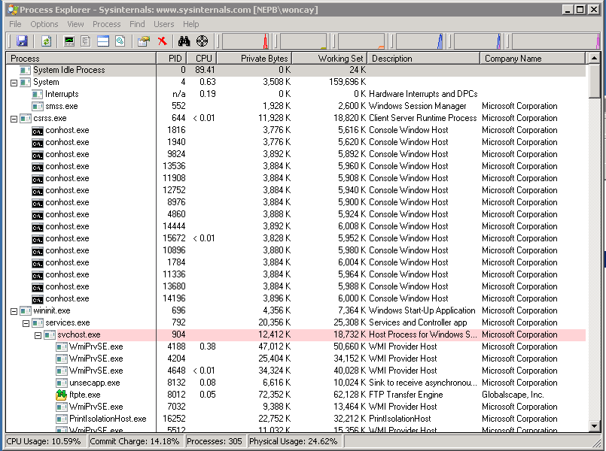

* 1. Click the binoculars on the toolbar (Find DLL/File handle)



* 1. Search for “Scoreboard”

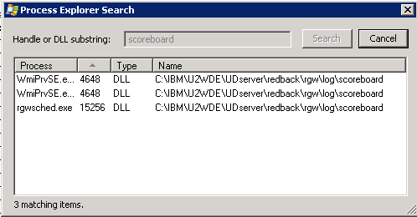

* 1. Kill the processes that appear a search results
  2. Restart RedBack Service (Start at Step 2).  It should now restart.

1. If RedBack is being restarted due to a crash of unknown origin, you must now preserve a copy of the log files so that a developer can troubleshoot the cause of the crash. If RedBack crashes again, the archived log files will be overwritten, so they must be preserved in a separate location.
   1. Go to this folder:

\\00SRV01\c$\IBM\U2WDE\UDserver\redback\rgw\log.old

* 1. Copy the files there to a local folder
  2. Compress the files and send them to a developer for troubleshooting.