**PRODUCT BRIEF**

**Laddawn Print Designer**

**September 2016, V1**

**Objective of Product Brief:** The goal of the Product Brief is to provide internal teams with a clear overview of the product design, function and features, as well as a snapshot of competitive landscape and how the products are currently being sold within the industry. The product brief is an objective look at the product category and can be used to as a basis to educate any internal stakeholder, such as Purchasing or the Creative Team, on the category basics.

**Print Designer**

1. **Background** 
   1. **Overview**  
      There is a growing demand for printed bags in the industrial packaging marketplace. Most print jobs received by Laddawn are 1-2 colors, requiring much communication back and forth between the customer, the distributor and Laddawn. Laddawn has listened to our distributors’ “horror” stories and frustrations, and believes there is a way to simplify the process and greatly improve the printing experience. Laddawn has developed a new tool, called **Print Designer**, which takes the guesswork and stress out of the industrial printing process, from initial quick quote to final delivery of the product. This tool will not only benefit our distributors and end customers, but will also empower our own internal sales and customer support teams.
   2. **The Industrial Printing Market**  
      The market for printed plastic bags is estimated at $15 to $20 billion. Printed polyethylene bags for industrial and commercial applications sold through distributors comprise about 5-10%, or $750 million to $2 billion. Since January 2016, Laddawn is averaging 50 converted Random repeat print jobs a month, and about 20 Registered print jobs. Laddawn expects the total custom print business to reach about $1.5 million in sales by end of year.
   3. **The Laddawn Target Market**  
      The Industrial Packaging market is primarily served by independent packaging distributors across America. Distributors are mostly family-owned businesses who sell to local businesses. A typical distributor has a warehouse, purchasing department, a dozen sales people and between 8-10 thousand items. Larger, multi-location distributors might have from 2-3 to dozens of locations in multiple states. Laddawn only sells through these distributors; about 3,300 total across the country. These distributors that offer printed bags are our initial target market.
   4. **The Current Print Process**Perhaps the best way to appreciate where Laddawn is taking industrial bag printing is to review where the industry has been. Currently the industrial market for printed polyethylene bags includes some of the most simple, familiar items such as bread and pita bags for the supermarket, birdseed and mulch bags found in hardware stores, or bags used for internal packaging with printed suffocation warnings.   
      The process for quoting and ordering printed bags requires multiple steps and communications. Typically, a customer (i.e. a pita bread manufacturer) reaches out to their local packaging suppliers (an industrial packaging distributor salesperson) for a quote on a printed bag, such as a reclosable pita bread bag. Some may quote with multiple distributors to get the most competitive terms. The distributor salesperson will need basic information like the bag type, style, dimensions, gauge, colors in the printed design, etc. to get a quote from a vendor that manufactures printed bags. It usually takes the vendor a few days to get back to the distributor salesperson with an initial quote and lead times. The sales person then needs present the quotes back to the customer. The entire process can take a few days, more if information is missing or unclear.   
        
      It is important to note that the distributor salesperson normally requests a quote prior to having the actual artwork from the customer. After the initial quote, the customer will need to provide the artwork and placement directions, and perhaps a sample, for the distributor salesperson to pass on to the vendor to finalize the quote and place the order. The vendor then reviews the graphics file, and if acceptable, provides a line drawing of the artwork for approval. It may take a few days of communications between the vendor, the distributor salesperson and the customer to produce a satisfactory line drawing. Once the line drawing is sent to and approved by the customer, the distributor salesperson will advise the vendor to create the printing plates for the job, and print the bags. This may take even a few more days, before the vendor starts working on any part of the order.   
        
      The process for quoting and ordering a printed bag is time-consuming and can be challenging, especially for a distributor or customer not familiar with the printing process.
   5. **Current Capabilities:**
      1. **Random Repeat Printing**Laddawn currently has the equipment and expertise to offer Random Repeat printing to our distributors. Random Repeat printing is a type of flexographic printing (Flexography covered in further detail below).   
           
         Random Repeat printing repeats an image or block of text a specific distance apart; in Laddawn’s case no more than 24". In Random Repeat printing, the images may land on perforations resulting in the top of an image on one side of a perforation and the bottom on the next. Laddawn’s configurator does internal calculations to guarantee at least one full image will display uninterrupted by a perforation. Because the spacing between images doesn’t match the bag length, images are seen as “randomly” placed on the bags from bottom to top, spilling over to the next bag.   
           
         Laddawn has a one-color, Random Repeat printer in each of our five manufacturing facilities, which are high-end, inline flexographic printers.
      2. **Registered Printing**Registered printing is another type of flexographic printing, which refers to a defined placement of a single color or multicolor image on a bag. The artwork prints once on each bag, in the same location. Depending on the type of image, multicolor images require separate plates for each color. Printing photographic images, called process printing, requires four plates to layer a combination of cyan, magenta, yellow and black (a familiar concept to those who buy ink cartridges for their color printer at home).   
           
         Laddawn does not have the capability to produce Registered Printing jobs in our facilities; we rely on outside printing companies who have the specialized equipment to produce this type of job. There is a high level of manufacturing subject matter expertise required to run registered print jobs well. Therefore, 100% of these orders are produced by Laddawn-certified outside vendors for Laddawn and shipped directly to our customers on our behalf.
      3. **Flexography**  
         Both Random Repeat and Registered printing are accomplished by flexographic printing. Flexography is a method of direct rotary printing, which uses relief image carriers, called printing plates. The plates are mounted to a printing cylinder and placed in a printing press machine, in which a motor drives the rotation of the cylinders. The plate has two contact points; the anilox roll that transfers ink to the printing plate, and the impression cylinder which holds the substrate; in this case a plastic bag or sheet. The anilox roller transfers a precise amount of ink to the printing plate; which is unique to flexography.  
           
         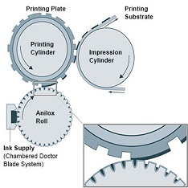  
           
         The quality of the printing is heavily dependent on the type of flexographic press. There are three main types of flexographic presses:

**Types of Flexography**  
**Inline** - Color stations are placed horizontally and the press can print on both sides. Best for 1-2 color printing. **Stack** - Color stations stack up vertically (for easier access) and print on both sides of the substrate. Good for multicolor printing, however a drawback of stack presses is their poor registration; the image position on every printed sheet is not as consistent as in many other printing processes.   
  
**Central Impression** - Color stations are located in a circle around the impression cylinder. Can only print on one side, but provides precise registration which allows for very good color impressions. This type of press is best for 3+ colors, intricate designs or images that are of photographic quality (process printing).  
  
The experience of quoting and ordering Registered Print items is exactly as it is for Random Repeat. To the customer, there is no difference in the pricing and ordering process, and both options will be available using **Print Designer**.  
  
Given the potential for errors and their impact on the amount of time a job takes, and the potential impact to our relationship with our customers, selecting the right print vendor becomes a very important task. We utilize several factors in making the best decisions possible. Laddawn reviews each print job for complexity, and directs the job to the correct printer based on product type, number of colors, complexity of design, etc.

1. **Functionality: How does Print Designer Work?**Following is a general summary of how the **Print Designer** works:

* The salesperson (Distributor) logs onto Laddawn.com and quotes a custom (clear) bag, using the current process.
* The salesperson selects “Printing”. There will now be options for both Random Repeat and Registered printing, with descriptions of both.
* A new screen with dimensions will appear, and gives options for the salesperson to either get a quick price, or to start the design by placing an image and/or text on the bag. If an image is not available yet, the salesperson can use a placeholder and input the approximate size and number of colors.
* The **Print Designer** is visually intuitive, utilizing a WYSIWYG editor. The salesperson can easily move the image, resize it, rotate it and add text.
* Once the salesperson is satisfied with the image, they can save the item or add it to the cart. There is a “Share” option which allows the salesperson to send the image and total quoted price to their customer via email for review.
* If the salesperson used a placeholder for the image, the real graphic should be added prior to checking out.

1. **Print Designer Interface**
   1. **Expansion on current widget**- The **Print Designer** is an expansion of the current Laddawn widget, and has been completely integrated into the custom quoting process. The **Print Designer** is accessed by initiating a quote on a printable item such as a clear layflat or reclosable bag, and clicking on the drop-down option that becomes available under the Printing option on Level 3 of the widget. Note: There is not a separate icon on the current widget to directly open the **Print Designer** program. This is a training opportunity; for users browsing the website it may be helpful to have a separate training video or demo available, otherwise the feature will be “buried” on the site.
   2. **Iconography and Text**- **Print Designer** has been developed for a non-technical user, meaning that the icons and messaging are geared toward the salesperson, not a professional graphic designer. Like the Laddawn 2.0 website, the text is friendly and conversational, and the icons are intuitive. The instructions are easy to follow, and key terms and decision points are clearly explained. Following are examples of the icons:  
        
      Random Repeat printing

Registered printing

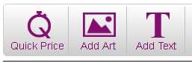 Design options

  
Additional design and formatting options

* 1. **WYSIWYG Interface**- Unlike a standard business card, the dimensions for printable bags can vary widely, which could make it difficult to envision how large a logo, image or text should be on the bag. The **Print Designer** will initially show a scaled line drawing of the bag with the bag’s dimensions (width and length). Once the image or placeholder is added, the image dimensions can be added, if known, or the user can click and expand the image to the desired size. Text can also be entered, and sized by clicking and dragging to expand the text without needing to indicate the actual font size.
  2. **Main Functions**- Following is a more in-depth description of the key screens and decision points.  
     1. **Getting started**- To utilize the **Print Designer**, the salesperson must first enter select the type of product in Level 1 in the Laddawn 2.0 widget, then enter the initial quote parameters into the Level 2 fields: the bag ***Category*,** the bag ***Size***, ***Gauge***, and ***Ship To*** location. Level 3 options such **as *Material and Additives*, *Color*, *Printing*, *Venting*** and ***Packaging*** will become enabled. The salesperson should click below the ***Printing*** option to open up the Printing Method.   
          
        The salesperson has the option to either select ***Registered*** printing or ***Random Repeat*** printing. Included are descriptions of both types of printing, and other hints to help the salesperson choose the correct printing method.  
          
        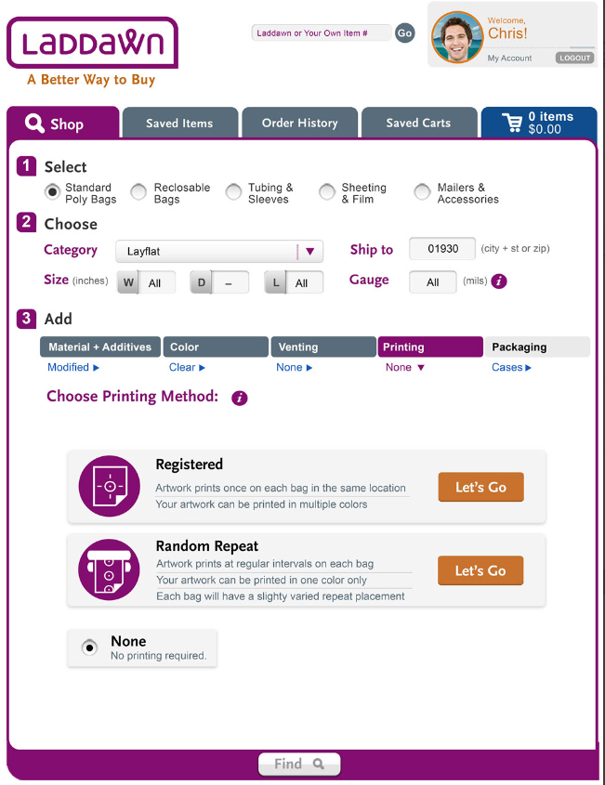

Friendly, intuitive iconography and   
conversational text

* + 1. **Options** - Once either Registered printing or Random Repeat is selected, you have a choice to click directly on the bag to get started, or you can select options on the orange buttons to either get a ***Price without Artwork****,* ***Add Artwork***, or ***Add Text***, which will ultimately give you a more accurate price and allow the customer to see a representative finished bag.

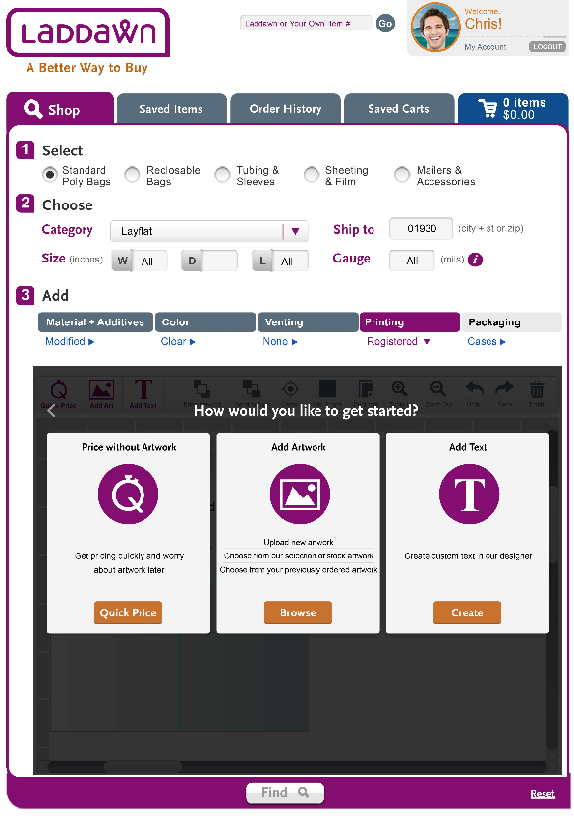

Options for getting started

***Quick Price***- The ***Price without Artwork*** feature allows you to quote and share an immediate price for a printed bag, even if you don’t have artwork yet from your customer. This feature is especially important, as many times the salesperson does not have the artwork file, but the customer wants a price. The salesperson can enter an estimate of the size of the artwork on the bag, or choose the most commonly requested size from other similar bags. This unique feature really allows the salesperson to get a quick quoted price on a custom printed bag, and lets them worry about the artwork later. This option is ideal when time is of the essence, and an exact quote is not required.

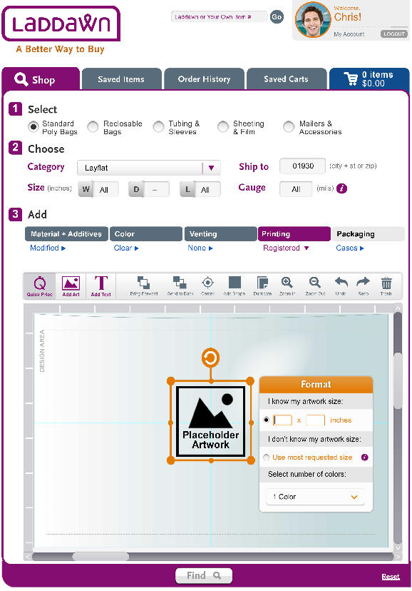 ***Add Artwork***- The ***Add Artwork*** feature allows the salesperson to quickly “design” the bag themselves by inserting, placing and sizing the uploaded artwork. The salesperson has three ways to add artwork:   
  
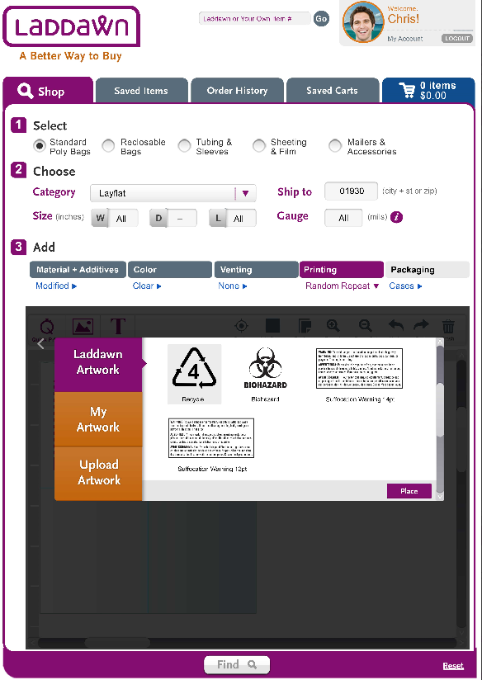

* + - 1. ***Laddawn Artwork***- The salesperson has an option to choose from a selection of Laddawn stock artwork, with commonly used images such as Biohazard and Recycle symbols, or Suffocation warnings.   
           
           
         These are standard images, and are used on a significant portion of Laddawn custom-printed bags.
      2. ***My Artwork***- The salesperson has an option to upload images from previous quotes or orders, which can save time and improve consistency across the customer’s range of printed items.
      3. ***Upload Artwork****-* The sales person has a third option of uploading new artwork files. The salesperson will need to reach out to their customer for the desired artwork. Though **Print Designer** allows you to easily place and change the size of the artwork, it does not allow you to add new elements or design other than adding basic shapes. (Confirm type of files accepted, .ai, etc.) Following is an example of external art.  
           
         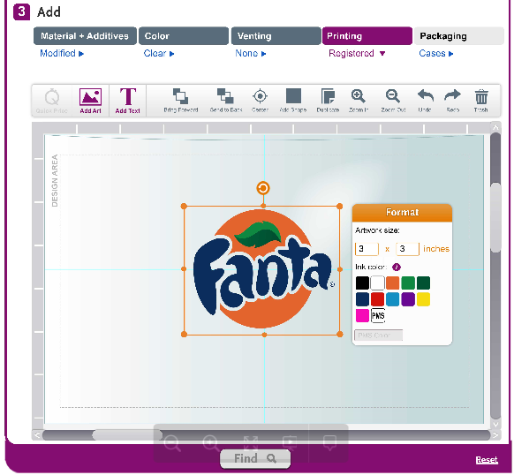

***Add Text-*** The Add Text feature is the final design feature that allows the salesperson to add additional text, in a variety of web-friendly fonts and colors. This feature allows the salesperson to add free-form text such as dates, part numbers, assembly instructions or other types of warnings or messages. The text can be easily placed and sized on the line drawing, alone or in conjunction with an image.

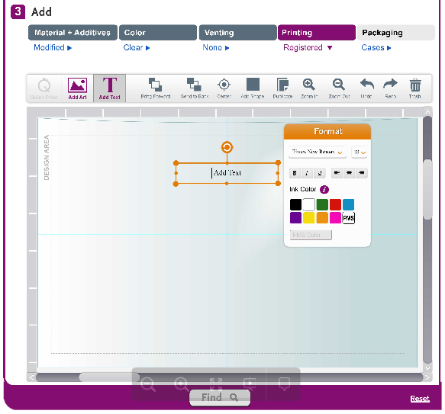

* + 1. **Deliverables-** What you see is what you get; after finalizing the design, receiving pricing and saving to their cart, the salesperson will see a line drawing of the custom bag, with the actual image and text sized to scale. The salesperson can share the system-generated bag drawing in the form of a.pdf file with a quote attached, without multiple renderings and communications between Laddawn, the salesperson and their customer.

**First Deliverable:** Design Proofs

Here are 2 examples of generated design .pdfs which accompany the results when shared:

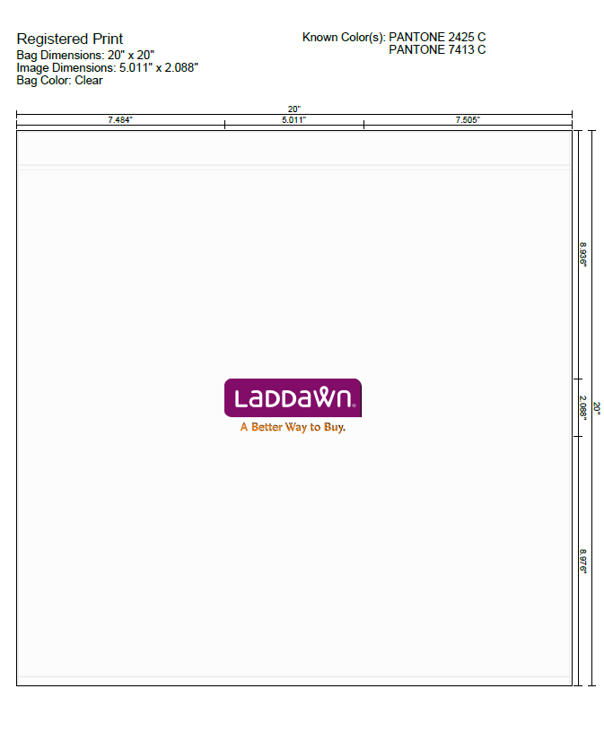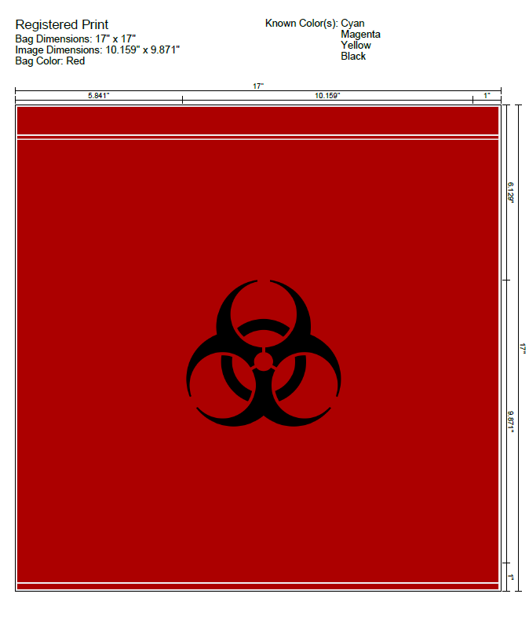

**Second Deliverable: Print Designer Concierge**

Laddawn will be rolling out a Print Designer Concierge service upon launch of Print Designer, to help distributors feel comfortable and confident at every step of the printing process, from initial quote to customer receipt of the final product. The concept is to dedicate a Vendor Relationship Partner to each and every job; the Print Designer Concierge will personally call the distributor once the initial order is placed and will handhold the distributor through each phase of the process. The Print Designer Concierge will be in direct contact with the distributor, but will also be facilitating communications between the Vendor Relationship Partner, the print vendor, Purchasing and anyone else involved in the custom print order. This service is unique to Laddawn. Laddawn believes the personal touch will help smooth out any technology glitches during the launch, and build a stronger working relationship with our distributors. Additionally, the role will help streamline communications and order tracking internally.

1. **Key Updates from 2.0**  
   Laddawn customers had the opportunity to order custom printing online prior to the launch of **Print Designer**, however it was limited to Random Repeat printing, and there was no visual design tool. In 2015, Laddawn experienced about $1.3 million in Random Repeat print bag sales. Even without the graphical print display, the instant quoting of Random Repeat printing is unique to the packaging industry. Here’s what it looks like:

Laddawn.2.0  
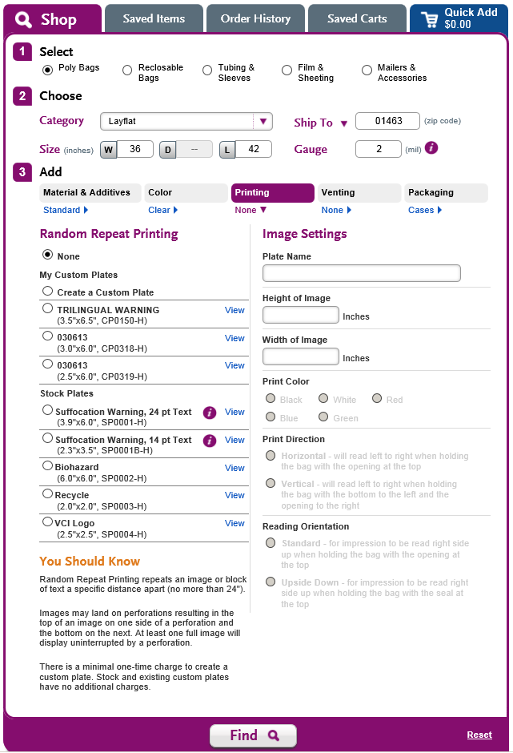

1. **Limitations**The first release of the **Print Designer** will support all current Random Repeat offerings as well as Registered printing on layflats and zip tops on widths from 3” – 30” and lengths from 3” – 36". Although we will eventually support Registered printing on two sides, the first release will support only one side.

Additionally, it must be called out that new artwork cannot be created in Print Designer; images and text can be added and manipulated to some extent, but Print Designer is not graphic design tool to develop new artwork.

1. **Summary of Print Designer Features & Benefits**

|  |  |
| --- | --- |
| Feature | Benefit |
| Get product quotes and ship times in minutes. | Quote much faster than your competition. |
| Quote without an image (you can upload later). | Provide quotes without being disruptive to your customer. |
| Capture key design and printing details. | Less chance for getting the job wrong. |
| Intuitive graphical interface. | No training needed – anyone can log on and do it. |
| Easy quote-sharing functionality. | Get your quote and design proof in the hands of your customer in minutes. |
| Order your printed and non-printed bags all  on the same site. | Be more efficient in your work. |
| Takes the “magic” out of getting printed quotes. | Be the go-to expert in printing for your customers |

1. **Positioning**

**One Distinct Benefit -***With the one and only online designer, Laddawn takes the hassle* out of printing.*

*Manual steps, time and worry  
  
**Position Statement**  
*For America’s packaging distributors, Laddawn.com’s* ***Print Designer*** *is the industry’s fastest and simplest way to quote, order and secure print business.*

1. Competitive Offering  
     
   Custom print design tools exist in the market, however only one of Laddawn’s competitors offers a similar service specifically for printing on polyethylene bags, which is limited in scope. Laddawn has reviewed several print design tools, and compared functionality, ease of use, quoting capabilities and ability to provide a proof (with a savable file). Following is a sample of companies offering varying custom print design tools, for printing on various products:

ULINE – custom-printed plastic t-shirt, die-cut and grocery/tote bags

PaperMart, VistaPrint and Zazzle – custom-printed retail shopping, t-shirt and tote bags

Staples – custom-printed marketing materials, banners, signs, etc.

**ULINE -** [**https://www.uline.com/CustomProduct/CustomStaticDieCutBags.htm**](https://www.uline.com/CustomProduct/CustomStaticDieCutBags.htm)

ULINE is Laddawn’s only direct competitor that offers a type of online custom printing tool. They currently limit online custom printing to a very limited set of categories and sizes within plastic retail shopping bags. The bag image and dimensions are shown, and there is an opportunity to insert artwork and text, and to center, scale, rotate and reposition images and test. You can specify font size and add up to five lines of text, but you cannot click and drag on the text to resize it. Additionally the text cannot overlap the artwork, and can only be repositioned by selecting options to be centered or to be aligned horizontally, and for the text to be left-, right- or center- justified.

|  |  |  |  |
| --- | --- | --- | --- |
|  |  |  |  |

ULINE gives an immediate quote including plate charges, but there is not an option to save the proof as a separate file and to share with an end-customer. ULINE has made recent changes to their capabilities, so it is safe to assume that they will refine functionality and add additional categories. Laddawn will need to monitor ULINE’s features to ensure we are offering a competitive and compelling alternative. Here is what ULINE’s custom design feature looks like:

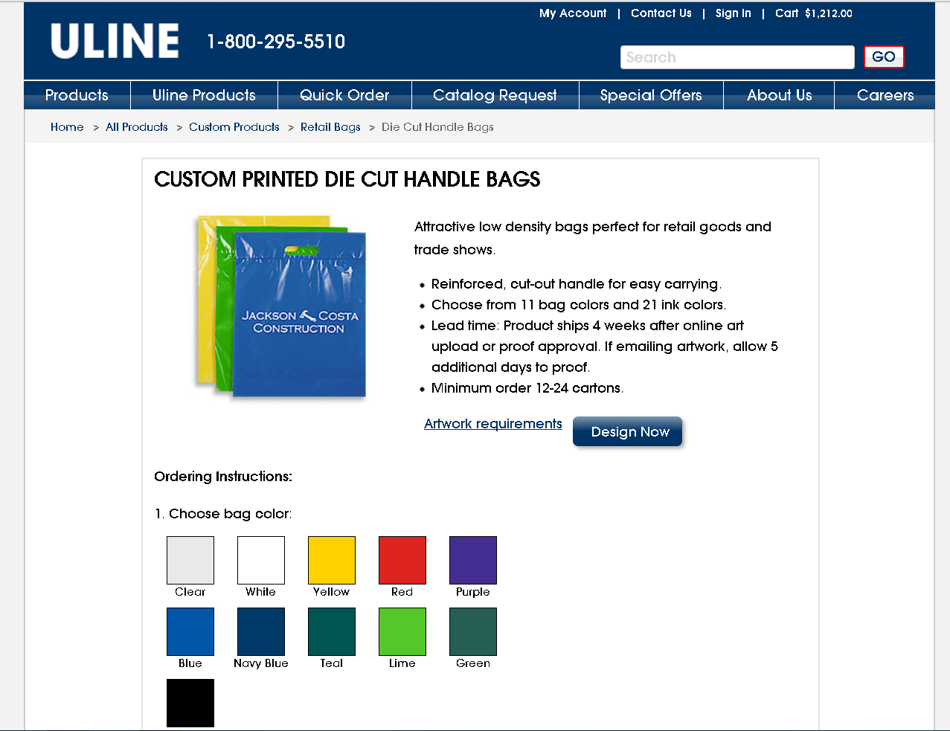

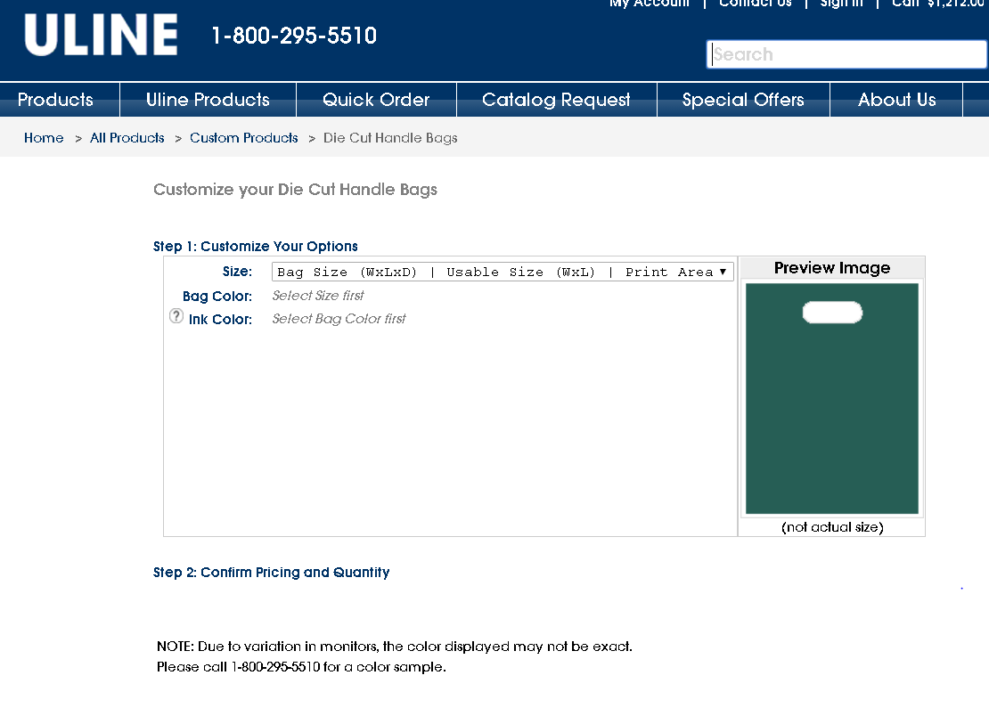

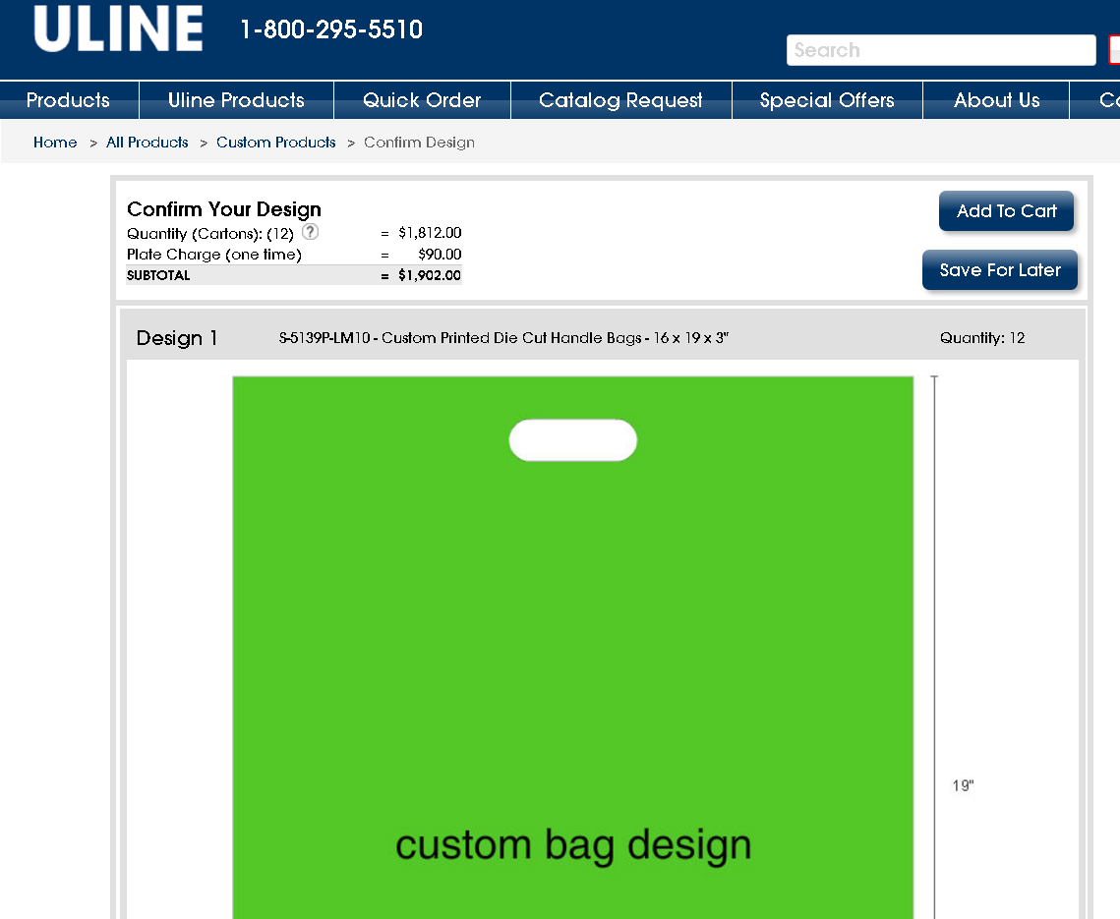

**PAPERMART, Vistaprint and Zazzle:**

PAPERMART, VistaPrint and Zazzle print on retail bags such as tote bags or shopping bags, as well as on a variety of other plastic, paper and fabric logo and promotional products. They do not print on industrial plastic bags, and are not considered direct competitors to Laddawn. VistaPrint is the industry leader for printing business cards and other marketing materials, however their design tool for bags was not more sophisticated than the Laddawn **Print Designer** tool. Following are links to their design sites:

PAPERMART - <http://www.papermart.com/Custom-Pattern?GroupID=48236>

Vistaprint - <http://www.vistaprint.com/promo/product/hercules-grocery-tote-bag/PZ3Q1Q208.aspx>

Zazzle - <http://www.zazzle.com/custom/tote+bags>

**Print Designer** uses a very similar WYSIWYG design interface in comparison to VistaPrint, in addition to several identical functions, features and icons.

**VistaPrint design tool**

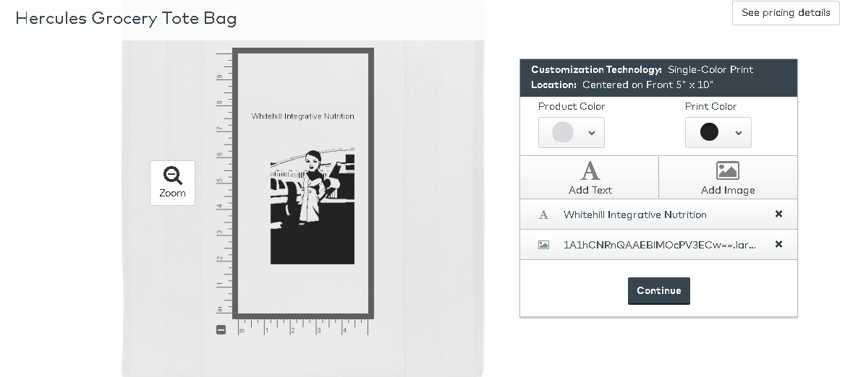

Zazzle and PaperMart show the product image and design, however do not clearly show product dimensions and objects to scale, making them less flexible than **Print Designer**. PaperMart’s tool was more user-friendly than VistaPrint or Zazzle, and offered some creative fonts and clip art images that may be of interest someone trying to create their own design with stock artwork.

**Zazzle design tool**

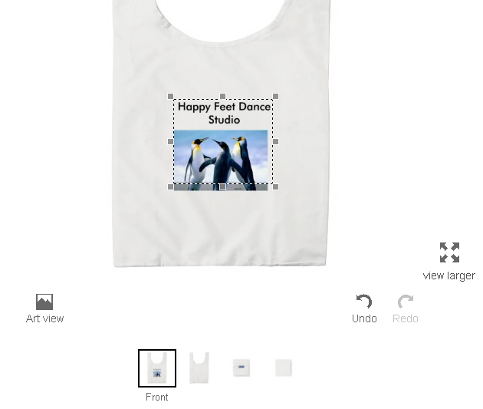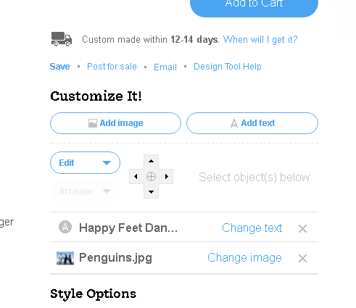

PaperMart design tool

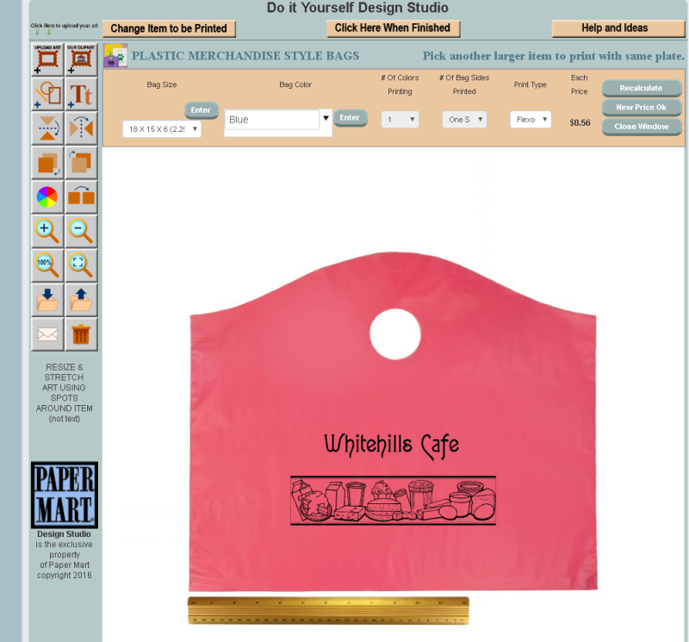  
**Staples**

Staples has a rudimentary online design tool for creating banners, marketing assets, calendars and other promo items. You can add images and text, however it is very difficult to manipulate and resize design elements This program is very basic, and does not offer any unique design features: <http://www.staples.com/sbd/content/copyandprint/banners.html>

