**YMAC: No Stock Match**

**Introduction**

The following is a mapped out series of YMAC (You Might Also Consider) quote results to be used when a user enters in item dimensions and we are unable to generate a stock item result. The purpose of this is to first show what was asked MTO (Made to Order), then to highlight credible stock alternatives and lastly to show Laddawn’s MOD (Made on Demand) capabilities. We want to deliver the message that, despite the fact that we don’t readily stock what was asked, Laddawn will more than meet your needs. While delivering this message YMAC results will simultaneously strengthen our image and educate our users of the breath of Laddawn’s customization to boost current and future sales.

**Condition – No Match**

The user has entered all of their item parameters and the site is unable to find a stock match.

**Guiding Principles**

We will show the user a single MTO or MOD custom item along with a credible list of alternatives that the customer might also consider purchasing at this time or in the future.

**The Results**

The following is the most basic outline for what we will present to customers, in order of importance. The first result is our exact match to what the customer requested, while the following are considered to be the YMAC data results.

1. MTO
2. MTO Cradle Packed
3. Opposite Pack (Stock or MTO)
4. Stock Items at Neighboring Mil Thicknesses: 1-Up and All Down
5. Next Closest Stock Items Within Mil
6. Final Stock Item Check
7. For LD Reclosable Requests Only – Additional MOD Reclosables
8. Different Materials MOD (Same Closure)
9. Different Closure MOD (Same Material)
10. Opposite Bag Configuration (Layflat Vs. Gusset)
    * Changing a layflat to a gusseted bag or vice versa

**The Flow Chart**

Here we can see the bag flow chart for when a user enters a set of dimensions that does not resonate an exact match from our stock SKUs. Here we can see the basic process, mapped out, that will generate credible alternatives to what the user asked for.

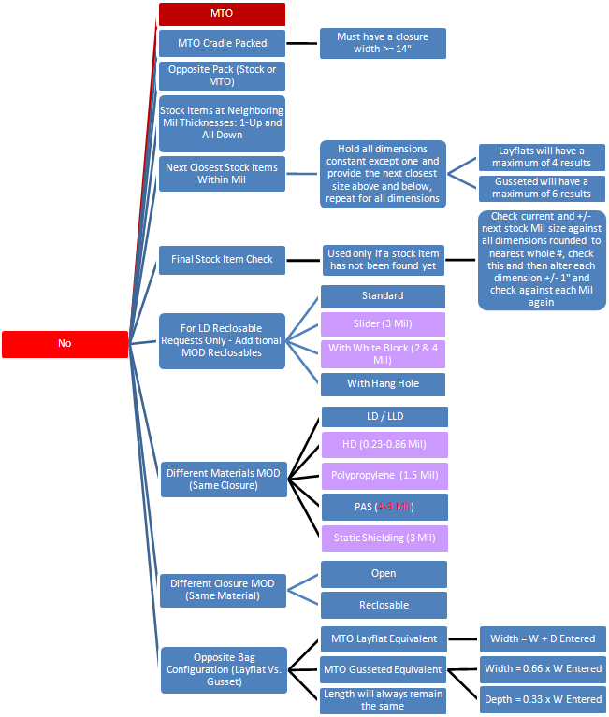

**Graphic’s Key:**

Maroon: MTO, exact customized result

Purple Cells: This denotes a category that we currently don’t offer a custom bag to be built from.

Red Text: This denotes the currently limited Mil range we have users custom build items at today.

**The Details**

The following is a detailed review of each search result.

**1. MTO**

In instances where we are unable to match a stock item to a customer’s request we should first populate what this item would be made to order. This is considered to be exactly what the customer was looking for, without alteration.

We now begin the YMAC data.

**2. MTO Cradle Packed**

The first YMAC result is geared towards “down selling,” providing the most inexpensive alternative at minimal change to a customer’s request. However, it should be noted that not all items can be cradle packed. For example products that cannot be sold on a roll, such as our current reclosable bag selection, thus cannot be cradle packed. Also, if an inquiry does not have a width that is greater than or equal to 14” the item cannot be cradle packed. This holds true even if a gusseted item has a combined width and depth of 14” or greater.

**3. Opposite Pack (Stock or MTO)**

This query exists to highlight various packaging methods available (BOR Vs. Boxed Loose), which will result in another pricing option that the user may have been unaware of. This search is not altering any aspect of the product itself but rather looking for other packing alternatives. A stock match is being searched for first, and, if unsuccessful, we would then populate the MTO result, if applicable.

**4. Stock Items at Neighboring Mil Thicknesses: 1-Up and All Down**

Here we are looking for a stock match to the dimensions entered by the customer, but outside of the Mil thickness that was entered. Here, we will take the Mil that was entered and look above to the next stock Mil thickness up and then to all the sequential Mil below in an attempt to find a stock item that is slightly thicker or thinner than what was initially requested.

Example: Say a customer entered a 20x18x36x00175 LD bag. We stock this size in other Mil thicknesses but not under a 1.75 Mil. We would show two stock items: 1638 – 20x18x36x002 and 1508 – 20x18x36x0015. However, we would NOT show 1764 20x18x36x003 since this is not the next stock Mil thickness above what was entered.

**5. Next Closest Stock Items Within Mil**

This is the last point that we are purposely looking to find a stock item relative to what was initially requested by the customer. Here, we hold all dimensions constant except one, WxDxL, and provide the next closest size above and below, repeating this process for all dimensions. Thus, layflat requests will have a maximum of four results while gusseted will have a maximum of six.

Example: Say a customer entered a 6x7x002 Reclosable Bag. First, holding the width and looking for the next closest length we would populate 3610A – 6x8x002 RB and 3605A – 6x6x002 RB. Next, we will hold the length and look for the next widths to what was entered. With this we would also show an YMAC result of 3580A – 5x7x002 only, since there isn’t bag that is 7” long with a width greater than 6”. Please note, we are not looking outside of the specified Mil thickness here.

**6. Final Stock Item Check**

This is serving as a conditional stock check. Only when we have been unable to populate a credible stock match will this conditional search be activated. The basic logic for having this check is that a customer may have a need that must be met in the shortest amount of time. Here we will make one additional check for such a substitution. What we will do is look at the Mil and the dimensions and check for alternatives. We will look simultaneous at the neighboring Mil thicknesses as we did earlier as well as the entered Mil, and now we are going to round the dimensions to the nearest whole number and check for a stock match. Also we will +/- 1” from each dimension individually and check all Mils again.

Example: If a customer were to enter a 3.1x5x002 PAS reclosable we would be unable to populate a matching stock item at this point. However this conditional search would populate a search result of stock item 4025 – 3x5x004 PAS reclosable. The following is the actual check this search is preforming under this circumstance: no stock Mils below two, no stock Mils at two, 3x5x004, 2x5x004, 4x5x004, 3x4x004, 3x6x004.

**Transition Point - YMAC’s New Purpose**

At this point, we are exhausted our ability to provide credible additional stock results, it is logical to provide users with an opportunity to see what else we can provide for them in terms of credible purchase opportunities. From here forward we will present the user with credible alternatives to what was initially requested. This will deliver a message that despite the fact that we didn’t have your exact product as stock we are more than capable of meeting your needs since we can do so much more than you even just asked of us. This will not only help us “flex” our ability to meet our customer’s needs but act as a selling tool to educate users of our custom capabilities now and in the future.

**7. For LD Reclosables Only – Additional MOD Reclosables**

This is the other real conditional check to produce exposure & relative substitution found within our primary reclosable offering. This query is only active if a customer is already requesting a LD reclosable bag. This is an appropriate time to logically pitch our highest grossing sales category within YMAC. Here we will showcase our reclosables that have zip and slide closures, have white block and those that come with a hang hole.

Example: If a customer initially requested a 4x7x003 LD reclosable we would, here, show the customer a 4x7x003 slider and a 4x7x003 with hang hole.

**8. Different Materials MOD (Same Closure)**

Here we begin to showcase the real breath of our capabilities relating to material substitutions. This is where we show the user popular material capabilities, but not all, quoting what this item would be if composed of the specified, alternative materials (not additives). The current, primary materials to be showcased are LD/LLD, HD (0.23-0.86), Polypro (1.5 Mil), PAS (4-8 Mil) & Static Shielding (3 Mil). The initial item entered must fall within these Mil thicknesses to be custom quoted today. We are presenting the user our capabilities by showing what an item would cost if we held all dimensions and the closure constant, including the Mil thickness, but switched their entered material for one of our most popular sellers.

Example 1 – If a customer were to enter a 6x9x004 PAS reclosable, here would show them stock 3740A – 6x9x004 reclosable or, if not a stock size, a MOD quote for that size.

**9. Different Closure MOD (Same Material)**

Here is where we will designate the two primary closures that we mainly work with, open & reclosables. Within the same material entered, and again noting the Mil thicknesses we currently can search within, the YMAC will populate MOD alternate closure styles. If the user entered any reclosable bag (including LD alternatives like a slider top) we would look to populate a standard, open bag made of the same material. If the customer entered an open bag we would populate relative MOD results for that material in a reclosable.

Example: A customer enters 10x20.5x002 LD. We would retrieve a quote for a 10x20.5x002 LD standard reclosable.

**10. Opposite Bag Configuration (Layflat Vs. Gusset)**

Finally, the last YMAC consists of altering the dimensions to provide layflat or gusseted equivalent of what was entered by the user. This means that we changing the dimensions of an entered layflat bag to a gusseted equivalent or vice versa. However, for a layflat bag to be changed into a gusseted bag quote the layflat bag’s width must exceed 6” and may not be a reclosable bag. If the customer entered a gusseted bag we would add the width and depth dimensions together to create a layflat equivalent. If the customer entered a layflat bag we would multiply the width by .66 to give us our new width dimension and multiply the original width again by .33 to give us our new depth dimension. All other aspects of the bag remain constant.

Example: The customer enters a 30x50x002 LD bag.

Width = 0.66 x W Entered

Depth = 0.33 x W Entered

Length = L Entered

So we would show the user a MTO 20x10x50x002 LD bag.

**Areas Unresolved**

1) Should we disregard Mil thicknesses for Polypropylene, PAS, Metallic Shielding, Black Conductive, Hang Hole, Parts Bag, Slider, Bubble and others? For example say a customer requested a 4x5x004 Open PAS bag, this is ultimately serving a static control function. So should we present the customer with a 4x5x003 Open TMSS bag (3 Mil since this is the industry standard for TMSS)? This would break the current rule not to go beyond “one step” away since we are altering material and Mil thickness.

2) Should we show more than one bag color result? If we can tell that a size or material is for a trash liner we could then show it in black or clear. However, trash liners come in many sizes and someone might want a bag for use as a trash liner, which we wouldn’t consider as a trash liner size.

**Sample Entries**

The following A, B, C, D, E & F are sample inquiries, that could be submitted by the user, to demonstrate what the YMAC results would look like for these entries. Under *List Displayed to End User* this area shows the basic results and sequence YMAC will present to the user. Under *How List Was Determined* the results are paired to their numbered section so we can easily follow from which query each result came from.

**A) 3.1x5x002 LD Open (Case)**

**List Displayed to End User**

* 3.1x5x002 LD Open
* 3.1x5x002 LD Open BOR
* Item 365: 3x5x002 LD Open
* Item 385: 4x5x002 LD Open
* 3.1x5x002 LD Reclosable

**How List Was Determined**

1. 3.1x5x002 LD Open
2. NA
3. 3.1x5x002 LD Open BOR
4. NA
5. Item 365: 3x5x002 LD Open  
   Item 385: 4x5x002 LD Open
6. NA
7. NA
8. NA
9. 3.1x5x002 LD Reclosable
10. NA

**B) 3.1x5x002 LD Reclosable (Case)**

**List Displayed to End User**

* 3.1x5x002 LD Reclosable
* Item 3550A: 3x5x002 LD Reclosable
* 3.1x5x002 LD Reclosable w/ White Block
* 3.1x5x002 LD Reclosable w/ Hang Hole
* 3.1x5x002 LD Open

**How List Was Determined**

1. 3.1x5x002 LD Reclosable
2. NA
3. NA
4. NA
5. Item 3550A: 3x5x002 LD Reclosable
6. NA
7. 3.1x5x002 LD Reclosable w/ White Block  
   3.1x5x002 LD Reclosable w/ Hang Hole
8. NA
9. 3.1x5x002 LD Open
10. NA

**C) 3.1x5x002 PAS Open (Cases)**

**List Displayed to End User**

* 3.1x5x002 PAS Open
* 3.1x5x002 PAS Open BOR
* Item 12005: 3x5x002 PAS Open
* 3.1x5x002 LD Open
* 3.1x5x002 PAS Reclosable

**How List Was Determined**

1. 3.1x5x002 PAS Open
2. NA
3. 3.1x5x002 PAS Open BOR
4. NA
5. Item 12005: 3x5x002 PAS Open
6. NA
7. NA
8. 3.1x5x002 LD Open
9. 3.1x5x002 PAS Reclosable
10. NA

**D) 3.1x5x002 PAS Reclosable (Case)**

**List Displayed to End User**

* 3.1x5x002 PAS Reclosable
* Item 4025: 3x5x004 PAS Reclosable
* 3.1x5x002 LD Reclosable
* 3.1x5x002 PAS Open

**How List Was Determined**

1. 3.1x5x002 PAS Reclosable
2. NA
3. NA
4. NA
5. NA
6. Item 4025: 3x5x004 PAS Reclosable
7. NA
8. 3.1x5x002 LD Reclosable
9. 3.1x5x002 PAS Open
10. NA

**E) 6.5x9x002 LD Open (Case)**

**List Displayed to End User**

* 6.5x9x002 LD Open
* 6.5x9x002 LD Open BOR
* Item 440: 6x9x002 LD Open
* Item 458: 7x9x002 LD Open
* 6.5x9x002 LD Reclosable
* 4.29x2.15x9x002 LD Open

**How List Was Determined**

1. 6.5x9x002 LD Open
2. NA
3. 6.5x9x002 LD Open BOR
4. NA
5. Item 440: 6x9x002 LD Open  
   Item 458: 7x9x002 LD Open
6. NA
7. NA
8. NA
9. 6.5x9x002 LD Reclosable
10. 4.29x2.15x9x002 LD Open

**F) 6.5x9x004 LD Open (Case)**

**List Displayed to End User**

* 6.5x9x004 LD Open
* 6.5x9x004 LD Open BOR
* Item 1110: 6x9x004 LD Open
* Item 1108: 7x9x004 LD Open
* 6.5x9x004 PAS Open
* 6.5x9x004 LD Reclosable
* 4.29x2.15x9x004 LD Open

**How List Was Determined**

1. 6.5x9x004 LD Open
2. NA
3. 6.5x9x004 LD Open BOR
4. NA
5. Item 1110: 6x9x004 LD Open  
   Item 1108: 7x9x004 LD Open
6. NA
7. NA
8. 6.5x9x004 PAS Open
9. 6.5x9x004 LD Reclosable
10. 4.29x2.15x9x004 LD Open