HACCP Certificate of Compliance / Letter of Guarantee
(Valid January 1, 2017 – December 31, 2017)

To Whom it May Concern:

This letter is submitted on behalf of Laddawn, Inc. and is intended to stand as a continuing guarantee of Laddawn’s Hazard Analysis Critical Control Points (HACCP) compliance in its Manchester, Iowa and Reno, Nevada facilities.

The following item(s) supplied to you by Laddawn, Inc.:

LOT# are produced in facilities that comply with the rules and regulations set forth under HACCP guidelines.

To comply with HACCP guidelines, Laddawn, Inc. conducts hazard assessments for all produced products, constructs a HACCP plan where applicable, writes and implements standard operating procedures and follows Good Manufacturing Practices.

Thank you for your business.

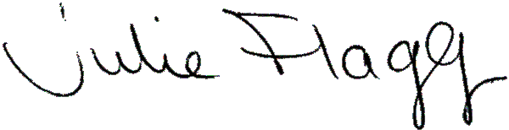
Julie Flagg
Compliance Manager
Laddawn

