Charitable.aspx

## Do my purchases help support any charitable causes?

Yes. Laddawn is very active in supporting non-profit organizations, most notably [Easter Seals](http://www.easterseals.com). Easter Seals is committed to expanding the independence of children and adults with disabilities. Laddawn donates $1 to charity for every online order of $100 or more. Since you make our giving possible, you tell us where to send your dollar at checkout.

### What can $1 do?

|  |  |
| --- | --- |
| **Nature Conservancy** | $1 can help fund restoration efforts |
| **The Red Cross** | $1 can help fund relief efforts |
| **Boys & Girls Clubs** | $1 can help provide a wholesome breakfast for a deserving child. |
| **American Cancer Society** | $1 can help fund research. |
| **Easter Seals** | $1 can help fund learning activities for children with special needs. |

Can't Decide? We will select one of the charities listed above on your behalf.

One dollar....can plant a tree, feed a child, help fund research and provide relief for those in need. There is no limit to what $1 can do.

### Easter Seals

Help, Hope and Answers

|  |  |
| --- | --- |
| Easter Seals -- helping people with disabilities gain greater independence | Easter Seals provides exceptional services, education, outreach, and advocacy so that people living with autism and other disabilities can live, learn, work and play in our communities.  Easter Seals primary services benefit over 1.3 million individuals each year through more than 550 centers nationwide and in Puerto Rico and Australia. Easter Seals allocates 94% of its program dollars to providing direct services. |

#### How Laddawn Helps

Laddawn is the biggest corporate donor to Easter Seals in Central Mass. Laddawn happily supports employees as they raise money throughout the year, which has resulted in some very creative fundraisers - anything from chili contests put on by our Customer Relationship Team, to bowling tournaments, to comedy shows.

The annual “Walk With Me” walk in Worcester is the big fundraiser of the year. In 2012 Laddawn had its largest team of walkers. We raised a record total amount of $125,722. This prompted Kirk Joslin, President and CEO of Easter Seals of Massachusetts, to write:

*Thank you and to everyone at Laddawn for completely outdoing yourselves this year in both your fundraising and your enthusiastic commitment to Easter Seals. Your team’s presence at the walk helps bring our event to a whole new level. The* Worcester Telegram *reporter who was there called me this morning for additional information. She said “what a warm and enthusiastic group you had at your event.” That was Laddawn.*

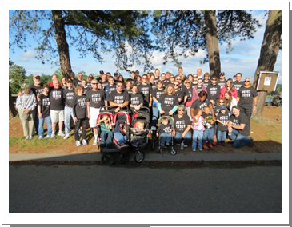

Laddawn is proud of its generous family of employees and grateful for the work they do here to make our giving possible.