By the Pound to by the Roll

**Example**

1. 24” 2 mil Tubing **by the Pound**. B. 24” 2 mil Tubing **by the Roll**

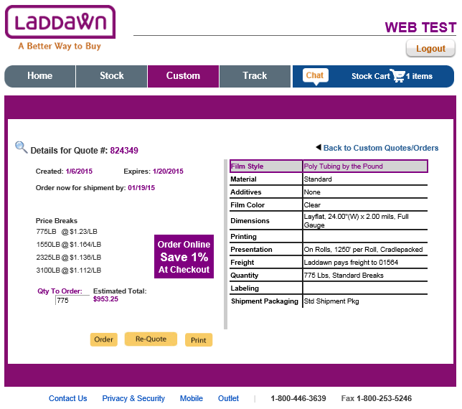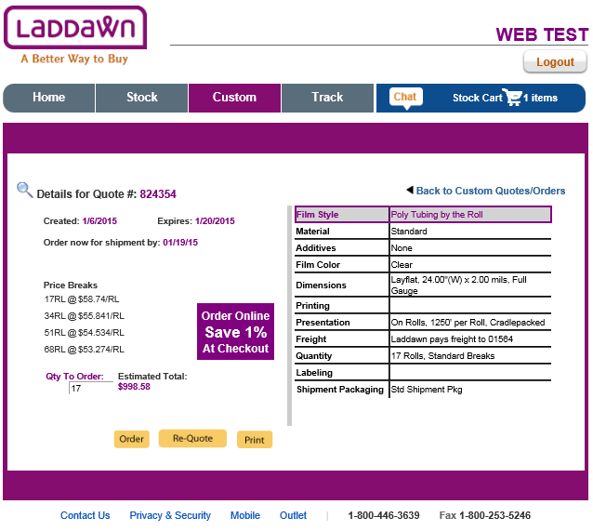

1. Calculation of lbs. per roll: (Width + Depth) x Gauge x 0.8 = lbs./1000 ft.

In this case: (24 + 0) x 2 x 0.8 = 38.4 lbs./1,000 feet roll

38.4lbs./roll. x (1,250 ft./1,000 ft.) = **48.0lbs./roll of 1,250 ft.**

*The differences of 100ths of pennies are attributed to the small differences in breaks (a 17 roll min does not exactly equal 775lbs.).*

2. Compare … $58.740/roll / 48 lbs./roll = $1.223 / lb. (as compared to $1.230/lb.)

$55.941/roll / 48 lbs./roll = $1.165 / lb. (as compared to $1.164/lb.)

$54.534/roll / 48 lbs./roll = $1.136 / lb. (as compared to $1.135/lb.)

$53.274/roll / 48 lbs./roll = $1.110 / lb. (as compared to $1.112/lb.)