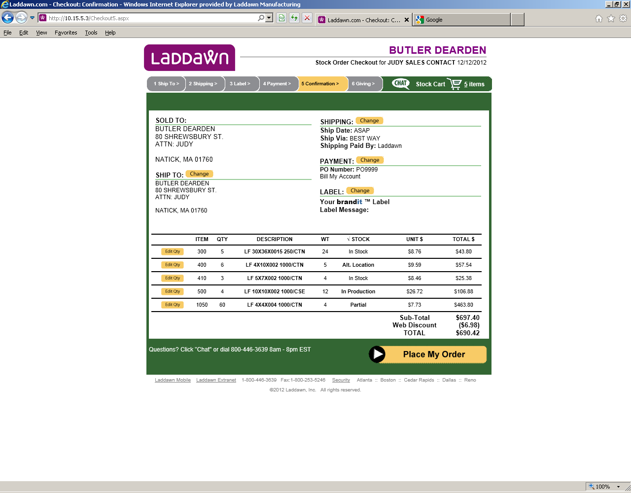
- LINES 1 AND 3 ARE IN STOCK IN STERLING (MY CLOSEST WHS)
- LINE 2 – I CHOSE ‘ALTERNATE WHS’, SO ITEM WILL SHIP FROM DALLAS
- LINE 4 – NOTHING WAS AVAILABLE SO SHOWS ‘IN PRODUCTION’ – WILL ‘SHIP COMPLETE’ FROM STERLING IN 72 HRS
- LINE 5 – SHOWS ‘PARTIAL’ – 55 ARE IN STOCK AND 5 ARE B/O – SHIP&B/O FROM STERLING

EMAILED ORDER ACKNOWLEDGEMENT:
Thank you for placing your order with Laddawn, Inc. Please review order #103338 for accuracy. If you would like to make a change to your order, please contact Customer Experience at 1-800-446-3639.

Order Date: 12/12/12
Customer Po Nbr: PO9999
Drop Ship Po Nbr:
Sales Contact: HOUSE MONTHLY
Shipped Via: BEST WAY
FOB Point: PREPAID
Payment Terms: NET 30
Tax Code: TE

Brandit / Custom Label Information
Source: BILLTO
Label Comment:

Third Party Information

SOLD TO:
BUTLER DEARDEN
80 SHREWSBURY ST.
ATTN: JUDY
NATICK, MA 01760
USA
SHIP TO:
BUTLER DEARDEN
80 SHREWSBURY ST.
ATTN: JUDY
NATICK, MA 01760
ATTENTION:

Items Purchased:

Part Number: 000300
LF 30X36X0015 250/CTN
DESCRIPTION 2
UOM: CS
TOTAL QTY: 5 PRICE: 8.76 TOTAL PRICE: 43.80
SCHED QTY: 5 SHIP ON: 12/12/12

Part Number: 000400
LF 4X10X002 1000/CTN
UOM: CS
TOTAL QTY: 6 PRICE: 9.59 TOTAL PRICE: 57.54
SCHED QTY: 6 SHIP ON: 12/12/12

Part Number: 000410
LF 5X7X002 1000/CTN
UOM: CS
TOTAL QTY: 3 PRICE: 8.46 TOTAL PRICE: 25.38
SCHED QTY: 3 SHIP ON: 12/12/12

Part Number: 000500
LF 10X10X002 1000/CSE
UOM: CS
TOTAL QTY: 4 PRICE: 26.72 TOTAL PRICE: 106.88
SCHED QTY: 4 SHIP ON: 12/12/12

Part Number: 001050
LF 4X4X004 1000/CTN
UOM: CS
TOTAL QTY: 60 PRICE: 7.73 TOTAL PRICE: 463.80
SCHED QTY: 60 SHIP ON: 12/12/12

*** Line Comments ***
Line 4: Ship Complete
Line 5: Ship and Backorder

SUBTOTAL 697.40
WEB DISCOUNT -6.98
TAX 0.00
TOTAL 690.42

ORDER HEADER COMMENTS:
AS YOU CAN SEE, THE CURRENT WEB ALLOWS THE CUSTOMER TO CHOOSE ‘SHIP COMPLETE’ AND ‘SHIP AND BACKORDER’ ON THE SAME ORDER. THIS IS NOT HOW WE HANDLE BACKORDERS IN THE WAREHOUSE.

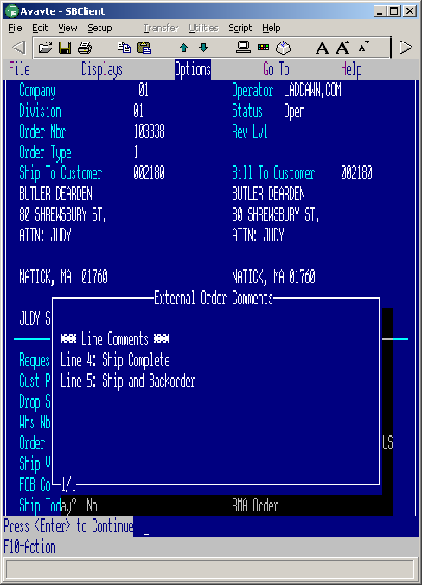

ORDER’S SCHEDULE SHIP DATE (REQUEST DATE) IS TODAY’S DATE

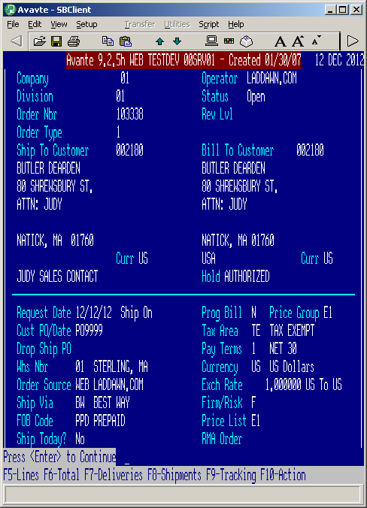

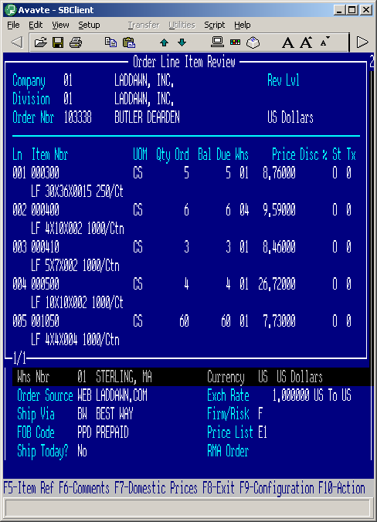
LINE 2 OUT OF DALLAS – THIS ORDER WILL NOW GO IN TWO DIRECTIONS:
- DALLAS WILL GET PICKSLIP FOR LINE 2 SHOWING ALL AVAILABLE
- STERLING WILL GET A PICKSLIP FOR LINES 1,3,4,5 SHOWING:
  - LINE 1 – ORDER 5, PICK 5, B/O 0
  - LINE 3 – ORDER 3, PICK 3, B/O 0
  - LINE 4 – ORDER 4, SHIP 0, B/O 4
  - LINE 5 – ORDER 60, PICK 55, B/O 5

By the time the warehouse gets the pickslip, c/e has already corrected the comments stating to either ‘SHIP COMPLETE’ or ‘SHIP AND BACKORDER’. If shipping complete, no lines will be shipped out of Sterling until all backorders are available. The customer’s scheduled ship date will reflect when all backorders will be available. If ship and backorder, the first shipment will be done sending everything that is in stock, then c/e will change the scheduled ship date to be the furthest date out when all backorders will be available. The customer is told when the b/o is expected.

FROM MEME:
Judi

I think some customers would like to ship complete and ship and back order on the same order. It would be very costly for us to ship complete of some item and backorder some item and also do this from multiple ware houses base on the same order. We are the ones who discourage this from happening.

If anything customers would rather ship the complete order when they are paying the freight . If we are paying and they want complete orders the request would be ship from closest location.

I think decisions are made depending on the demand at the time.

Sorry if this is not clear. It is case by case basis. Sarah you may chime in if you had something add please

Meme

FROM LEO:
I spoke w/Leo Legault. He confirmed that the policy is ‘ship complete’ or ‘ship and bo’ is ‘per order’. He believes that the customer doesn’t always understand what they are asking for when they mix these on a single order. The bottom line is we don’t want to do more than 2 shipments of an order, so ‘ship complete’ is our best bet. In most cases, the customer is only waiting a max of 3 days for us to produce the backorders because these w/o’s take top priority in production. But we will ‘ship and backorder’, meaning that we will ship what we have now, then ship all of the backordered lines at once, for a total of two shipments. The third option is that they choose ‘alternate warehouse’.

