Category | Canvas elements | Construction & plates
Zip top | Front, back; lip is present/printable on both sides. | SW – 1 plate
Zip top with round hang hole | Front, back; lip is present/printable on both sides; round hang hole centered on lip | SW – 1 plate
Zip top with sombrero hang hole | Front, back; lip is present/printable on both sides; sombrero hang hole centered on lip | SW – 1 plate
Slider top | Front, back, slider | SW – 1 plate
Layflat | Front, back | SW – 1 plate
Side gusset - PHASE 2 | Front, back, gusset lines | BS – 2 plates
Auto bags (aka pre-opened bags on rolls) - PHASE 2 | Front, back | BS – 2 plates
Wicketed layflat | Front, including lip - show 2 wicket holes (distance between holes = wicket width?); back. Note: no printing on lip of wicketed bags.  We also need to illustrate chosen bag release option (tear start or perforated lip) in designer and preview (as we do now in tech drawings).  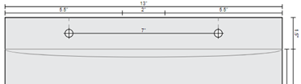  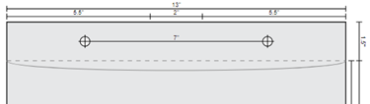 | SW – 1 plate
Wicketed bottom gusset | Front, including lip - show 2 wicket holes (distance between holes = wicket width?); back; bottom gusset. No printing on lip.  As stated above, we also need to illustrate chosen bag release option. | SW – 1 plate
Lip & tape, permanent Any visual difference between permanent and resealable (below) other than one’s tape is clear and other is white? If not, canvases for permanent and resealable can be the same, but preview/tech drawings should show diff. | Front (including lip) and back; we will also depict the non-printable area (area from the back opening down, that the lip folds over onto). Also: show tape in preview & tech drawings for back side. | SW – 1 plate
Lip & tape, resealable | Front (including lip) and back; we will also depict the non-printable area (area from the back opening down, that the lip folds over onto). Also: show tape in preview & tech drawings for back side. | SW – 1 plate
Poly mailers (aka co-extruded) – non-perforated | Front (including lip) and back; always full bleed, so no "safe-line." Also: show tape in preview & tech drawings for back side.  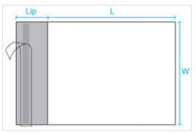 | SW – 1 plate
Poly mailers (aka co-extruded) – perforated | Front (including lip, show perforation line) and back; always full bleed, so no "safe-line." Also: show tape in preview & tech drawings for back side.  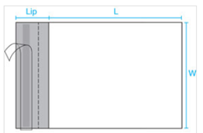 | SW – 1 plate
Poly mailers (aka co-extruded) - returnable | Front (including lip, show two perforation lines) and back; always full bleed, so no "safe-line." Also: show both tape strips in preview & tech drawings for back side.  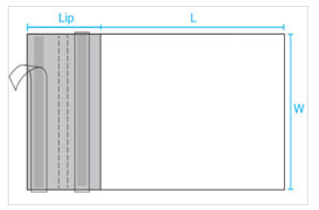 | SW – 1 plate

