Category | Canvas elements | Construction & plates
Wicketed layflat | Front.  Back, including lip - show 2 wicket holes (distance between holes = wicket width). Note: no printing on lip of wicketed bags – to be indicated by position of safety line.  We also need to illustrate chosen bag release option (tear start or perforated lip) in designer and preview (as we do now in tech drawings).  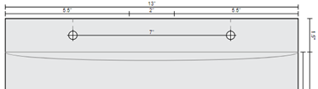  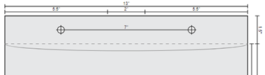 | SW – 1 plate
Wicketed bottom gusset | Front, with safety lines for sides, top and bottom.  Back, including lip - show 2 wicket holes (distance between holes = wicket width). Note: no printing on lip of wicketed bags; indicate with height of safety line.  Bottom gusset; safety lines at sides only.  As stated above, we also need to illustrate chosen bag release option. | SW – 1 plate
Lip & tape, permanent | Long side (including lip). Safety lines on sides, top and bottom. Line indicating lip.  Short side (see below) showing flip side of the lip (interior of bag with tape – tape is white ). Depict the non-printable area (area from the top of the opening down, that the lip folds over onto) with safety line. TBD whether other indicators are necessary like watermark text “Non-printable area.”  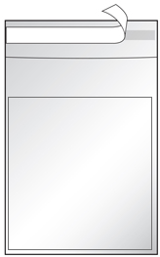 | SW – 1 plate
Lip & tape, resealable | Same as above except the resealable tape is clear. | SW – 1 plate
Poly mailers (aka co-extruded) – non-perforated | Film exterior is white.  Long side (including lip)  Short side (see below) showing flip side of the lip (interior of bag with clear tape).  Both sides: always full bleed, so no "safety line."** **Jay to confirm: Should we have a nonprintable area for where the lip folds over onto the short side? In any case, no safety lines on sides or bottom of short side; no safety lines on top, sides or bottom of long side.  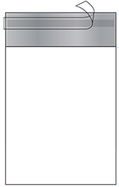 | SW – 1 plate
Poly mailers (aka co-extruded) – perforated | Same as above but depicting perforation in addition to tape strip.  Short side:  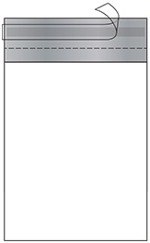 | SW – 1 plate
Poly mailers (aka co-extruded) - returnable | Same as above but depicting two clear tape strips and two perforations.  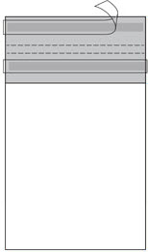 | SW – 1 plate
Zip top | Front (including zipper and lip), back (including zipper and lip). Safety lines on sides, top, bottom of lip and sides, top, bottom of front/back. | SW – 1 plate
Zip top with round hang hole | Same as zip top above with centered, round X” hang hole shown on front and back of lip. | SW – 1 plate
Zip top with sombrero hang hole | Same as zip top above with centered sombrero hole shown on front and back of lip. | SW – 1 plate
Slider top | Front (including slider), back (including slider); safety lines sides, top and bottom. | SW – 1 plate
Layflat | Front, back. Safety lines on sides, top and bottom. | SW – 1 plate
Side gusset - PHASE 2 | Front, back, gusset lines | BS – 2 plates
Auto bags (aka pre-opened bags on rolls) - PHASE 2 | Front, back | BS – 2 plates

