

Business | Creative Brief

**Laddawn 2.0**

1. **STATEMENT OF PURPOSE**

Laddawn will be to poly bags what Zappos was to shoes – a superior provider of customer service driven by work flow process, a quality product offering and agile project sourcing.

Above all, Laddawn will provide a very personalized and proactive electronic experience.

We seek to change the industry. We will advance our online business and develop, what is internally known as, “The Laddawn Marketplace”. Laddawn 2.0 will inform and enable our transition from manufacturer of plastic bags, tubing and film to online provider of industrial packaging materials with a manufacturing arm.

1. **BRAND POSITIONING**

Positioning Statement:

For distributors of packaging materials, Laddawn.com provides a highly personalized and proactive electronic experience for purchasing the broadest array of industrial packaging materials.

Laddawn.com ODB:

Laddawn.com provides a smarter, faster ecommerce experience.

Brand Position:

We use innovative systems and technology to provide the easiest and most reliableway to buy packaging products

Value Proposition:

Laddawn helps customers win profitable business with quick answers, pricing and turnaround, and guaranteed quality. Laddawn speeds the flow of their business.

Brand Personality:

Sincere, reliable, friendly, progressive, dynamic, socially responsible, generous in spirit and actions.

1. **BACKGROUND**

In 2000, Laddawn launched its first web site as a stock-only ordering portal for distributors. Users could search, check inventory levels, order and track orders. An important underlying attribute was Laddawn.com’s direct tie-in to our MRP/CRM systems which allowed fully automated order transactions and a direct view into inventory levels in real time. There are few analytics from the period – other than gross sales. Online orders grew to about 25% of all stock purchases by 2005.

A new version of Laddawn.com was launched in early 2005. A dated layout was replaced with a more intuitive tabbed design. More importantly, we added custom quoting and ordering. (Note: Custom ordering was never fully integrated into our system - CE manually converts all custom orders placed online.)

Online sales transactions grew quickly to about 30% of total orders; however, few custom orders were converted online (about 10%). Later that year we began to offer a 1% discount for all orders placed online – a promotion that is still in place today. The number of online purchases jumped to about 35% of overall sales.

We believe that lower online custom order placement reflects the general uneasiness users have about self-service on larger orders (custom order average between $2,500 and $3,000 – and can’t be returned to stock). In an effort to ease that concern, Laddawn adopted a more liberal custom return policy in 2012.

Laddawn introduced a Charitable Giving Page in 2008. Here, for all orders over $100, Laddawn donates $1 to charity at the direction of users. Charity selections included Easter Seals, the Nature Conservancy, Boys & Girls Clubs of America and the American Cancer Society. The American Red Cross was added in 2009.

In March of 2013, Laddawn modified its landing page. The LOAP (lipstick on a pig) project was intended as an intermediate step forward in parallel with concurrent advances in print marketing. Laddawn’s twitter feed was added as well as a four image marketing carousel. We also took the opportunity to clean up some of the static content.

1. **CURRENT ANALYTICS**

From Google Analytics: (for May 2014)

* Laddawn.com hosted 920 visitors per workday; 28 visitors per weekend day
* 5,806 distinct visitors came to Laddawn.com a total of 19,524 times
* The average total session time was 7:30
* 51% went right to the stock tab, 14% went to the custom tab and 10% went to the track tab

A Google Analytics snapshot for May of 2014 of Laddawn.com users shows the following:

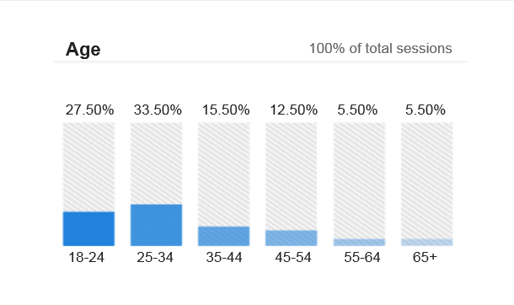

We believe the average distributor contact overall to be both older and more likely to be male.

This data suggests that new and future distributor contacts are as likely to be female as male, younger and more likely bring higher expectations for technology.

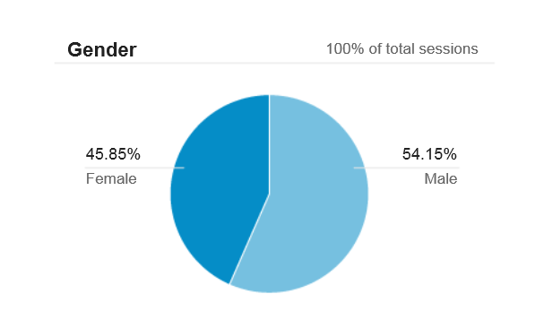

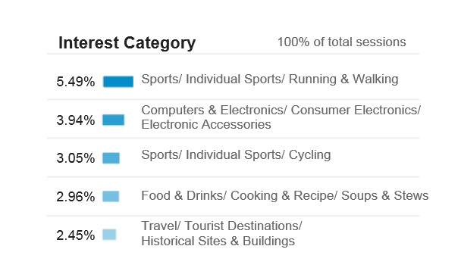

From Laddawn CRM Database: (for FY’14)

* There are 34,329 contacts in our system (our mailing List).
* 21,509 contacts are managed by Laddawn Customer Relationship Partners and Senior Customer Relationship Partners, representing 3,145 bill-to locations.
* 13,318 (62%) of our managed contacts have active email addresses, 8,191 do not (38%).
* There are a large number of unmanaged companies and contacts in our system.

Generally understood to be unworthy of focus – due to size, poor credit or unwillingness to work with us, there are 12,930 of these unmanaged contacts in our system representing 31,294 bill-to locations. The vast majority of these bill-to locations represent very old customer files. Of those 31,294, just 454 locations have sales in FY’14. They average just $1,034 per month.

In the 12-month period ending May 31, 2014:

* Laddawn customers placed 84,519 of their 174,626 orders online (48.4%, a very strong base of e-business, although we set 60% as the target).
* Laddawn customers are projected to direct $61,864 in charitable giving through the checkout page in the fiscal year ending October 31.
* Laddawn’s web discount is projected to reach $510,630 in FY’14 over the same period.

Online stock transactions average about 52% while online custom orders hover around 30%. In dollars, Total web orders will account for roughly 43% of all sales this year, about $52 million.

1. **User Personas**

**Personas** are archetypal users of a product or service. They typically describe a fictional person's attitude (motivation, emotion, risk tolerance, persistence, optimism, pessimism); aptitude (current knowledge, ability to make inferences, expertise); and ability (physical and cognitive attributes) - with respect to your product or service.

There are 3 persona described here. We’ll use these to help us build and market and work:

|  |  |  |
| --- | --- | --- |
| Sandy Green | Frank Garcia | Chuck Mason |
| **Pak Solutions** | **Atlantic Packaging** | |
| *Pak Solutions is a small, family-owned packaging distributorship.* | *Atlantic stocks 12,000 items in one giant warehouse location - about 1/3 janitorial supplies; 1/3 industrial products and 1/3 packaging. Atlantic works with 600 suppliers ranging from Kimberly Clark to Interstate Container. Poly bags make up a small fraction of Atlantic's packaging supplies.* | |
| Pak Solutions recently hired Sandy as a temp-to-perm purchasing agent.  Prior to this, Sandy had been a junior purchasing associate at a large medical device manufacturer that went out of business. In her short time at Pak Solutions, Sandy has grown to like the company and its people very much; she would really like a permanent position with full benefits.  She is new to the packaging industry and to poly bags in particular. But she is bright, resourceful, and ambitious, and isn’t afraid to try new things. She actively maintains a profile and professional connections on LinkedIn. She is proficient with basic office computing - word processing, spreadsheets and web browsing. She uses Google when she doesn't know where to begin.  In her personal life, she does most of her shopping online. She has a laptop and an iPhone. She makes 'point of sale' mobile payments at Starbucks, Target and elsewhere. She uses Facebook and texting to stay connected with friends and family.  She frequently uses sites like Yelp, TripAdvisor and OpenTable, and occasionally posts her own reviews. Sandy's hobby is knitting; she's posted some of her work, and the work of others she admires, on Pinterest. She uses Twitter, mainly in conjunction with entertainers she follows, though she occasionally Tweets about what she's up to and includes an Instagram photo. Sandy is concerned about the environment. | Frank has been a salesman for Atlantic Packaging for over 5 years.  He sells to a diverse base of clients, ranging from consumer electronics to apparel.   He’s a gregarious “people person”; he’d much rather be in the field interacting with clients, than spending time back at the office. He’s a great conversationalist and listener, and attentive to small details.  Frank gets by with basic word processing, email and some web use. He is somewhat risk-averse when it comes to new technology; as soon as he masters some complex system, they go and change it on him.  Atlantic recently replaced his cell phone with a smart phone, but he hasn't had time to master its new features. He uses it primarily for calls, texts and emails. He is still getting used to the touchscreen.  In order to grow his sales, Frank is constantly trying to increase his knowledge of the products he's selling and the industries he's selling to; he tends to ask his customers and suppliers lots and lots of questions. When he has a new sales opportunity, he occasionally does some preliminary research online at the office. But more often than not he hands quoting and ordering off to the Purchasing Department, unless he needs something after hours.  When it comes to polybags, he loves Laddawn’s fast quotes; he wishes everyone was like Laddawn. Frank is sensitive to pricing; he's always looking to increase his margin and isn’t afraid to ask for a better deal.  Frank also researches his personal buying decisions on the web, but because he doesn't like to use his credit card online, he tends to make purchases at stores or over the phone. He enjoys YouTube videos that his friends occasionally send to him him. He also plays fantasy football. He stays connected with friends and family mainly though phone and email. He had a Facebook account, but abandoned it - he's blocked from using it at work, and found Facebook's constant notifications and changes to privacy settings too difficult to keep up with. | Chuck has been with Atlantic Packaging for 18 years. He is one of three purchasing agents there.  Chuck has got a lot on his plate every day. It's hard for him to retain much information about the poly products he buys sporadically. In evaluating different vendors, he cares most about pricing, availability and return policies. He has a handful of favored vendors, based on his contacts at those firms who take really good care of him.  Chuck's job performance is graded on gross profits and turns; he is expected to increase his turns from 9 to 12 this year. Meeting such objectives is becoming harder and harder. Due to increased competition, Atlantic is not growing at the pace it did when he first started there. More and more he hears that providing excellent service is what will give you the competitive edge; however, he's not sure how that translates to his "behind-the-scenes" role.  His day is pretty much spent in email, on the phone, and in Volaré, Atlantic's ERP system for the last eight years. Although Chuck types with two index fingers, he knows all the ins and outs Volaré; new staff often turn to him for tips on how to use this quirky system with all the screens and special function keys.  Chuck gave in about 3 years ago and got a personal cell phone. His two colleagues resent the fact that Atlantic recently issued smart phones to the sales staff, but Chuck could care less - he fears that a company-issued phone would place more demands on his personal time, and wants to preserve that separation as long as he can.  Chuck owns a home computer, but his teenaged children are its main users.  On the rare occasions that he's done anything online (he thought he might give Ancestry.com a try), his children have had to help him with the website or browser. He hates feeling stupid and helpless. He's not much of a shopper, but when he is in the market for something, he prefers the comfort and familiarity of the in-store experience, and being able to see and touch whatever he's buying.  He has a personal email account but never checks it (which his sisters find extremely annoying) - he spends all day in front of a computer screen and that's enough.  His kids are on Facebook all the time. He hears about Twitter in news and entertainment media, but has no idea what that's about - probably a passing fad. |

1. **Vision: A PERSONALIZED AND PROACTIVE ELECTRONIC EXPERIENCE**

Laddawn.com has been a strong tool for distributors to process orders and inquiries. Distributors confirm its usefulness with high adoption rates and we benefit from lower transactional costs and greater efficiencies (neither well quantified).

Comparison to Other Great Sites (outside of our industry)

1. **Branding**. We don’t display our brand and value proposition succinctly and prominently.
2. **Proactivity**. We don’t use what we know about our customers to personalize their online experience.

Drawbacks to our Current Pricing Functionality

1. **Stock or Custom**. Customers must choose the path to search for a stock item or the path to quote a custom product without the means to know which to follow.
2. **Custom Q&A**. Our custom quoting software provides just one point of entry to a linear, somewhat intensive Q&A.
3. **Made or Sourced**. Neither of our search paths is well suited to quoting custom items we do not manufacture.

Two Important Things to Leverage

1. **Repeat Activities**. Our customers frequently quote or reorder the same items.
2. **Contacts**. When a contact logs in, we know many of the colleagues in their organization.

We also experience one obstacle that most great web businesses don’t. Many of our customers use ERP software to generate orders and quotes by fax, and view Laddawn.com as an extra effort. That is, they need to place an order on Laddawn.com and place the order in their own system: double entry, if you will.

We do not have a solution for the issue of double entry. We believe that if we make Laddawn.com intuitive and useful enough, the cost of “double entry” will pale in comparison.

**Characteristics of the new Laddawn.com**

So, Laddawn.com will:

1. be a destination for our customers,
2. provide a consistent model service experience,
3. offer intuitive yet robust real-time pricing tools,
4. eliminate the distinction between stock and custom*,
5. eliminate the distinction between what we make and what we source**, and
6. deliver a highly personalized, proactive and engaging online experience.

* Note about Stock vs Custom:

We know what we stock and what we make, but our customers don’t. Why should they? With the new Laddawn.com, you ask for an item – with as many or as few attributes as are important to you – and we’ll give you options, stock and custom.

* 5 cases of a 9x12 2 mil layflat? Sure. “We can pull it from stock and ship it today. If you can wait and order a bit more, we can make it for you at a reduced price and ship it in 5 days. The minimum for that is just 20 cases. We also stock it with a zipper closure…”
* 30 cases of a 9.5x16 1 mil layflat? Sure. “We can have that made for you and ready to ship in 5 days. In a hurry? We have both 9x16 and 10x16 2 mil layflats in stock. I can ship that today.”

** Note about Make vs. Source:

It’s great that we have such broad and nimble manufacturing capabilities. However, that we manufacture is far less important than our ability to provide instant pricing and availability through an efficient and engaging service model.

(a) Customers will have the same buying experience (primarily, we’re talking about instant pricing and ship dates) whether the item is made or sourced.

(b) Their product needs will inform our buy/make decisions.

**Through look and feel, new features, functionality and content, the new Laddawn.com will also clearly demonstrate:**

* Brand Position:

We use innovative systems and technology to provide the easiest and most reliableway to buy packaging products

* Value Proposition:

Laddawn helps customers land new and sustain existing business with quick answers, pricing and turnaround, and guaranteed quality. Laddawn speeds the flow of your business.

* Brand Personality:

Sincere, reliable, friendly, progressive, dynamic, socially responsible, generous in spirit and actions.

* How Laddawn is fundamentally different from its competitors.

**We envision a number of revisions and innovations on the old Laddawn.com.**

1. The new homepage will have a strong marketing statement and links to the features that define our business and culture.
2. The landing page (upon login) will be driven by unique customer data. It will include a warm welcome, an opportunity to establish online preferences, information about Laddawn and the industry as it relates to their business.
3. The landing page will provide easy access to past orders and/or pricing that may be due for reorder. This window will allow refinement of the search criteria, and present the link to search all past orders. This can become a destination for distributor sales reps planning their calls for the day.
4. The landing page will allow users to select from a list of their colleagues to establish standard workflow notifications for a variety of activities. A Purchasing Agent may elect to notify a Sales Rep and their Admin Assistant that an order has been entered on their behalf, for example.

These notifications, which customarily happen with calls, notes and emails within their office, will help balance the possible perception that Laddawn.com requires an extra effort. (The double-entry conundrum.)

1. A new search window will allow users to select criteria in whatever sequence they choose, and will return stock and/or custom results for items we manufacture and purchase. Users will select stock or custom solutions to place in a shared shopping cart.
2. **IMPACT ON KEY PERFORMANCE INDICATORS (KPIs)**

Laddawn’s Key Performance Indicators are tracked and posted monthly. They have been identified as those most representative of our business performance in service, operations and sales. There are 6 KPIs in play -

Service Leadership

* 1. **Orders on the Web**. This is defined as the
  2. *((# web custom + # web stock orders*) / *total # orders)*. We set a target of 60%. For the 12 month period ending May 31, 2014, web orders averaged 48.4%.

*The new Laddawn.com is designed to make Laddawn.com a desired destination for many decision makers.*

* 1. **Time to Process a Customer Service Request**. This is defined as (*total time to complete a request in placed in the CS queue / total # of requests*). We have set a target of 30 minutes. In the period ending April 30, 2014, we averaged 83 minutes.

*An inviting new Laddawn.com will both expedite CE response through its intuitive design and lower CE demand by encouraging self-directed work.*

* 1. **Customer Service Accuracy Rate**. This is defined as (*1 - (# of errors made / total # of orders*)), we have set a target of 99.85%. In the period ending December 31, 2010 we averaged 99.90%.

*Increased online adoption will encourage the move from manual (prone to errors) to automated transactions.*

Operational Efficiencies

* 1. **Finished Goods Inventory Turns**.Defined as the (total annual stock sales / the total stock item inventory value), we have set a target of 10 turns per year. For the 12-month period ending April 30, 2014 finished good inventory turn averaged roughly 8.6.

*An inviting and intuitive new web site design will encourage distributor self-service and make building of stock orders easier.*

Sales Leadership

* 1. **Sales per Managed Customer Location**.Defined as the ((*total sales for all managed locations / total # of managed locations*)/days per period), we have set a target of $200 per day. For the 12-month period ending April 30, 2014 sales per managed location reached $124 per day.

*A new Laddawn.com – built to be a desired destination for decision makers – will inform and facilitate stock and custom purchases.*

* 1. **Sales per Stock Item**.Defined as the ((*total sales for all stocked items / total # of stocked items*)/days per period), we set a target of $100 per day. For the 12-month period ending April 30, 2014 sales per managed location reached $78.

*A new Laddawn.com – built to be a desired destination for decision makers – will inform and facilitate stock purchases.*

1. **PROFIT CONSIDERATIONS**

Productivity

Reducing transaction costs is important, but it is not a driver of this work per se. The savings just don’t appear to be there. In a 2005 survey, we were surprised to learn just how efficient CE is. Average transaction costs totaled around 0.4% per order. The 1% discount provided at that time was therefore less about sharing our savings and more for encouraging user adoption.

Error Cost

But, there is real money to be made by reducing error rates – especially due to human intervention on edge case criteria. The current CRM system has provisions for nearly 2,000 individually created comments. These range from the innocuous and unhelpful (“Make good seals”) to the critical-or-the-order’s-coming-back (“Always make full gauge”). All are easy to miss and inconsistently written and presented to the CE Partner.

Hiring Costs & Employee Retention

By placing CE on the website, we expect to reduce new CE employee training from weeks to days – even hours for the most basic and common transactions. No longer will new employees fail or quit because of their inability to get their hands around a complex CRM system.

We also expect to be freed to train to customer contact behaviors rather than system procedures – thus making the role of the CE rep more engaging, more helpful and more fun. (See Section VIII below).

Order Size

We expect to see revenue per transaction increase. First, customers will now be able to put both stock and custom items on the same order. Second, the easy, intuitive nature of the site will encourage new item and add-on purchases.

Product Mix

Since the new web site will provide both stock and custom solutions, it’s likely that some number of people previously looking at stock will opt for custom answers and the other way around. Product mix and profitability will be important to watch.

Here’s why: we simply make more money on stock items. The average gross margin for custom items is in the 20-23% range, while stock margins hang around 40%.

In 2004, stock sales (dollars) averaged about 60% of total sales. Today, those numbers have inverted. February of 2014 showed an all-time custom high of nearly 58%. For the 12-month period ending May 31, stock sales accounted for 45.2%. More importantly, fiscal 2014 year-to-date numbers indicates a roughly 2:1 growth advantage to custom. It’s not uncommon to see daily total custom sales in dollars outpacing stock by 1.5 -1.75X. Stock profitability should drive web design and search results that favor stock solutions.

1. **CUSTOMER EXPERIENCE**

We seek to change the way Customer Experience works in support of our business and the way we manage the CE department. A move to an intuitive web front end will speed the flow of work and eliminate the need for system subject matter expertise, conditional responses on the fly, workarounds and a heavy reliance on system notes. No 3-ring reference binders required.

1. We expect to be able to train new hires to accomplish the majority of transactions in hours, rather than weeks.
2. We believe that it will be easier to hire and keep great CE employees.
3. Managers will be able to train to behavior rather than process and outcomes.

Simple, intuitive service workflow systems will allow Customer Experience Partners the opportunity to more fully engage in broader conversations with our customers. This will surely make their jobs more pleasant and fun – but it should also make contact more satisfying for the customer.

Without burdensome transaction processes to memorize, Customer Experience Partners will be trained to

(a) provide memorable experiences,

(b) teach users about Laddawn.com,

(c) engage customers more fully.

CE Partners will be able to employ adult learning principles as they guide customers to their product solutions – and to self-directed service on the web.

We believe that 85% of daily transactions performed in Avante by customer experience will be achievable on the new web site at launch.

These will include stock and custom pricing, ordering, finding past orders, sending order confirmations, checking stock and tracking orders. A minority of activities, including return authorizations and order changes will not be available for the initial launch.

1. **COMPETITION & BENCHMARKS**

Industrial Packaging

Companies in our space, Elkay Plastics and AEP, for example, show little in the way of functionality and nothing in the way of transactional capabilities. Elkay’s site (elkayplastics.com) is a professional looking industrial site that displays its brand and product images competently and buckets its products by class of trade. Elkayplastics.com has basic search functionality (a search box), but no ordering. AEP, a custom only manufacturer, is limited more still, containing only text, images, references to capabilities and contact information.

In the spring of 2013, Elkay added a new feature to their website: ebrochures. A customer brochure builder, it allows distributors to compile the item groups they want with images for printing or showing electronically.

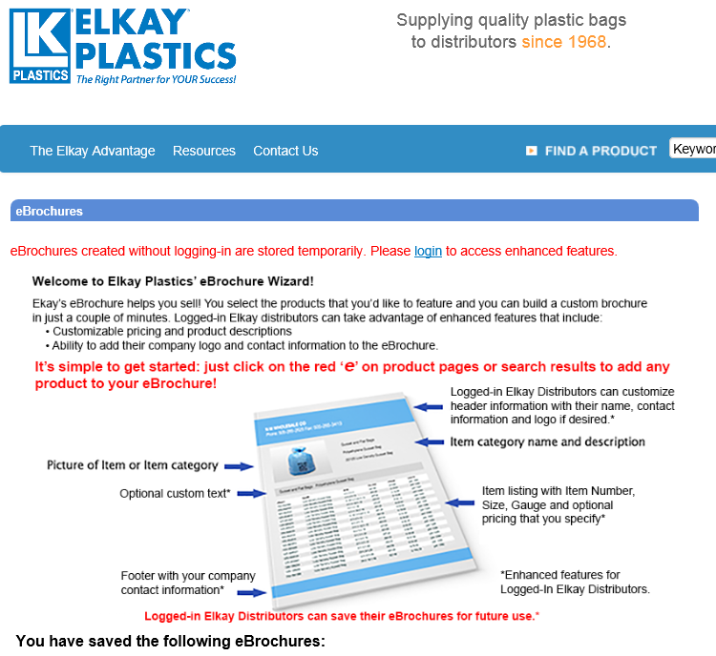

We have had requests for custom distributor catalogs. However, when we printed them for our customers in the past (they were discontinued in 2005) we found that they were simply not used. We concluded that the requests come from a vocal minority – primarily non-web savvy sales people – and that the creation of custom catalogs was not helpful.

A cautionary note. In 2013, Elkay changed its corporate enterprise system. Customer feedback suggested that it did not go well. Elkay was unable to issue proof of delivery answers and accurate inventory numbers. Their failure to move to a new system resulted in many new orders coming our way. It is unclear, over a year later, if all of their issues have been resolved.

Uline.com displays their brand well as a sort of crossover between industrial and commercial sites. Uline offers stock item searching through a search box and though category selections. You can order stock items on Uline.com. Uline’s web site is consistent in look and feel to their catalog.

Other B2B and B2C Sites

In the absence of innovative competitive companies from our industry, much of our benchmarking was conducted at the web sites of companies in other businesses.

* **Zappos** (zappos.com) We loved the way that Zappos creatively brought the cult of Tony Hseih to the fore, unfiltered, unabashed.

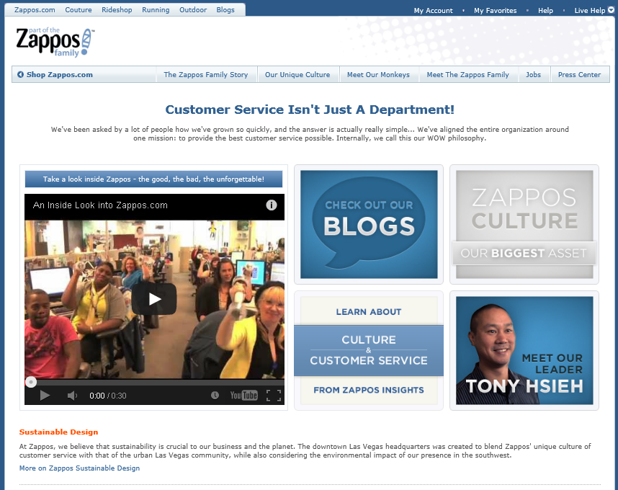

* **Priceline** (priceline.com) Priceline is representative of any number of build-your-trip sites (Kayak, Expeidia…). We looked to these sites as they provided powerful search widgets with primary and secondary options for a “pick what’s important to you” methodology.

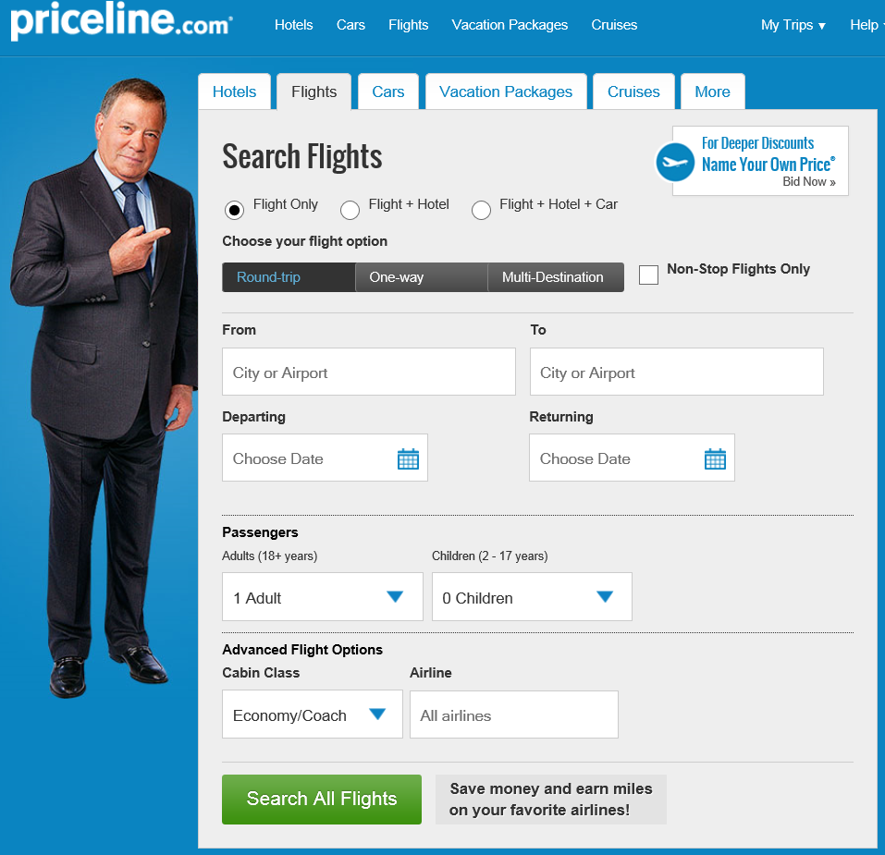

* **Coda** (codaautomotive.com) Coda’s bricklet format was appealing to us. We liked the modular presentation of information. (This site no longer uses the format)

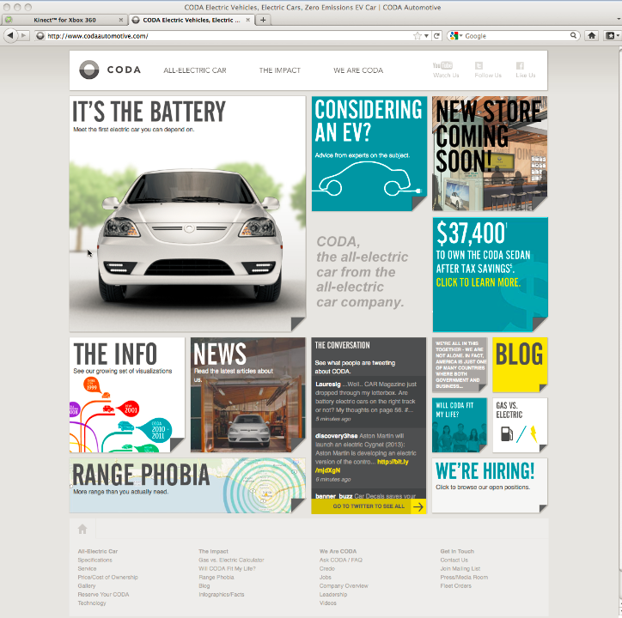

* **Rackspace** (rackspace.com) Providers of IT architectural solutions, we liked their personalization (“Joe Smith, Racker since 2004”). Some of that has changed, but they still do a good job creating a stand out brand in an otherwise dry industry.

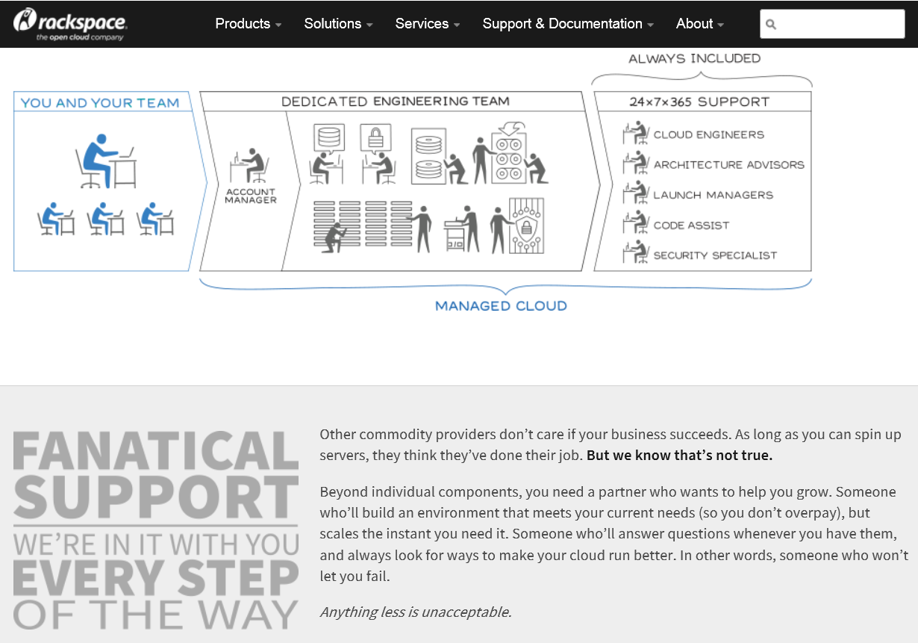

New Threat: Amazon

Amazon began its quest for wholesale business with the acquisition of smallparts.com in 2005. Amazon launched AmazonSupply.com, a wholesale site in 2012. Although still listed as a beta product, AmazonSupply’s product portfolio spans 17 categories – including janitorial supplies, food service, office supplies and packaging – and incudes more than 2.2 million products for sale.

While the other 35,000 of America’s wholesale distributors live on razor thin margins and net only 4 or 5% on each sale, that’s right where Amazon is comfortable. And while retailers sold $4 trillion in goods in 2012, wholesale distributors generated $7.2 trillion. W.W. Grainger, an apparent AmazonSupply target and one of the largest players, garnered just 6% of these B2B sales.

From a May 5 Forbes Article*, “The question is not whether AmazonSupply will be a threat,” says Richard Balaban, who has studied the site for management consulting firm Oliver Wyman. “Rather it is which customers, purchase occasions and categories will be attacked first.” Nor can small fry compete with AmazonSupply’s infrastructure and deep cache of consumer data. The company won’t disclose any details, saying only that AmazonSupply “utilizes all of Amazon’s fulfillment and logistics capabilities.” In the U.S. that’s a network of 40 U.S. fulfillment centers–and growing.*

Thus far, AmazonSupply’s take on poly bags is weak. Yes, they’re there, but you have to want them and pricing is not compelling. The item below, for example, priced at $25.92 sells for $8.10 at Laddawn.

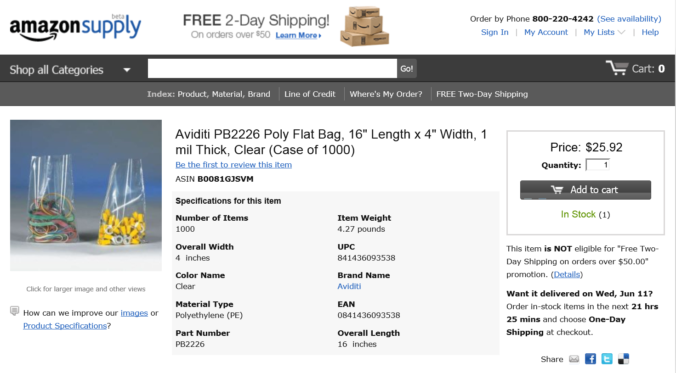

Today’s Take on the Amazon Threat

We believe that Amazon will not be able to compete with traditional distributors where service levels are important.

* 1. Distributors are better aggregators of larger volumes of packaging items. Amazon may have 2.2 million industrial items on line, but they don’t have hundreds of cases of all of them on hand in a local warehouse.
  2. Distributors are often (not always, certainly) better movers of items – in a local environment. Butler Dearden in Boylston sends a truck to Nypro in Clinton every day.
  3. Distributors are better consultative sellers. Perhaps their most sustaining attribute, they bring subject matter expertise to bear more fully than Amazon.

1. **PROGRAM LAUNCH**

External Launch

We will target our customers in 4 segments:

1. **Current Web Customer Contacts**. There are about 5,000 customer contacts who visit Laddawn.com each month. These are of primary concern – as they bring 49% of our orders through the web today.

Goal: Convert our current base of web business.

Message Strategy: (a) You don’t need to know stock from custom, (b) You can ship stock and custom together, (c) You can manage lots of work at once, and (d) You can share your work with colleagues and customers.

Note: depending on use data, it may be helpful to divide this segment in two: the Power Users vs. Casual Users.

1. **Managed Contacts Who’ve Not Yet Adopted**. There are about 8,000 of these. They have active emails in our CRM database, are contacted by phone, but do not use our web site. An important, if secondary, concern – we’ll try to bring these people to the new site.

Goal: Increase web adoption (get these guys to log on).

Message Strategy: Laddawn.com is a simple, fast way to get pricing and ship dates for custom and stock items.

1. **Managed Contacts with No Active Emails**. About 8,500 are connected to managed accounts yet have not provided their emails to us. As a third tier target – getting these people online will be important as we become more Laddawn.com and less Laddawn, manufacturer of plastic bags.

Goal: Entice them to get online (and get their emails in the process)

Message Strategy: There is something wonderful happening online.

1. **Prospects Not in our Database**. We believe this list to be the smallest (least bang for the buck). Still, Laddawn.com will provide a new way to show our position in the marketplace to those who don’t know us yet.

Goal: Be visible to them.

Message Strategy: None. Just look great when they find us.

Internal Launch

It’s useful to consider 3 employee groups:

1. **Customer Experience (CE)**. Customer Experience Reps process about 1,100 transactions each day. About 85% will migrate to the new web site on day 1.

Goal: CE will need to (a) be fluent in Laddawn 2.0, (b) get the context of this business sea change, and (c) be made Laddawn 2.0 evangelists.

Message Strategy: Get ready. Your job is about to become awesome.

1. **Customer Relationship (CR)**. Customer Relationship Reps, who do far fewer transactions, will need to know the basics.

Goal: CR will need to (a) be fluent in Laddawn 2.0 use, (b) get the context of this business sea change, and (c) be made Laddawn 2.0 evangelists.

Message Strategy: You think our customers love us now? Check this out.

1. **All Other Non-Production Employees**. These people will not use the web – but it is important that they remain in the know.

Goal: Appreciate change from Laddawn Manufacturer of Plastic Bags to Laddawn Powerful Ecommerce Front End.

Message Strategy: You work for a smart, forward thinking company with a bright future.

**Launch Tools**

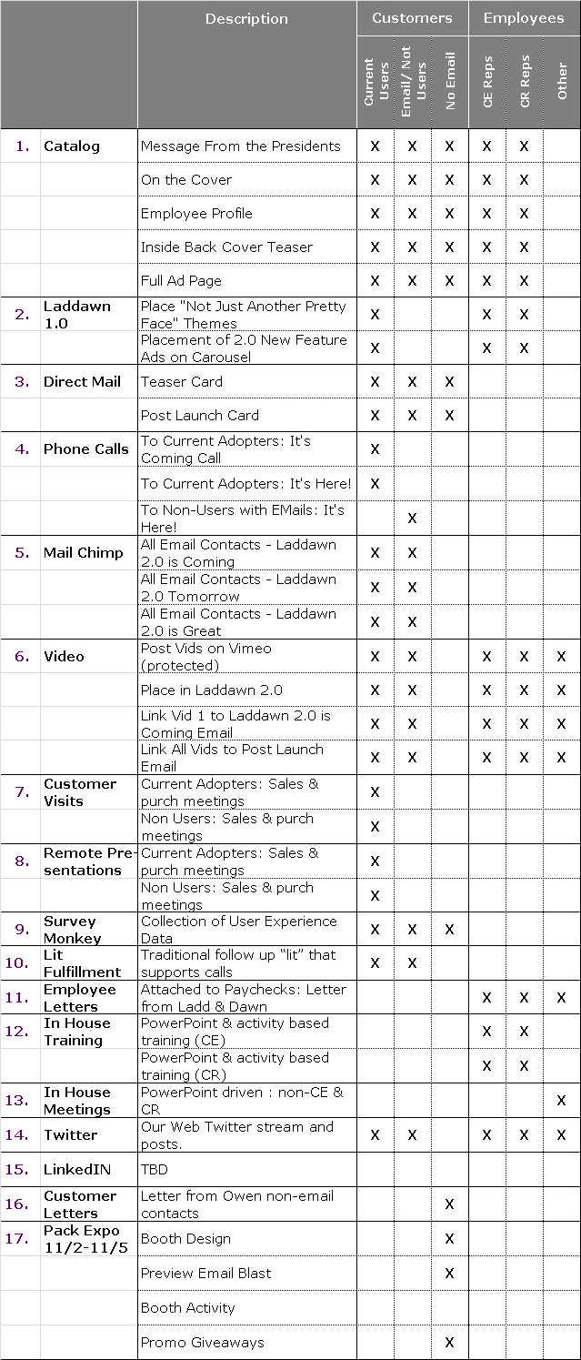



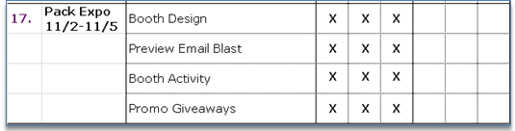

**The Brand**

“Make the web site feel like the rest of our sneakers that we’ve been wearing for the past year and a half.”

Our brand strategy will be to attach our brand personality (sincere, reliable, friendly, progressive, dynamic, socially responsible, generous in spirit and actions) to the new Laddawn.com from the start. We have to be sure we give the new website this life in the most powerful ways we can, as early as we can.

1. **HOW WE’LL KNOW WE’RE WINNING**
   * 1. There will be a buzz in the industry.
     2. We will retain 100% the current Laddawn.com user base.
     3. We will experience faster growth in revenues than the 7-10% projected year over year. Target 15%.
     4. We will retain more CE reps as turnover approaches zero.
     5. Customers will tell us more often of thoughtful and smart CE engagement.
     6. We will expand the adoption rates of our current managed contact (currently at 62%). Target 80%.
     7. We will gain access to a nearly all email addresses of our managed customer contacts.
     8. The performance of our sourcing initiatives will be validated with a flood of requests to add new products to our offering.
     9. The percentage of custom sales made from outside vendors will increase substantially – from under 2% to 20%.
     10. Laddawn videos – will be viewed by thousands of users monthly.
     11. The absolute number of custom quotes will increase significantly.
     12. The percent of quotes performed on line will increase significantly.
     13. Conversion rates of online quotes, now at roughly 12%, will approach overall company averages of 30%.
     14. Online usage – as measured by Google Analytics – will increase sharply from the current base of 950-1,100 per day.
     15. Increased adoption rates will benefit other online functionality as demonstrated by a greater number of self-directed non-custom related transactions.
     16. The look and feel of this endeavor will inform other brand work.