**Information Review: Sharing**

Items & Carts

1. **OPERATOR CODE**

***Background***.Pre-2.0, quotations had a place in the upper right hand corner for “Sales Representative” and “Code”. It is unclear as to whether this is helpful to the customer.

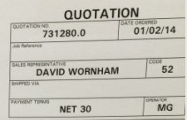

We think not. However, we also used to copy the sales rep on any quotes that were generated by the rep. This way, reps could decide whether or not to follow up with the customer (“hey, that’s an interesting | large | odd quote, I should follow up on that…”). The outcome, we believed, would be to landing the occasional order we’d otherwise miss or misquote.

***Recommendation***. Let’s copy the rep on shares sent from CE to a managed account.

***Priority.*** Lower (Feeder List)

1. **QUOTED BY [RELATIONSHIP PARTNER]**

***Background***.Pre-2.0, Account Relationship Partners or Senior Account Relationship Partners would send quotes to customers – with an implied invitation to get back to them with changes or questions (and, hopefully, progress to an order). Today, prices are shared through the system addressed from CE@laddawn.com regardless of operator.

Scenario: Ezra talks to Joe Smith from Veritiv about an opportunity. To push the conversation forward, he shares a quote or 2 with Joe. Joe decides to jump on it and replies via the share. His message goes into the CE queue. Today, the queue may lag 3 to 4 hours or more. But even when we’re staffed appropriately, we’ll be talking 15-45 minutes – plenty of time to cause frustration or miss an opportunity.

***Recommendation***. Items and carts shared by CR Partners and Senior CR Partners should be addressed from the CR Partner, not CE@laddawn.com/

***Priority.*** Low to Medium (Feeder List)

1. **CE NEEDS THE CUSTOMER NUMBER**

***Background***. Pre-2.0, quotations included the name and address of the customer, the bill-to number and the contact’s name. Now, when a customer replies or forwards a share, CE can’t tell who it’s for.

This creates a significant amount of detective work on behalf of the CE Partner. Moreover, when a purchasing person at a different Bill-to submits the PO, it can be a nightmare.

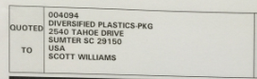

Because the customer contact is reflected in the email, we’re all set there. The address and bill-to name is not necessary for CE to perform their work. However, we need to insert the Bill-to number.

***Recommendation***. Put the customer’s bill-to number on the share. (This will need to be designed. Possibilities: add to the subject line or in a discrete area of the email page).

***Priority.*** Med-High. Can we do it in the next few weeks?

1. **SHIP TO ZIP**

Pre-2.0, quotations included the ship to zip right alongside the person responsible for paying for freight (see below). On the current share, we simple point out that freight is “include”, “not

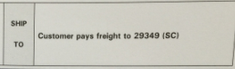

included”, or “free at $500”. The zip code seems to be the big thing here. Both customers and CE need this on shares going forward to help them assess cost and to help sort through different product pricing options.

***Recommendation***. Insert the 5-digit ship-to zip code as part of the freight designation (see below).

***Priority.*** High

**Current Shared Cart –**

There is no need to add the zip code to the items in the cart – it’s already at the top. However, the shared cart, as shown below, has no reference to ship to zip.

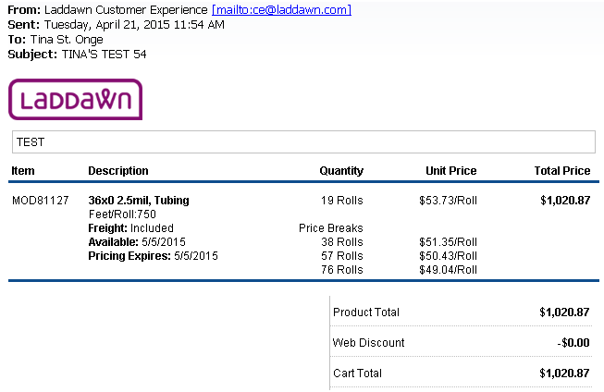

1. **Mockup of Zip Code Insertion –**

Format as… **Freight:** Included to ABCDE (ST); **Freight:** Not Included to ABCDE (ST); **Freight:** Free @$500 to ABCDE (ST)

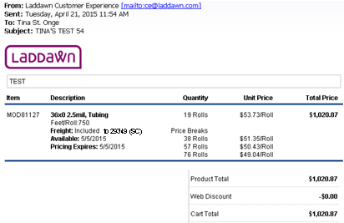

1. **Current Shared Item –**

There is no need to add the zip code to the items in the result – it’s already at the top in the widget. However, the shared item, as shown below, has no reference to ship to zip.

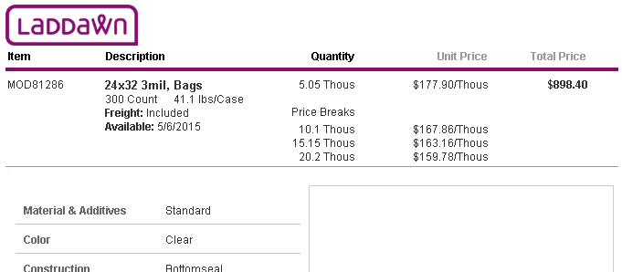

**Mockup of Zip Code Insertion –**

Format as…**Freight:** Included to ABCDE (ST);**Freight:** Not Included to ABCDE (ST); **Freight:** Free @$500 to ABCDE (ST)

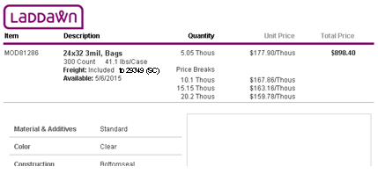

Design Note: It may be necessary in for both Shared Carts and Shared Items to move the Quantity Column to the right to accommodate the width of “Not Included” or “Free @$500”.

1. **Where Will the Job Ship From?**

Pre-2.0, quotations included a reference to the location in which the item would be made.

On the current share, we do not reference the location from which the item will be manufactured. To complicate things, we’re also need to include stock and marketplaced items (not made in a Laddawn facility). The good news is that



customers are really only interested in where the item is going to ship from. Shared items can have this designed in anywhere – however, shared carts will need to have this shown on an item by item basis.

Marketplace items add a level of complexity – they won’t actually ship from our facility but we don’t know from where it each will ship. Need Tom’s help here.

***Recommendation***. The solution for this fix may be provided with the solution for #6, below.

***Priority.*** High

1. **Shipment Date Disclaimer**

Pre-2.0, quotations included a shipment date disclaimer – “Shipment Dates are determined at the time of order. As of dd/mm/yy at hh:mm xm this quote can ship by dd/mm/yy.

On the 2.0, we provide a popup when someone clicks an availability date (see image to the left), “Manufacturing lead times fluctuate. Order now for shipping from [City, ST]”. And for stock, we say, “Please note that inventories fluctuate…”



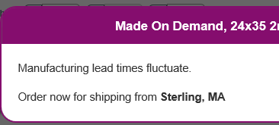 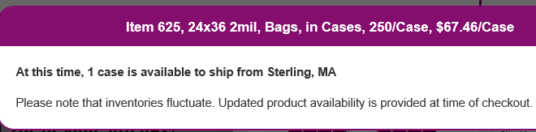

To be consistent with the well thought out phrasing on the web, let’s mirror that same language on the shared emails. This will provide the right solution for both item #5 (Where’s it shipping from?) and this one, #6 (Shipment Date Disclaimer).

***Recommendation***. For both shared cart and shared item emails, insert the lines, “Inventories and manufacturing lead times fluctuate. Order now for shipping from Sterling, MA (design to come).

***Priority.*** High

1. **Overrun Disclaimer**

Pre-2.0, quotations included a 10% overage disclaimer placed on the bottom left of the quote page.

On the current share, we do not reference the potential (likelihood) of an overrun.



We’ll need to create text to reflect our new language for customs. Perhaps, “MOD items may be subject to overruns of up to 10%”.

This disclaimer needs to be placed only in cases where the shared item is a MOD item, or when the shared cart contains a MOD item.

***Recommendation***. Insert the line, “MOD items may be subject to overruns of up to 10%”.

***Priority.*** Medium, although this could easily be designed and programmed in with #s 5 & 6 above.