**Inclusion of Customer Item Number:**

**Found In –**

1. The (GO) Box
2. Results
3. Cart
4. Shared Item
5. Shared Cart
6. Godzilla Results

**7-9.** Saved Items, Saved Item Hover, Saved Item Filter by Item

1. Save Item Add Number Popup

**11-14.** Order History Hover, Order History Re-price, Order History Tracking, Order History Summary

1. Saved Cart Hover
   1. Check Out Bundling Screen, Check Out Order Summary

**How Best to Display Item Number:**

1. **Default to the Customer’s Item Number if Available**

ie:

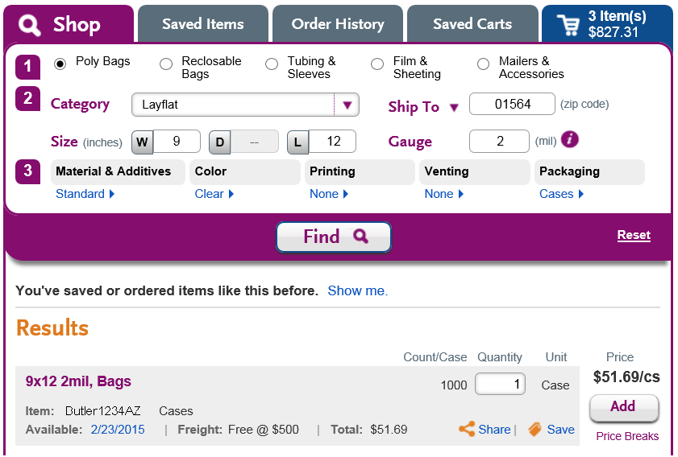

1. **Hover to Show Laddawn Item Number**

ie:

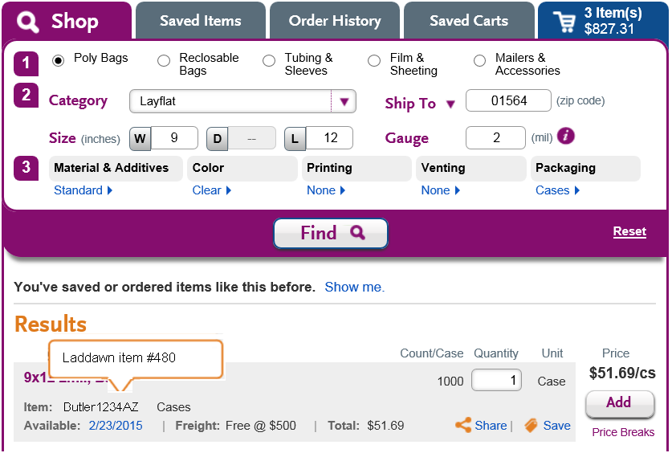

1. If Customer Item Number is Too Long, Wrap

ie:

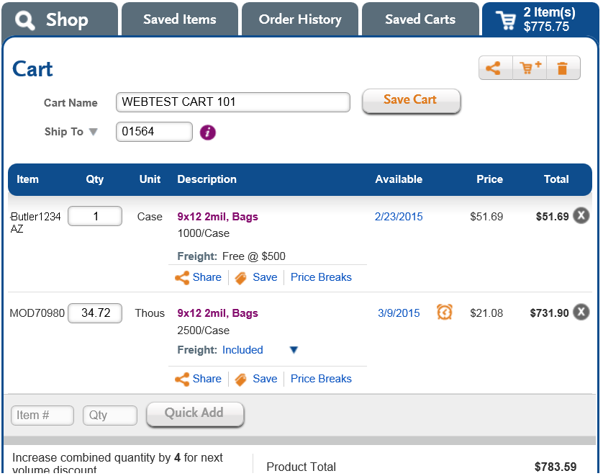

1. If There are 2 or More with the Same Item Number, Give them Options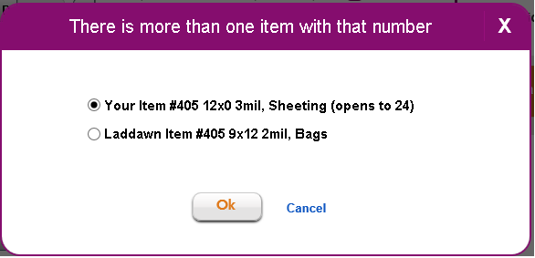
2. **The (GO) Box:**

Enable Searching in GO Box by Customer Number

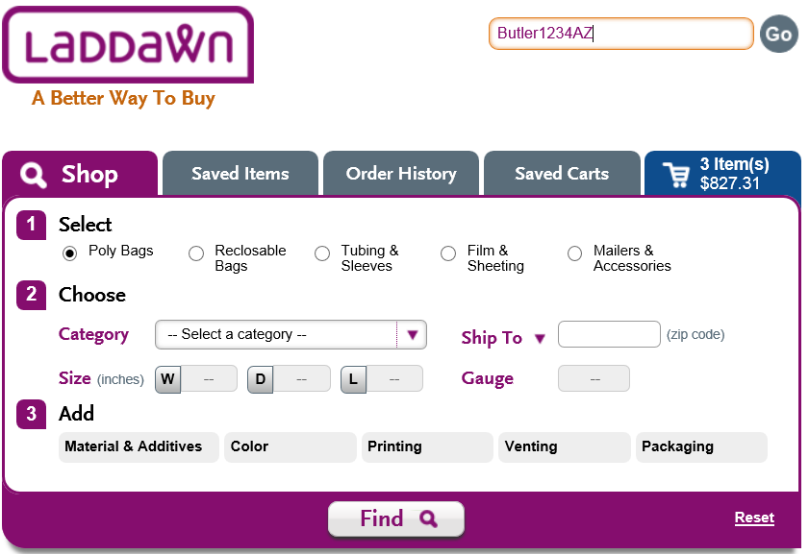

1. **Results:**

Default to Customer’s Number, Hover to See the Laddawn Number





1. **Cart:**

Default to Customer’s Number, Hover to See the Laddawn Number



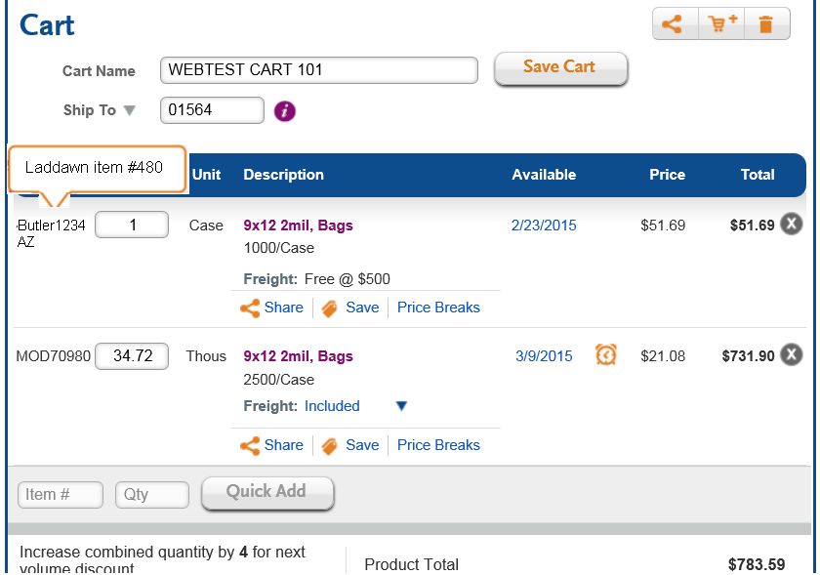

1. **Shared Item:**

Default to Customer’s Number, No Hover (it’s already in a shadow box).

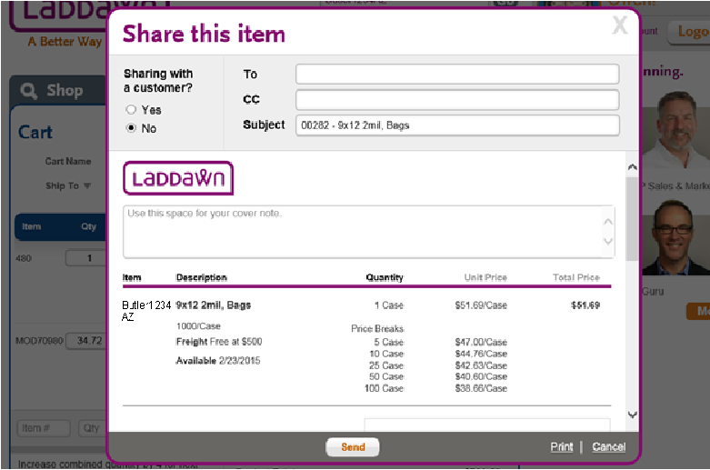

1. **Shared Cart:**

Default to Customer’s Number, No Hover (it’s already in a shadow box).

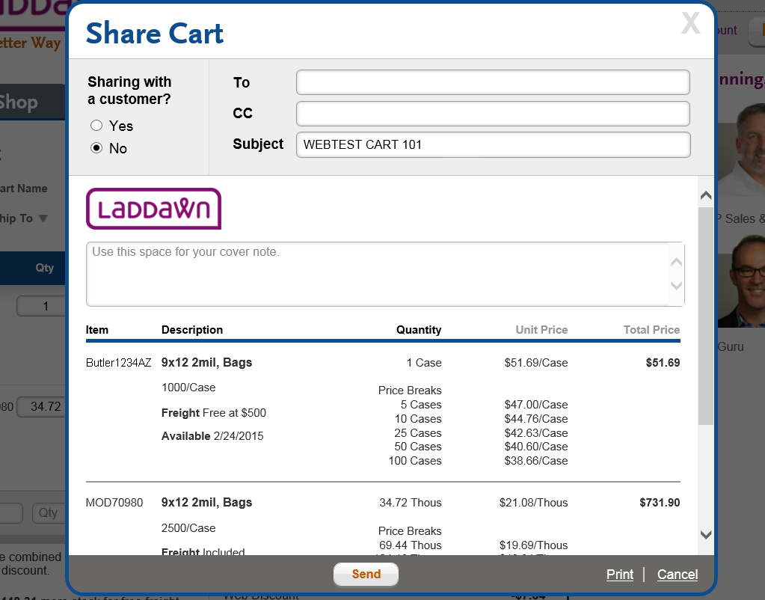

1. **Godzilla Results:**

Default to Customer’s Number, No Hover (it’s already in a shadow box).

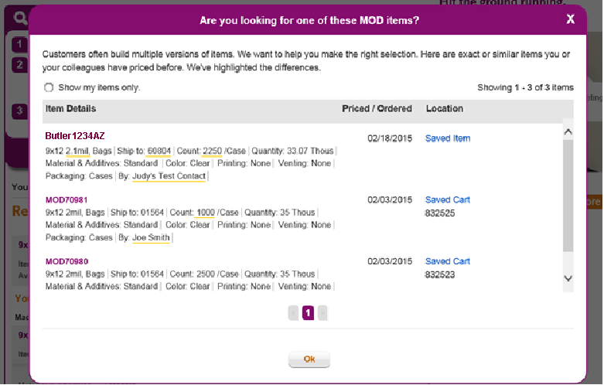

1. **Saved Items:**

Default to Customer’s Number.

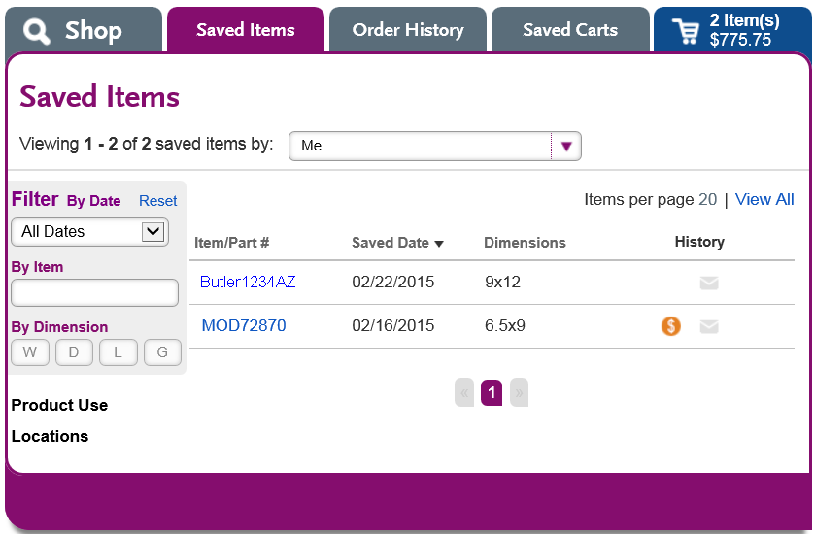

1. **Saved Items Hover:**

Add Laddawn Item Number to Bottom of Hover.

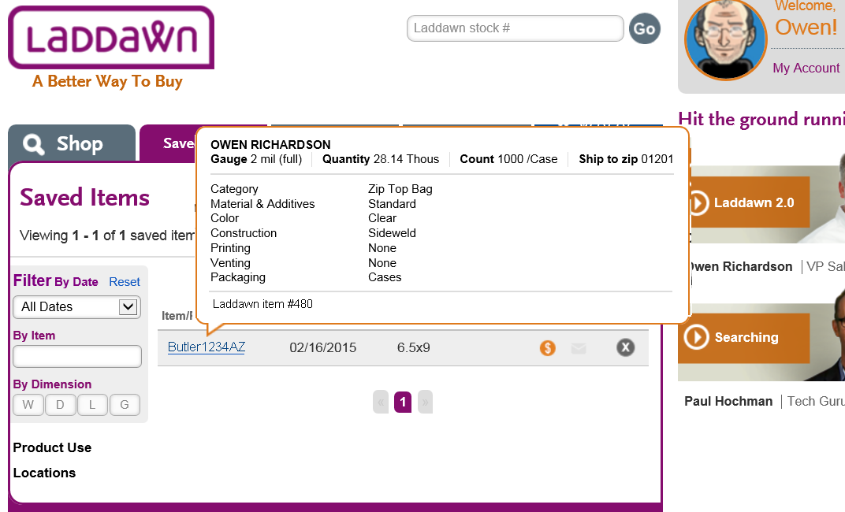

1. **Saved Items Filter by Item:**

Enable Searching by Customer Number.

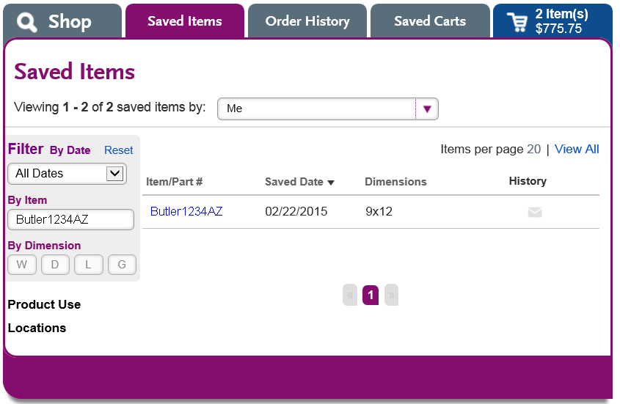

1. **Save by Items – Add Number Popup:**

No Change – Already a Shadow Box.

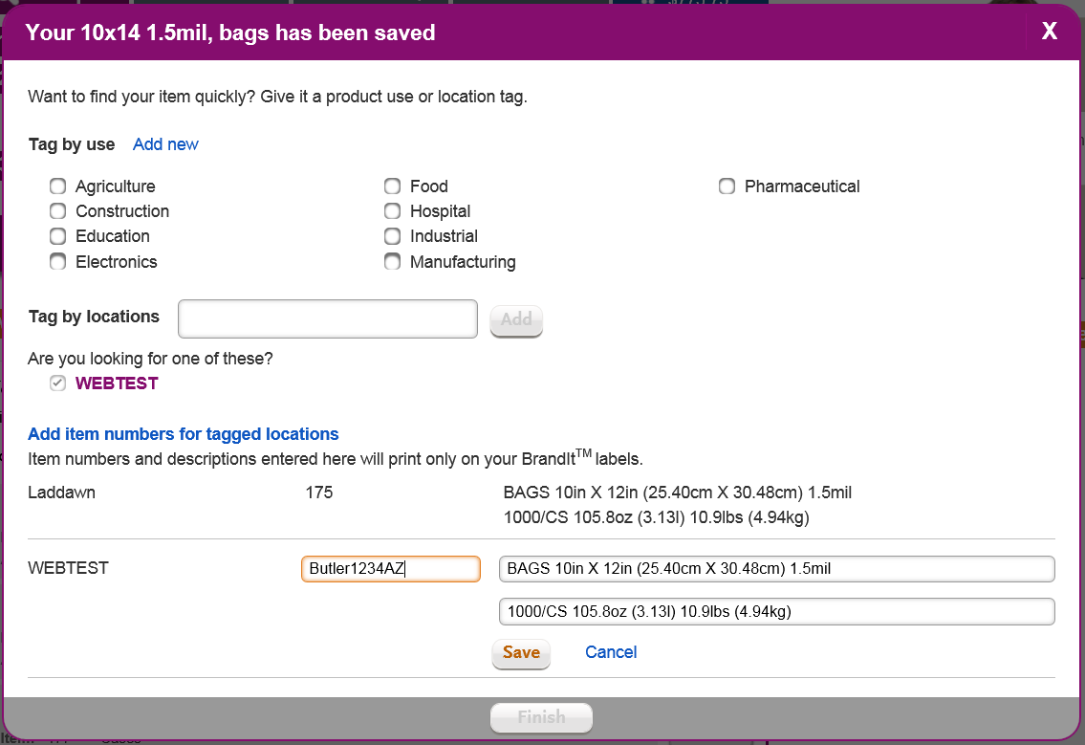

1. **Order History - Hover:**

Hover Should Contain Customer Item Number.

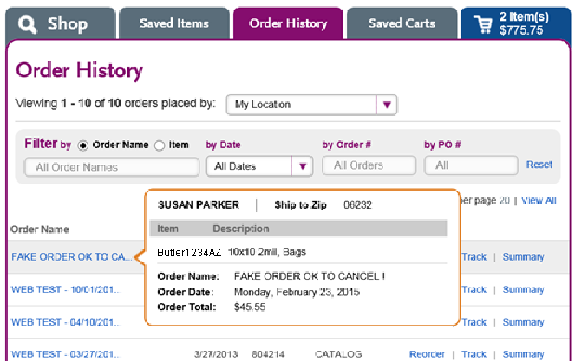

1. **Order History - Reprice:**

Shadow Box Should Contain Customer Item Number.

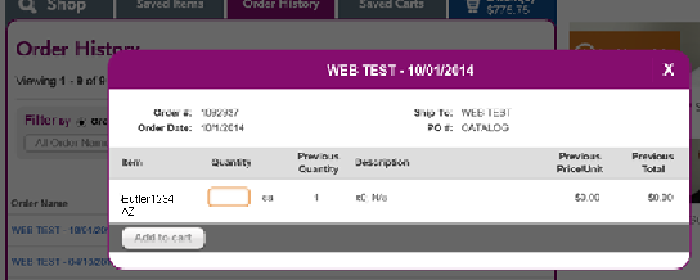

1. **Order History - Tracking:**

Shadow Box Should Contain Customer Item Number.

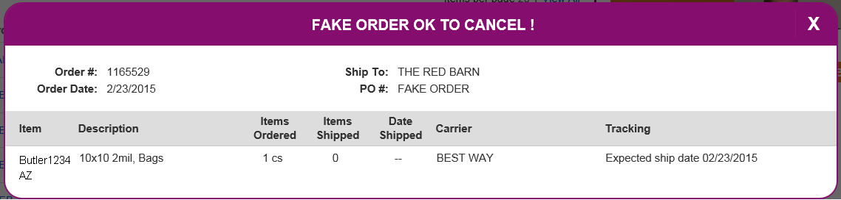

1. **Order History - Summary:**

Same as Check Out Summary (Show Customer’s Item Number)

1. **Saved Cart Hover:**

Show Customer’s Item Number in Hover (There May Be Lot’s of Items Listed Here).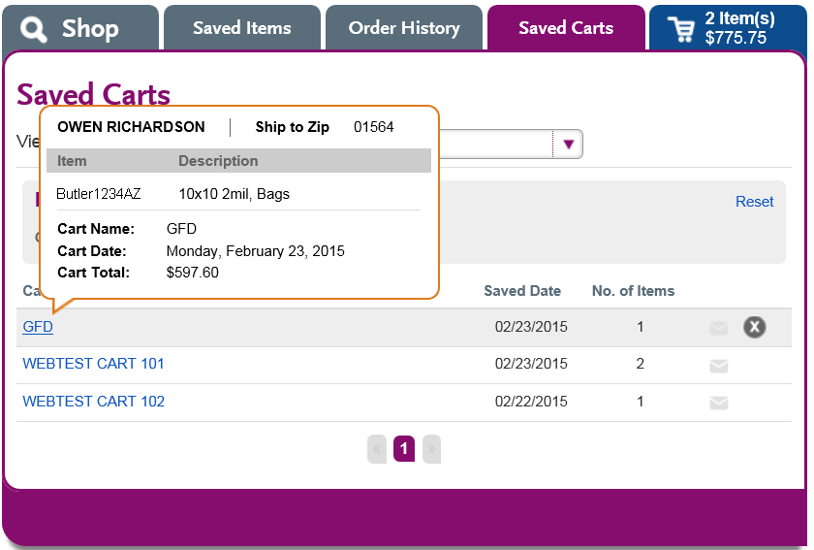

1. **Check Out** Bundling Screen**:**

Show Customer’s Item Number, Laddawn Item Number in Hover.

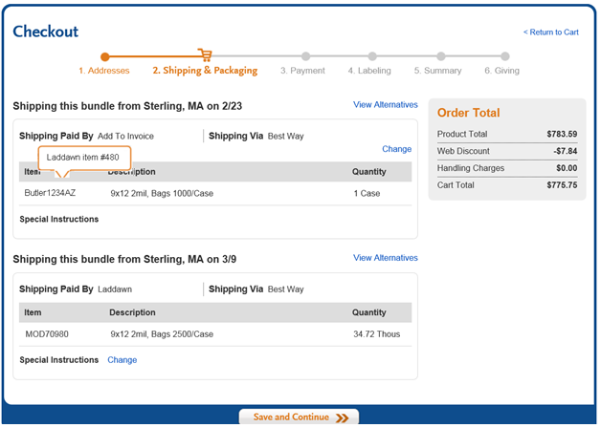

1. **Check Out** Summary Screen**:**

Show Customer’s Item Number, Laddawn Item Number in Hover.

