**Inclusion of Customer Item Number:**

**Found In –**

1. The (GO) Box
2. Results
3. Cart
4. Shared Item
5. Shared Cart
6. Godzilla Results

**7-9.** Saved Items, Saved Item Hover, Saved Item Filter by Item

1. Save Item Add Number Popup

**11-14.** Order History Hover, Order History Re-price, Order History Tracking, Order History Summary

1. Saved Cart Hover
   1. Check Out Bundling Screen, Check Out Order Summary

**General Rules: Search / Display Item Number**

* Customer item number search will only apply to the item number associated to the bill-to.
* Should the bill-to have associated one of their customer’s (ship-to’s) item numbers to the item, it will not be found here.
* Search by customer’s item number, show Laddawn item number and provide the customer’s item number in a hover.
* In the event that there is more than 1 match to the item searched for, the user will be offered a choice from a shadow box.

1. The shadow box will have the following text in the purple band at the top, “**We found more than one item with that number.**”
2. The content of the box will list the items:
   1. Item description taken from first line of results
   2. Bill-to first, Laddawn second
   3. Bill-to’s item number radio button selected
3. Below, will be an **“[OK] Cancel”** selection.

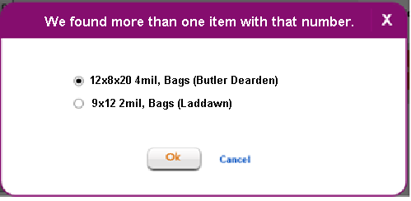

1. **The (GO) Box:**

Enable Searching in GO Box by Customer Number

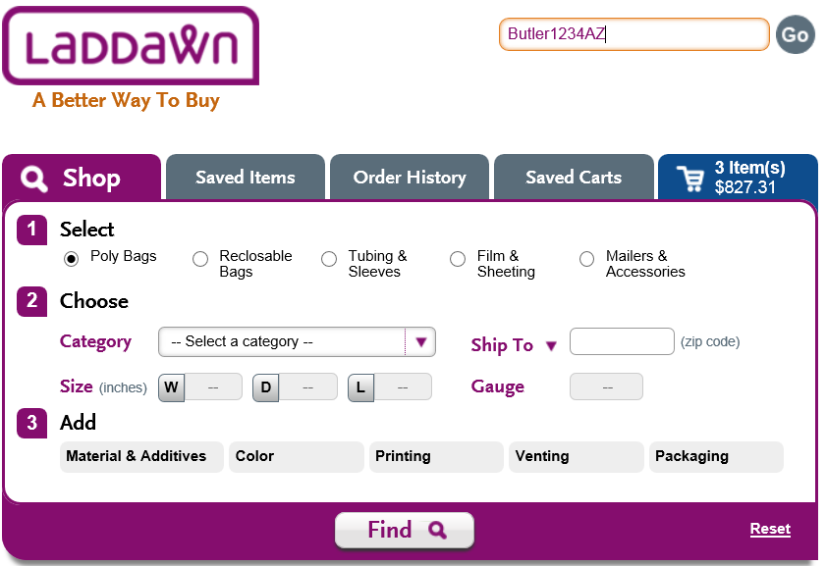

1. **Results:**

Default to Laddawn’s Stock Number, Hover to See the Customer’s Number

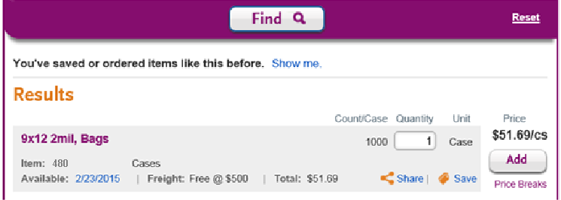

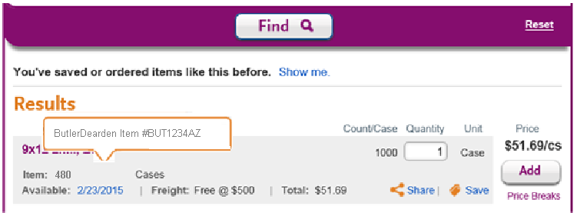

1. **Cart:**

Default to Laddawn’s Stock Number, Hover to See the Customer’s Number

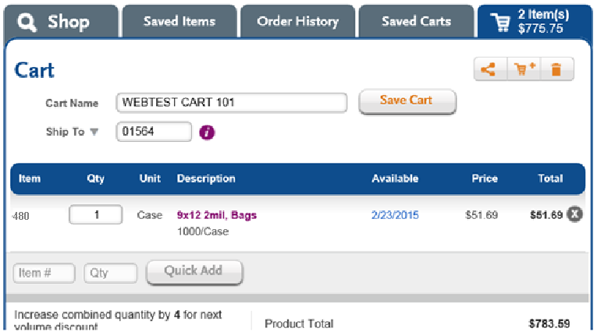

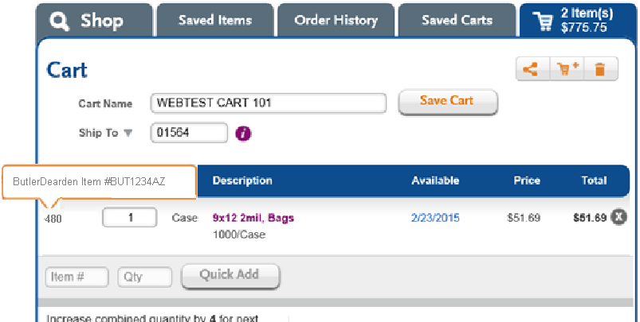

1. **Shared Item:**

Default to Customer’s Item Number, No Hover.

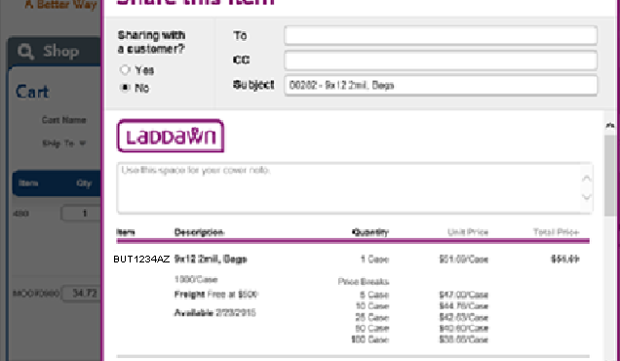

1. **Shared Cart:**

Default to Customer’s Item Number, No Hover.

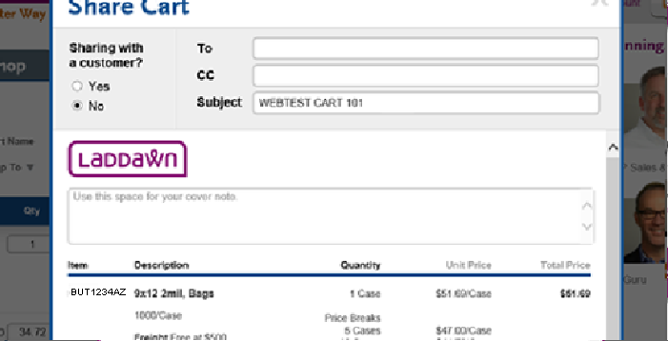

1. **Godzilla Results:**

Default to Laddawn’s Item Number, No Hover (it’s already in a shadow box).

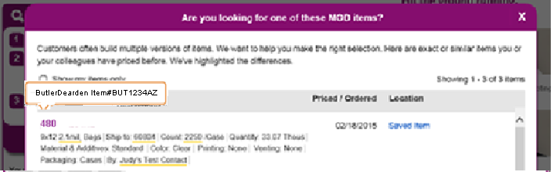

1. **Saved Items:**

Default to Laddawn’s Item Number, Hove to See Customer Number.

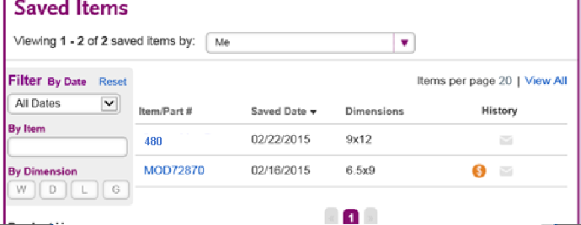

1. **Saved Items Hover:**

Add Customer’s Item Number to Bottom of Hover.

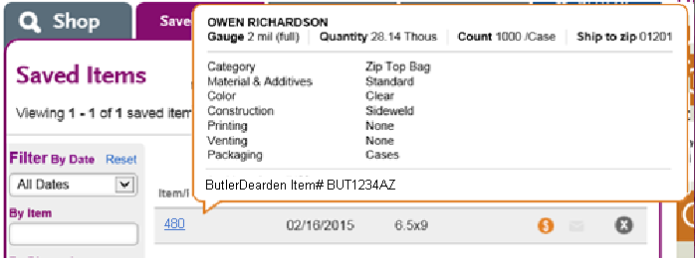

1. **Saved Items Filter by Item:**

Enable Searching by Customer Number – but Output=Laddawn Item Number

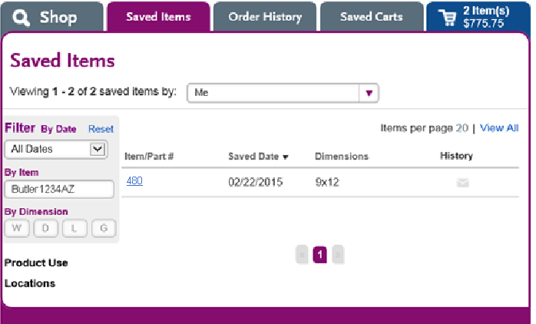

1. **Save by Items – Add Number Popup:**

No Change – Already a Shadow Box.

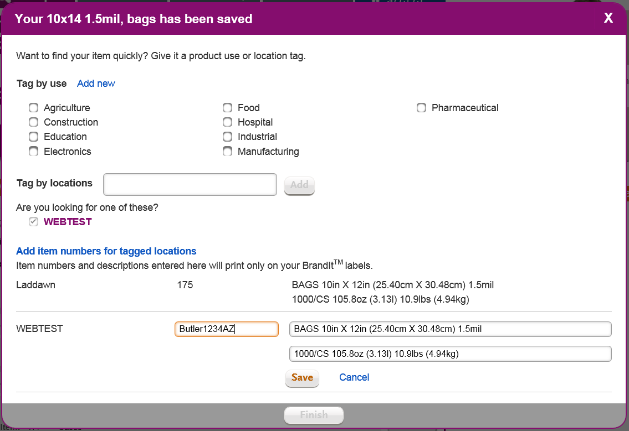

1. **Order History - Hover:**

Hover Should Contain Laddawn’s Item Number, but List Customer’s Item Number at Bottom of Hover.

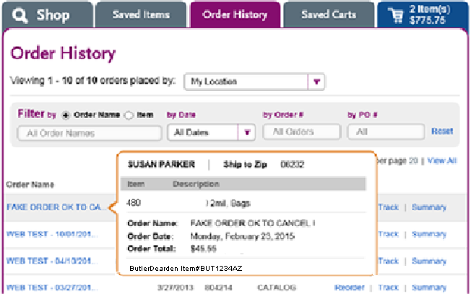

1. **Order History - Reprice:**
2. Shadow Box Should Contain Laddawn’s Item Number, Hover for Customer’s Number.

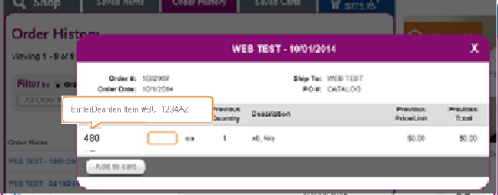

1. **Order History - Tracking:**

Shadow Box Should Contain Laddawn’s Item Number, Hover for Customer’s Number.

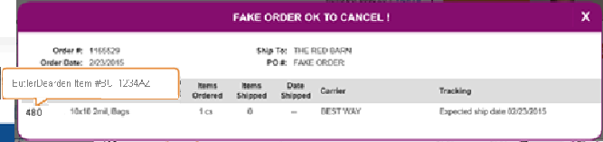

1. **Order History - Summary:**

Same as Check Out Summary (Show Customer’s Item Number)

1. **Saved Cart Hover:**

Hover Should Contain Laddawn’s Item Number, but List Customer’s Item Number at Bottom of Hover.

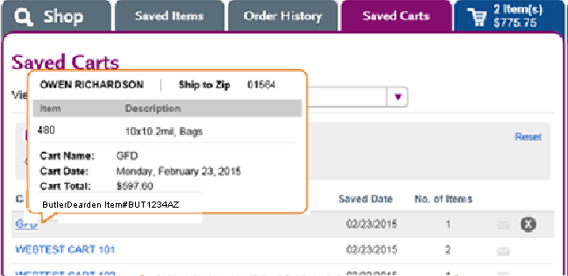

1. **Check Out** Bundling Screen**:**

Show Laddawn’s Item Number, Customer’s Item Number in Hover.

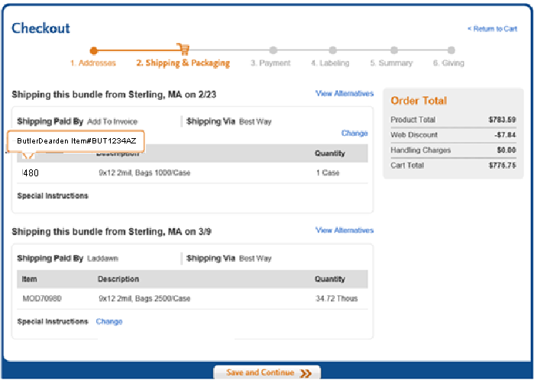

1. **Check Out** Summary Screen**:**

Show Laddawn’s Item Number, Customer’s Item Number in Hover.

