**Inclusion of MOD Item Number:**

**Found In –**

1. The (GO) Box
2. Results
3. Cart
4. Shared Item
5. Shared Cart
6. Godzilla Results

**7-9.** Saved Items, Saved Item Hover, Saved Item Filter by Item

1. Save Item Add Number Popup

**11-14.** Order History Hover, Order History Re-price, Order History Tracking, Order History Summary

1. Saved Cart Hover
   1. Check Out Bundling Screen, Check Out Order Summary
2. **The (GO) Box:**

Enable Searching in GO Box by Customer Number

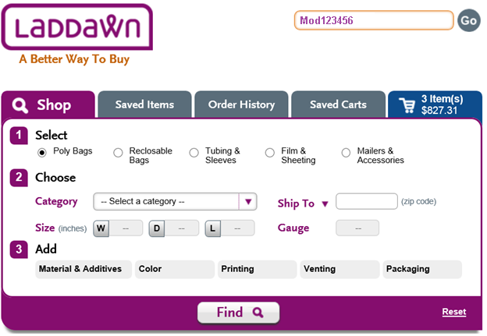

1. **Results:**

Default to Customer’s MOD Number

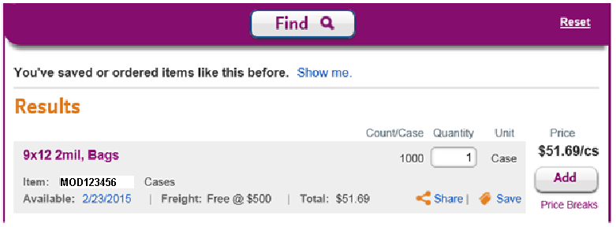

1. **Cart:**

No Change. Default to Customer’s MOD Number

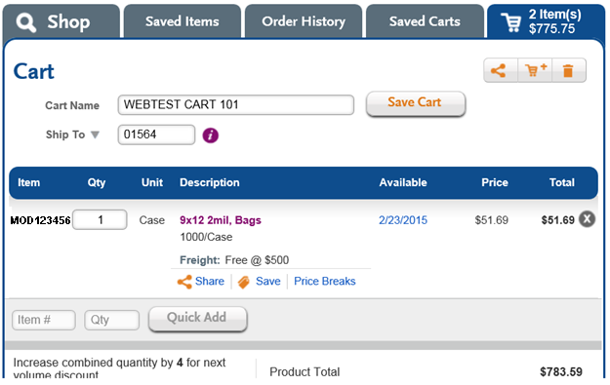

1. **Shared Item:**

No Change. Default to Customer’s MOD Number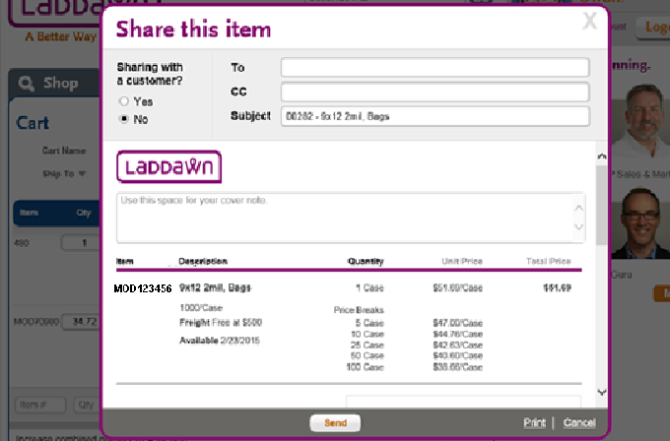

1. **Shared Cart:**

No Change. Default to Customer’s MOD Number

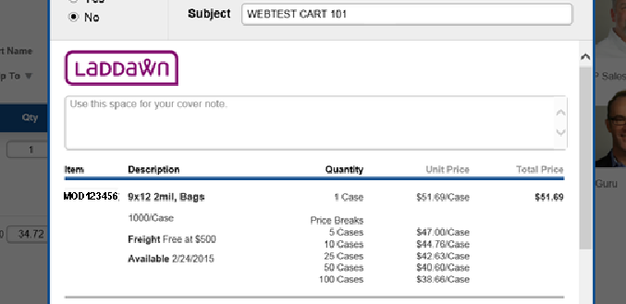

1. **Godzilla Results:**

No Change. Default to Customer’s MOD Number

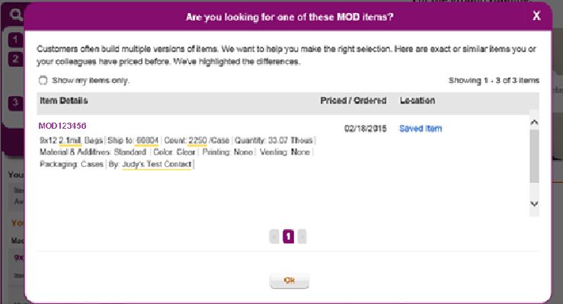

1. **Saved Items:**

No Change. Default to Customer’s MOD Number.

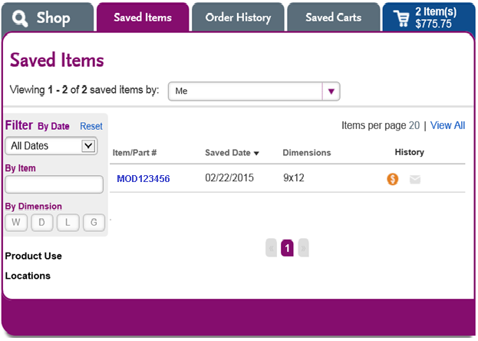

1. **Saved Items Hover:**

No Change.

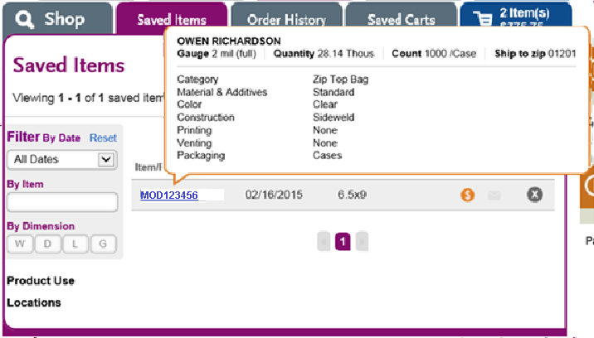

1. **Saved Items Filter by Item:**

Enable Searching by Customer’s MOD Number.

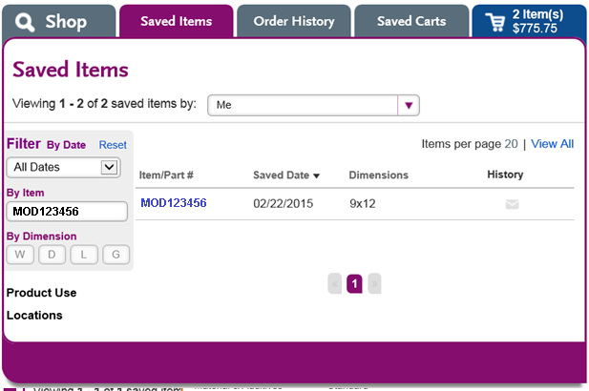

1. **Save by Items – Add Number Popup:**

No Change.

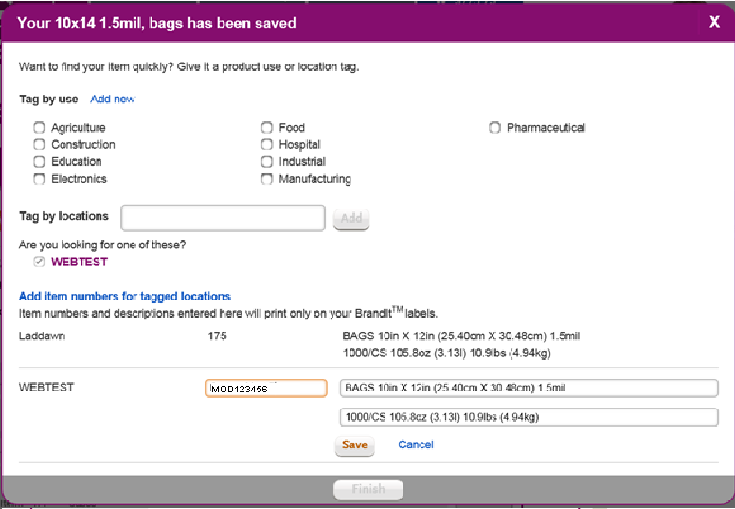

1. **Order History - Hover:**

Hover Should Contain Customer’s MOD Item Number.

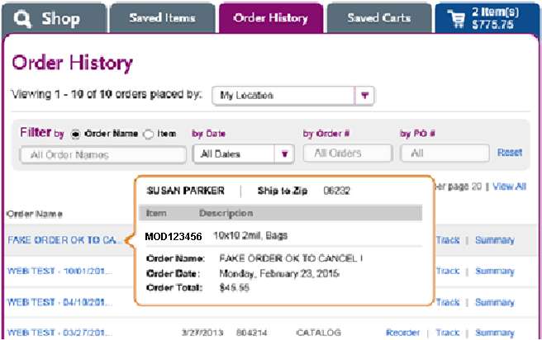

1. **Order History - Reprice:**

No Change. Shadow Box Should Contain Customer’s MOD Item Number.

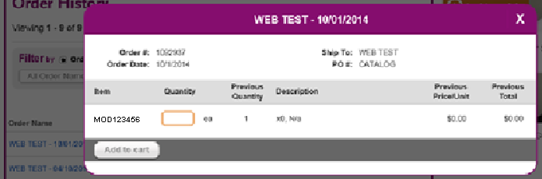

1. **Order History - Tracking:**

No Change. Default to Customer’s MOD Item Number.

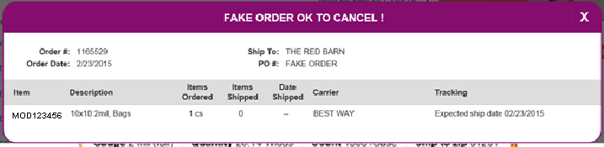

1. **Order History - Summary:**

No Change. Same as Check Out Summary (Show Customer’s MOD Item Number)

1. **Saved Cart Hover:**

No Change. Shadow Box Should Contain Customer’s MOD Item Number.

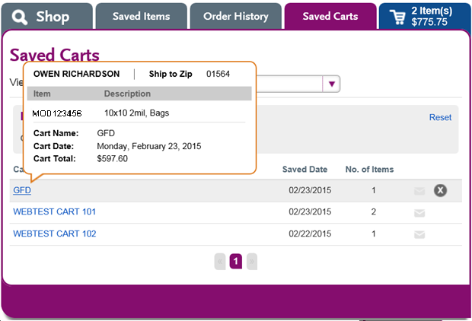

1. **Check Out** Bundling Screen**:**

No Change. Default to Customer’s MOD Item Number.

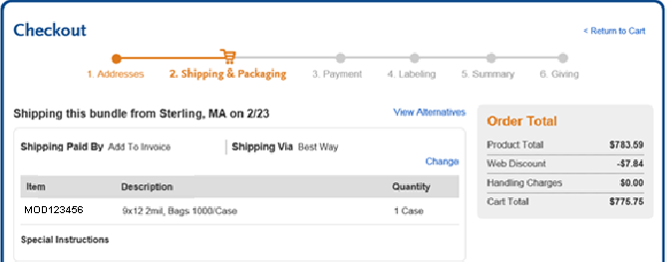

1. **Check Out** Summary Screen**:**

No Change. Default to Customer’s MOD Item Number.