**Inclusion of MOD Item Number:**

**Found In –**

|  |  |  |
| --- | --- | --- |
| 1. The (GO) Box | 1. Results | 1. Cart |
| 1. Shared Item | 1. Shared Cart | 1. Godzilla Results |
| **7-9.** Saved Items, Saved Item Hover, Saved Item Filter by Item | 1. Save Item Add Number Popup | **11-14.** Order History Hover, Order History Re-price, Order History Tracking, Order History Summary |
| 1. Saved Cart Hover | * 1. Check Out Bundling Screen, Check Out Order Summary |  |

**However, there are 3 places where programming will be different from where it is today:**

1. The (GO) Box
2. Saved Items, Saved Item Hover, Saved Item Filter by Item
3. **The (GO) Box:**

Enable Searching in GO Box by Customer Number

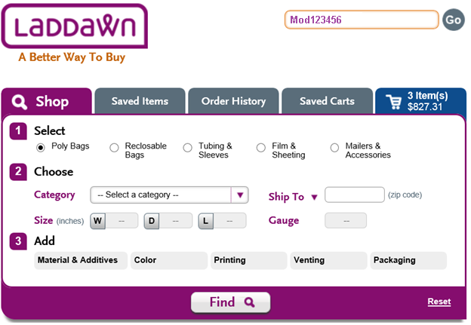

1. **Results:**

Default to Customer’s MOD Number

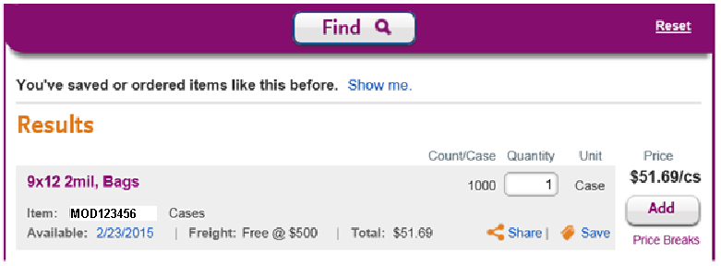

**9. Saved Items Filter by Item:**

Enable Searching by Customer’s MOD Number.

