*We add an Item specific checkbox to the list of preferences CE management can set. When you check the box, it expands open to show the MOD item grid:*

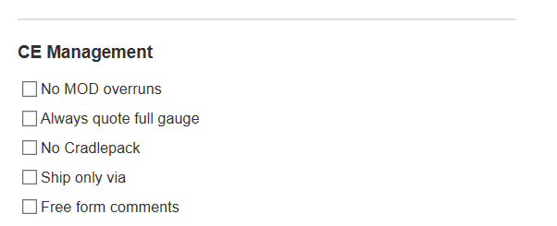

* **Item specific**

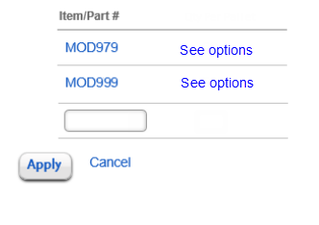

*CE manager types in number; “Add preferences” link appears. User can either hit return or click link, and the list of item-specific choices expands fully, with the apply/cancel links falling below. Clicking “See options” opens the same list, but showing prior inputs which can be edited.*

* **Item specific**

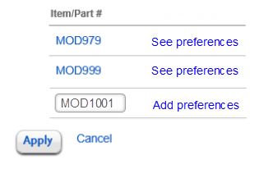

* + **Palletizing instructions** 
    - Layering & box placement [ fill in ] (11 dists, 14 products)
    - Pallet type other than 40 x 48 [ all fill in or ckboxes below?]
      * Export pallet (1 dist, 4 products)
      * Plastic pallet (1 dist, 1 product)
      * 40 x 60 (ULine)
      * GMA grade B (2 dists, 4 products)
      * Other pallet type [ fill in ]
    - Other palletizing instructions [ fill in ] (6 dists, 6 products: stretch wrap 1; edge protectors 1; extra strapping 1; use slipsheets 1; edge protectors 1*; reinforce strapping 1*)
  + **Write production date on retain label** (6 dists., 9 products)
  + **Label placement** [ fill in ] (10 dists., 13 products, specifics all vary; not counting ULine)
  + **Wrap & box rolls** (4 dists., 7 products)
  + **FREE FORM** [ fill in ] (2 piece box*; no core plugs*)

