**NESTED DROP-DOWN CATEGORY MENU CHANGE:**

**ISSUE:**

Category Drop-down list is very long and it is easy to select the wrong item; redundant sounding named items.

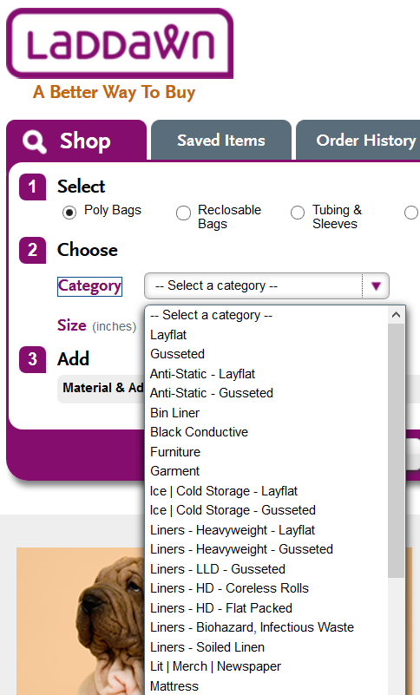

**FIX:**

Create a nested Category drop-down list.

**REDESIGNED CATEGORY MENU DESCRIPTION:**

We are adding FLUSH LEFT ” > ” CARROTS for the “expand-collapse” arrows as shown here.

NOTE:

The hover color change is the same – from no color to Laddawn purple on hover.  
All the text is indented from where it is now to allow space for the carrots to be FLUSH LEFT.  
Each Subcategory is indented further from this initial indent, in outline form.  
Click to expand, click to collapse. That way, Users can have 2 sections open at once if they choose to. Arrow switches to downward point when a level is opened, switches back when level is closed. This convention is followed for subcategories as well.

Lip & Tape Category is expanding to a fourth level, so we’ve used it in our example.

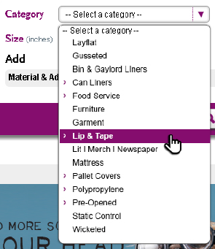 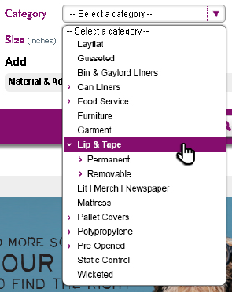 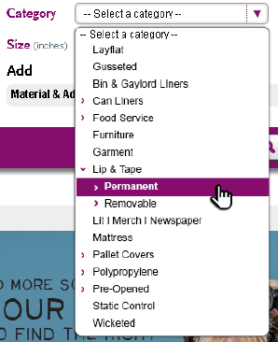

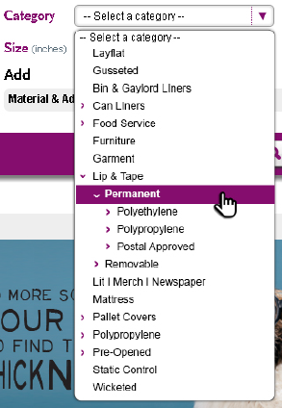 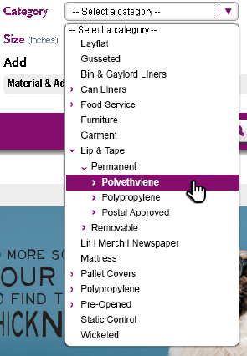 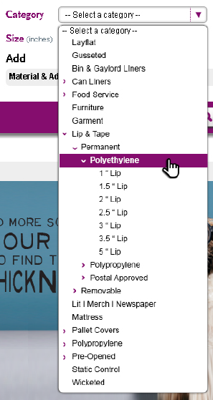 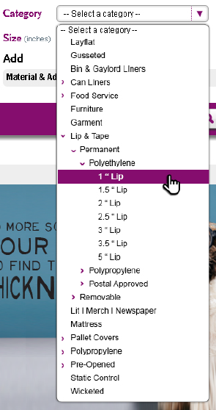 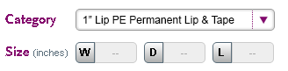

We will definitely be using CUSTOM DESCRIPTIONS for the final description that appears in the drop-down box that will include the necessary abbreviations.