Is there an existing menu or field that could be used, or that this could be added to?

**Amber (import & domestic quotes available)**

1. What is the construction?
   1. Lay Flat –Add “Amber” to a new nonstock section within polybag menu?  
      For example:  
        
      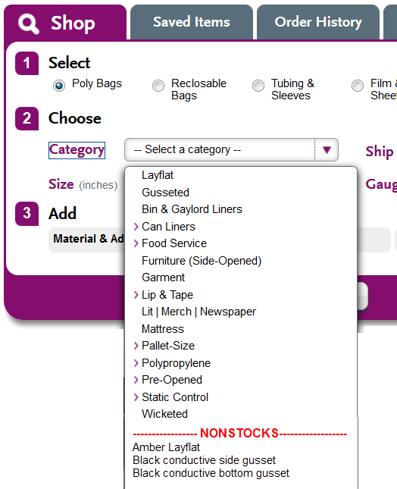
   2. Zip Top Yes, already in reclosable menu – when non-stock is checked, and amber zip top is selected… menus and validations change to reflect options below?

For example:  
  
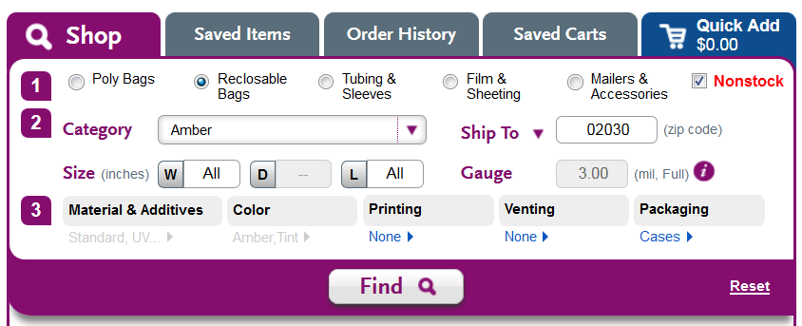

1. What is the bag size? We can use existing dimension fields; maybe with some “dumb” min/max validation driven solely by category?
   1. Width?
      1. Lay Flat: 2” – 60”
      2. Zip Top: 2” – 40”
   2. Length?
      1. Lay Flat: 2” – 80”
      2. Zip Top: 2” – 53”
   3. Mil?
      1. Lay Flat: 1 mil – 8 mil
      2. Zip Top: 1.5 mil – 8 mil
2. Is it vented? Yes – use existing?
   1. How many vents?
   2. What type of vent? We can do ¼”, 1/8”, c-vent and butterfly.
   3. Where are they located on the bag?
3. Is it printed?   
   Until amazing print goes live, we could leverage existing random repeat menu and incorporate a slideout menu for the other printing types
   1. What type of print (random, registered spot, registered screen, process print)
      1. If random repeat:
         1. Horizontal or vertical print direction? yes
         2. What is the space between the repeat if random? yes
      2. If registered spot, registered screen, or process print NO, but until amazing print goes live, could be ckbox w/out validations?
         1. How many inches from the bottom of bag does the artwork start?
         2. How many inches in from the left side of the bag?
   2. How many colors (1-2) no, but until amazing print goes live, could be added to print menu (when ns is checked)?
   3. How many sides (1-2) no, but could be added to print menu (when ns is checked)?
   4. What is the image width? Yes – random; for the other types, see slide out menu
   5. What is the image length? Yes – random; for the other types, see slide out menu
   6. Do they have a useable artwork file? No; add optional upload link to random print menu and slideout?
      1. If no, will you be providing one at the time of order?(shouldn’t they have to?)
   7. Do you have any image of the printing such as a photo of the bag? No; add optional upload link to to random print menu and slideout?
4. Number of bags per case? Yes, count field in results
5. What is the quantity? Yes, quantity field in results

|  |  |
| --- | --- |
| Random printing: | All other types of printing – slide out: |

Generate a result that does not have availability date, unit and total price, weight or share/save features. Add button is replaced with “submit for quotation” button. “Dumb” count and quantity fields must be filled out in order to submit for quotation.

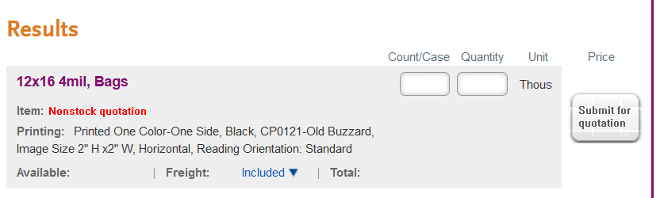

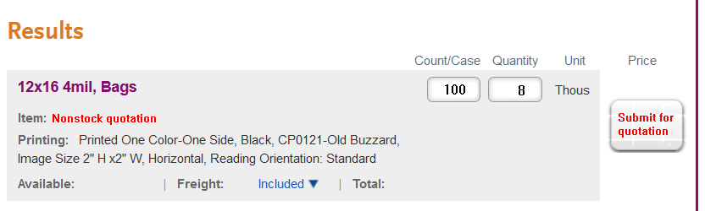

Clicking this button queues a quote workflow request to be routed to the appropriate NS quoting team when CE exits the session - until then, it will show in the CE workflow request box, and CE can manually add additional notes on the routing request form (???). Once it is routed for NS quoting, all else happens within Avante as it does today – the quote cannot be put in a cart or shared or checked out on the website.

**Black Conductive (domestic quotes only)**

1. What is the construction?
   1. Lay Flat – yes, static control, black conductive - when non-stock is checked, and this category is selected, menus and validations change to reflect options below?
   2. Side Gusseted no, add to polybag men in new nonstock section
   3. Bottom Gusseted no, add to polybag menu in new nonstock section?
   4. Tubing – yes, in current tubing/sleeves menu - when non-stock is checked, and this category is selected, menus and validations change to reflect options below?
2. What is the bag size? yes
   1. Width?
      1. Lay Flat: 3” – 50”
      2. Tubing: 2” – 60”
   2. Length?
      1. Lay Flat: 4” – 100”
      2. Tubing: n/a
   3. Mil?
      1. Lay Flat: 2 mil – 10 mil
      2. Tubing: 2 mil – 10 mil
3. Is it vented? yes
   1. How many vents?
   2. What type of vent? We can do ¼”, 1/8”, c-vent and butterfly.
   3. Where are they located on the bag?
4. What is number of bags per case or feet per roll? yes
5. What is the quantity yes

**Co-Ex Mailers (import & domestic quotes available)**

1. Does the mailer have a perforation below the lip?
2. Is it white on the outside and grey on the inside?
   1. If no, what color/s?
3. What is the bag size?
   1. Width? 3” – 70”
   2. Length? 5” – 72”
   3. Lip Size? Standard is 1.5”
   4. Mil? 1.5 mil – 7 mil
4. Is it vented?
   1. How many vents?
   2. What type of vent? We can do ¼”, 1/8”, c-vent and butterfly.
   3. Where are they located on the bag?
5. Is it printed?
   1. What type of print (random, registered spot, registered screen, process print)
      1. If random repeat:
         1. Horizontal or vertical print direction?
         2. What is the space between the repeat if random?
      2. If registered spot, registered screen, or process print
         1. How many inches from the bottom of bag does the artwork start?
         2. How many inches in from the left side of the bag?
   2. How many colors (1-2)
   3. How many sides (1-2)
   4. What is the image width
   5. What is the image length
   6. What is the space between the repeat if random?
   7. Do they have a useable artwork file?
      1. If no, will you be providing one at the time of order?
   8. Do you have any image of the printing such as a photo of the bag?
6. What is the number of bags per case?
7. What is the quantity

**Garment Bags (domestic quotes only)**

1. What is the bag size?
   1. Width? 15” – 60”
   2. Length? 17” – 120”
   3. Gusset? 0” – 20”
   4. Mil? 0.35 mil – 2.5 mil
2. Is it vented?
   1. How many vents?
   2. What type of vent? We can do ¼”, 1/8”, c-vent and butterfly.
   3. Where are they located on the bag?
3. What color is the film? (clear, red, white, blue, green, orange, brown, yellow, or black)
   1. If colored, is the film tinted or full color?
4. Stock printed suffocation label?
5. Is it custom printed?
   1. What type of print (random, registered spot, registered screen, process print)
      1. If random repeat:
         1. Horizontal or vertical print direction?
         2. What is the space between the repeat if random?
      2. If registered spot, registered screen, or process print
         1. How many inches from the bottom of bag does the artwork start?
         2. How many inches in from the left side of the bag?
   2. How many colors (1-2)
   3. How many sides (1-2)
   4. What is the image width
   5. What is the image length
   6. Do they have a useable artwork file?
      1. If no, will you be providing one at the time of order?
   7. Do you have any image of the printing such as a photo of the bag?
6. What is the number of bags per roll?
7. What is the quantity?

**High Density (import & domestic quotes available)**

1. What is the bag size?
   1. Width? 9” – 52”
   2. Length? 12” – 80”
   3. Gusset? Must be less than width.
   4. Mil? 6 Micron – 101 Micron (25.4 Mic = 1 mil)
2. What type of seal does it have?
   1. Star Seal
   2. Flat Seal
   3. Gusset Seal
3. Is it case packed or on rolls?
   1. If rolls, coreless or 3” core?
4. Is it vented?
   1. How many vents?
   2. What type of vent? We can do ¼”, 1/8”, c-vent and butterfly.
   3. Where are they located on the bag?
5. What color is the film? (clear, red, white, blue, green, orange, brown, yellow, or black)
   1. If colored, is the film tinted or full color?
6. Is it printed?
   1. What type of print (random, registered spot, registered screen, process print)
      1. If random repeat:
         1. Horizontal or vertical print direction?
         2. What is the space between the repeat if random?
      2. If registered spot, registered screen, or process print
         1. How many inches from the bottom of bag does the artwork start?
         2. How many inches in from the left side of the bag?
   2. How many colors (1-2)
   3. How many sides (1-2)
   4. What is the image width
   5. What is the image length
   6. Do they have a useable artwork file?
      1. If no, will you be providing one at the time of order?
   7. Do you have any image of the printing such as a photo of the bag?
7. How many bags per roll, or per case?
8. What is the quantity?

**Lip & Tape Bags (import & domestic quotes available)**

1. What is the type of film?
   1. LDPE yes (standard)
   2. Polypro yes 3/materials
   3. BOPP no?
   4. OPP No?
2. What is the bag size?
   1. Width? 4” – 30” yes
   2. Length? 5” – 32” yes
   3. Bottom Gusset? No?
   4. Lip? 0.5” – 6”
   5. Mil? 1 mil – 4 mil
3. Does it have permanent or resealable tape?
4. Does it need to be postal approved?
5. Is it vented?
   1. How many vents?
   2. What type of vent? We can do ¼”, 1/8”, c-vent and butterfly.
   3. Where are they located on the bag?
6. What color is the film? (clear, red, white, blue, green, orange, brown, yellow, or black)
   1. If colored, is the film tinted or full color?
7. Is it printed?
   1. What type of print (random, registered spot, registered screen, process print)
      1. If random repeat:
         1. Horizontal or vertical print direction?
         2. What is the space between the repeat if random?
      2. If registered spot, registered screen, or process print
         1. How many inches from the bottom of bag does the artwork start?
         2. How many inches in from the left side of the bag?
   2. How many colors (1-2)
   3. How many sides (1-2)
   4. What is the image width
   5. What is the image length
   6. Do they have a useable artwork file?
      1. If no, will you be providing one at the time of order?
   7. Do you have any image of the printing such as a photo of the bag?
8. Does the bag require any additives?
   1. Anti-Stat: Clear or Pink?
   2. UVI/UVI: 3 month, 6 month or 12 month?
9. How many bags per case?
10. What is the quantity?

**Packing List Envelopes (domestic quotes only)**

1. What is the bag size?
   1. Width? 4” – 12”
   2. Length? 4.5” – 15”
   3. Mil? 2 mil – 5 mil
2. Is it top loading or back loading?
   1. Back Loading – documents inserted from the side.
   2. Top Loading – documents inserted from the top
3. Is it printed or clear face?
   1. Is it custom printed?
      1. How many colors?
      2. What is the image width
      3. What is the image length
      4. Does the customer have artwork?
   2. Stock Image?
      1. Packing List Enclose: Full Panel or Top Panel (Orange back, black print)
      2. Invoice Enclosed: Full Panel or Top Panel (Orange back, black print)
4. How many bags per case?
5. What is the quantity?

**\**

**Polypropylene (import & domestic quotes available)**

1. What is the type of bag?
   1. Lay Flat
   2. Zip Top
   3. Side Gusseted
   4. Bottom Gusseted
2. What is the Film Type?
   1. Caste (typical polypro)
   2. BOPP (biaxially oriented polypro)
      1. Does it have a lap seal (center seam)?
      2. Does it have a crimp bottom seal?
   3. OPP (oriented polypro)
3. What is the bag size?
   1. Width? 2” – 36” Varies if import or domestic
   2. Length? 6” – 59” Varies if import or domestic
   3. Side Gusset? Import ONLY, less than width
   4. Bottom Gusset? Domestic ONLY 1” – 5”
   5. Mil? 0.8 mil – 4 mil
4. Is it vented?
   1. How many vents?
   2. What type of vent? We can do ¼”, 1/8”, c-vent and butterfly.
   3. Where are they located on the bag?
5. Is it printed?
   1. What type of print (random, registered spot, registered screen, process print)
      1. If random repeat:
         1. Horizontal or vertical print direction?
         2. What is the space between the repeat if random?
      2. If registered spot, registered screen, or process print
         1. How many inches from the bottom of bag does the artwork start?
         2. How many inches in from the left side of the bag?
   2. How many colors (1-2)
   3. How many sides (1-2)
   4. What is the image width
   5. What is the image length
   6. Do they have a useable artwork file?
   7. If no, will you be providing one at the time of order?
   8. Do you have any image of the printing such as a photo of the bag?
6. How many bags per case?
7. What is the quantity?

Zip Top Bags (domestic and import quotes available)

1. What is the film? (LDPE or Polypropylene)
2. What is the film color? (clear, red, white, blue, green, orange, brown, yellow, or black)
   1. If colored is the film tinted or full color?
3. What is the Width? (2”-40”)
4. What is the Length? (2”-50”)
5. What is the Gauge? (1.5-6 mil domestic, 1-6 mil import)
6. Is there a bottom gusset?
7. How many bags per case?
8. Is it printed?
   1. How many colors (1-8)
   2. How many sides (1-2)
   3. What type of print (random, registered spot, registered screen, process print)
      1. If random repeat:
         1. Horizontal or vertical print direction?
         2. What is the space between the repeat if random?
      2. If registered spot, registered screen, or process print
         1. How many inches from the bottom of bag does the artwork start?
         2. How many inches in from the left side of the bag?
   4. What is the image width
   5. What is the image length
   6. Do they have a useable artwork file?
      1. If no, will you be providing one at the time of order?
   7. Do you have any image of the printing such as a photo of the bag?
9. Is it vented?
   1. How many vent?
   2. What size/style of vents?(1/8”, ¼”, c-vents, sombrero, flutter)
   3. Where are they located on the bag?
10. Are there any special additives? (VCI, Anti-stat, Metallocene, and UVI)
    1. VCI
    2. Anti-stat
    3. Metallocene
    4. UVI -3, 6, or 12 month
11. What is the Quantity?

Wicketed Bag (domestic quotes available)

1. What is the film? (LDPE or HDPE)
2. What is the film color? (clear, red, white, blue, green, orange, brown, yellow, or black)
   1. If colored is the film tinted or full color?
3. What is the Width? (3”-32”)
4. What is the Length? (5”-43”)
5. How large is the Lip? (.75”-4”)
6. What is the Gauge? (.75-4)
7. Is there a bottom gusset?
8. Is the lip perforated?
9. How wide is the wire wicket, and how long are the wicket legs?
10. Is there a chipboard header? If yes, is it on the front, the back, or both sides?
11. What is the number of bags per wicket?
12. What is the number of wickets per case?
13. Is it printed?
    1. How many colors (1-8)
    2. How many sides (1-2)
    3. What type of print (random, registered spot, registered screen, process print)
       1. If random repeat:
          1. Horizontal or vertical print direction?
          2. What is the space between the repeat if random?
       2. If registered spot, registered screen, or process print
          1. How many inches from the bottom of bag does the artwork start?
          2. How many inches in from the left side of the bag?
    4. What is the image width
    5. What is the image length
    6. Do they have a useable artwork file?
    7. Do they have a useable artwork file?
       1. If no, will you be providing one at the time of order?
    8. Do you have any image of the printing such as a photo of the bag?
14. Is it vented?
    1. How many vent?
    2. What size/style of vents?(1/8”, ¼”, c-vents, sombrero, flutter)
    3. Where are they located on the bag?
15. Are there any special additives?
    1. VCI
    2. Anti-stat
    3. Metallocene
    4. UVI -3, 6, or 12 month
16. What is the quantity?

Static Shielding Bags (domestic quotes available)

1. Standard Static Shielding Bags or Moisture Barrier Static Shielding Bags?
2. Zip top, open top, or lip & tape?
   1. If lip & tape then is the tape permanent or re-sealable?
   2. What is the size of the lip?
3. What is the width? (2-40)
4. What is the length? (3-40)
5. Is there a side gusset?
6. How many bags per case?
7. Is it printed?
   1. How many colors (1-8)
   2. How many sides (1-2)
   3. What type of print (Hot stamp, random repeat, registered spot, registered screen, process print)
      1. If Hot Stamp;
         1. Is it the standard ESD symbol?
      2. If random repeat:
         1. Horizontal or vertical print direction?
         2. What is the space between the repeat if random?
      3. If registered spot, registered screen, or process print
         1. How many inches from the bottom of bag does the artwork start?
         2. How many inches in from the left side of the bag?
   4. What is the image width
   5. What is the image length
   6. Do they have a useable artwork file?
      1. If no, will you be providing one at the time of order?
   7. Do you have any image of the printing such as a photo of the bag?
8. Is it vented?
   1. How many vent?
   2. What size/style of vents?(1/8”, ¼”, c-vents, sombrero, flutter)
   3. Where are they located on the bag?
9. What is the quantity?

Staple Packed Bags & Literature Bags (domestic and import quotes available)

1. What is the film? (LDPE or HDPE)
2. What is the film color? (clear, red, white, blue, green, orange, brown, yellow, or black)
   1. If colored is the film tinted or full color?
3. What is the width? (3-30)
4. What is the length? (3-40)
5. How large is the lip? (.5-4)
6. Is there a back flip AKA flip top?
7. Are there any hang holes in the header?
   1. How many?
   2. What size?
   3. Location?
   4. Do they have a picture of the header?
8. How many per staple pack?
9. How many staple packs per case?
10. Is there a doorknob hang hole? (1.5” or 2” diameter)
11. Is it printed?
    1. How many colors (1-8)
    2. How many sides (1-2)
    3. What type of print (random, registered spot, registered screen, process print)
       1. If random repeat:
          1. Horizontal or vertical print direction?
          2. What is the space between the repeat if random?
       2. If registered spot, registered screen, or process print
          1. How many inches from the bottom of bag does the artwork start?
          2. How many inches in from the left side of the bag?
    4. What is the image width
    5. What is the image length
    6. Do they have a useable artwork file?
    7. Will you be providing one at the time of order?
    8. Do you have any image of the printing such as a photo of the bag?
12. Is it vented?
    1. How many vent?
    2. What size/style of vents?(1/8”, ¼”, c-vents, sombrero, flutter)
    3. Where are they located on the bag?
13. Are there any special additives? (Anti-stat, metallocene/EVA, VCI, UVA/UVI)
    1. VCI
    2. Anti-stat
    3. Metallocene
    4. UVI -3, 6, or 12 month
14. What is the quantity?

Slider Top Bags (import)

1. What is the film color? (clear, red, white, blue, green, orange, brown, yellow, or black)
2. If colored, is the film tinted or full color?
3. What is the Width? (4”-18”)
4. What is the Length? (4”-20”)
5. What is the Gauge? (2-4)
6. What is the preferred case pack?
7. Is it printed?
   1. How many colors (1-8)
   2. How many sides (1-2)
   3. What type of print (random, registered spot, registered screen, process print)
      1. If random repeat:
         1. Horizontal or vertical print direction?
         2. What is the space between the repeat if random?
      2. If registered spot, registered screen, or process print
         1. How many inches from the bottom of bag does the artwork start?
         2. How many inches in from the left side of the bag?
   4. What is the image width
   5. What is the image length
   6. Do they have a useable artwork file?
   7. Will you be providing one at the time of order?
   8. Do you have any image of the printing such as a photo of the bag?
8. Is it vented?
   1. How many vent?
   2. What size/style of vents?(1/8”, ¼”, c-vents, sombrero, flutter)
   3. Where are they located on the bag?
9. Are there any special additives? (Metallocene, UVI/UVA)
10. What is the quantity?

Shrink Bundling Film (Domestic)

1. Is the film Single wound or center folded?
2. What is the width?
   1. If single wound 8”-80”
   2. If center folded 14”-116”(opens to twice the stated width)
3. What is the number of feet on the roll? (10”-30” roll outer diameter)
4. What is the gauge? (1.25-3)
5. Is it printed?
   1. How many colors (1-2)
   2. How many sides (1-2)
   3. What is the image width
   4. What is the image length
   5. What is the space between the repeat?
   6. Do they have a useable artwork file?
   7. Do you have any image of the printing such as a photo of the bag?
6. Is it vented?
   1. How many vent?
   2. What size/style of vents?(1/8”, ¼”, c-vents, sombrero, flutter)
   3. Where are they located on the bag?
7. *Minimum run is 2,500#s for non-printed and 3,000#s for printed*
8. What is the quantity?

Polyethylene Shrink Bags on Rolls (Domestic)

1. What is the width? (24-120)
2. What is the length? (24-250)
3. Is there a side gusset? (24-60)
4. What is the gauge? (1.5-6)
5. How many bags per roll?
6. What is the film color? (clear, red, white, blue, green, orange, brown, yellow, or black)
7. Is it printed?
   1. How many colors (1-2)
   2. How many sides (1-2)
   3. What is the image width
   4. What is the image length
   5. What is the space between the repeat?
   6. Do they have a useable artwork file?
   7. Do you have any image of the printing such as a photo of the bag?
8. Is it vented?
   1. How many vent?
   2. What size/style of vents?(1/8”, ¼”, c-vents, sombrero, flutter)
   3. Where are they located on the bag?
9. Are there any special additives?
   1. Anti-stat
   2. Metallocene
   3. UVI/UVA (3, 6, or 12 month)
10. What is the quantity?

Pre-Opened Bags On Rolls (domestic)

1. What is the width? (2-25)
2. What is the length? (2-36)
3. What is the gauge? (1-4)
4. On rolls of fan folded in a case?
5. What is the film?
   1. LDPE or HDPE?
6. What is the film color? (Clear, White, White Front/Clear Back, Pink-antistat)
7. How many bags per roll?
8. Is it printed?
   1. How many colors (1-8)
   2. How many sides (1-2)
   3. What type of print (random, registered spot, registered screen, process print)
      1. If random repeat:
         1. Horizontal or vertical print direction?
         2. What is the space between the repeat if random?
      2. If registered spot, registered screen, or process print
         1. How many inches from the bottom of bag does the artwork start?
         2. How many inches in from the left side of the bag?
   4. What is the image width
   5. What is the image length
   6. Do they have a useable artwork file?
   7. Will you be providing one at the time of order?
   8. Do you have any image of the printing such as a photo of the bag?
9. Is it vented?
   1. How many vent?
   2. What size/style of vents?(1/8”, ¼”, c-vents, sombrero, flutter)
   3. Where are they located on the bag?
10. Are there any special additives?
    1. Anti-stat
    2. UVI/UVA (3, 6, or 12 month)
11. What is the quantity?