**From:** Susan Parker   
**Sent:** Wednesday, July 09, 2014 10:32 AM  
**To:** Chuck Forest  
**Subject:** RE: 162 + 163 (sorry I thought I sent this ...)

As discussed – before and after

**From:** Susan Parker   
**Sent:** Wednesday, July 09, 2014 9:20 AM  
**To:** Chuck Forest  
**Subject:** RE: 162 + 163

**I. When item in stock at alternate warehouse (813)**

Before

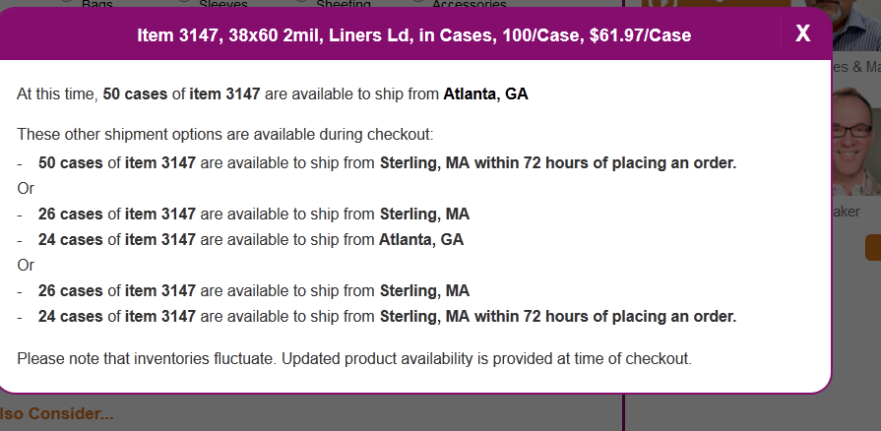

After

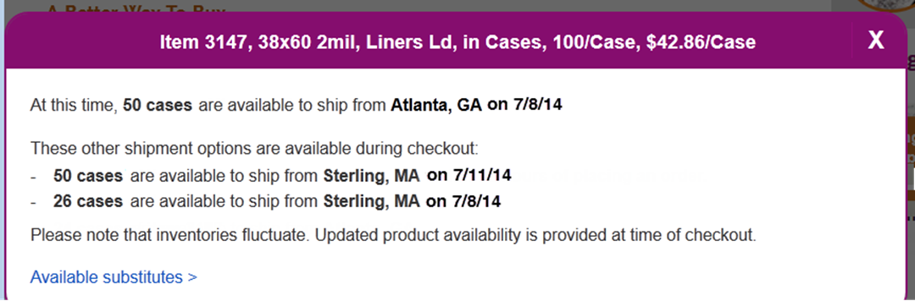

**II. When item not in stock at alternate or primary (814)**

Before

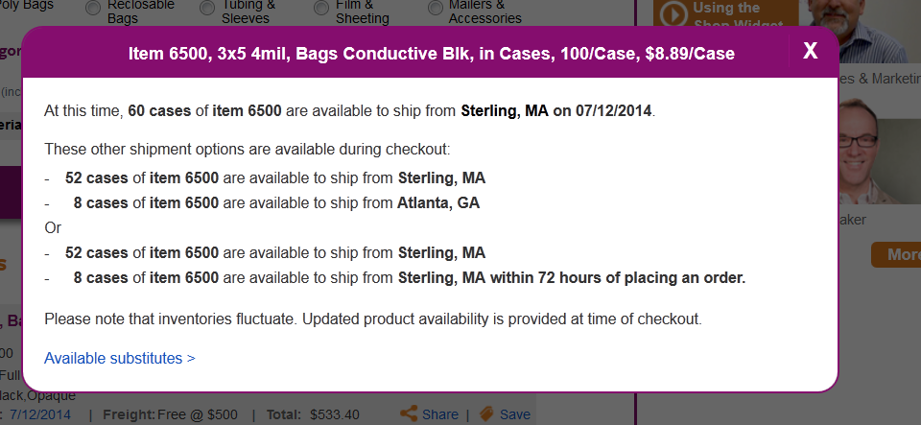

After

