[www.globalsources.com](http://www.globalsources.com):



I like that you can see all categories at a glance w/hover – no nested menus:

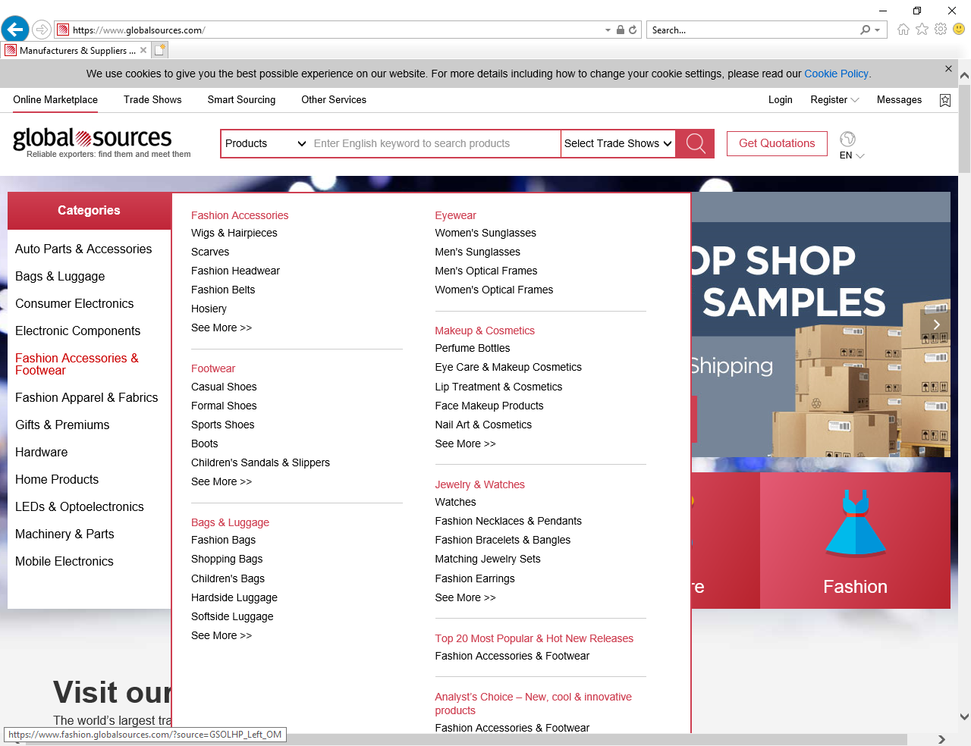

Selection of an individual category shows individual products, then allows filtering on the left:

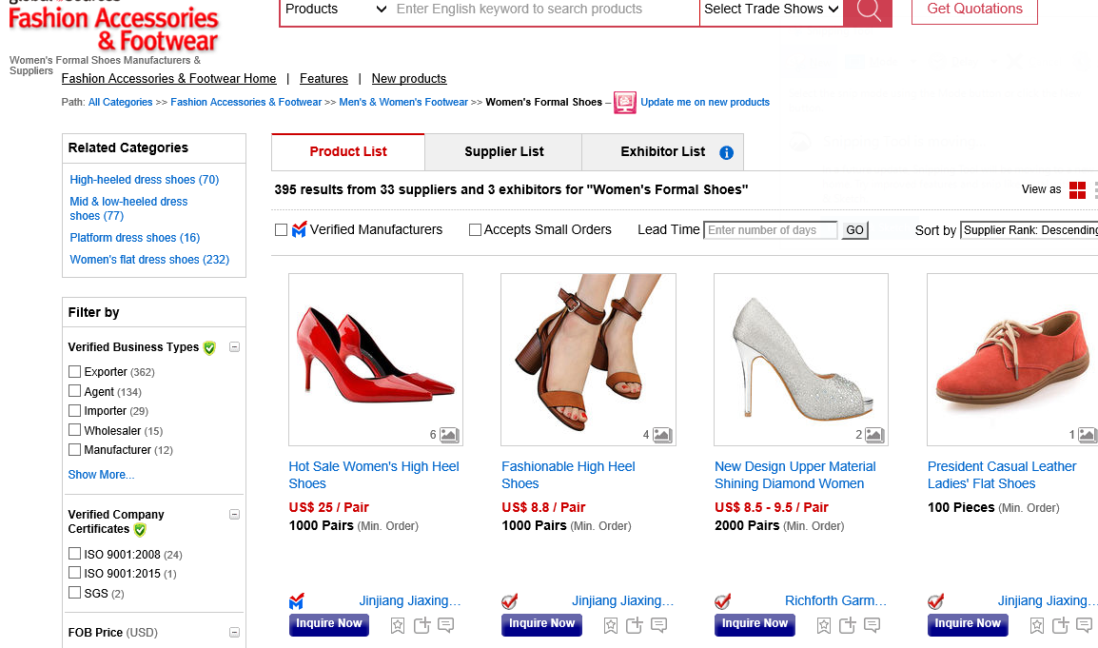

Clicking on the red button “FASHION” shows category selections across the top with single level drop downs. The 4 buttons combine like categories from the list on the left, showing them as tabs once selected:

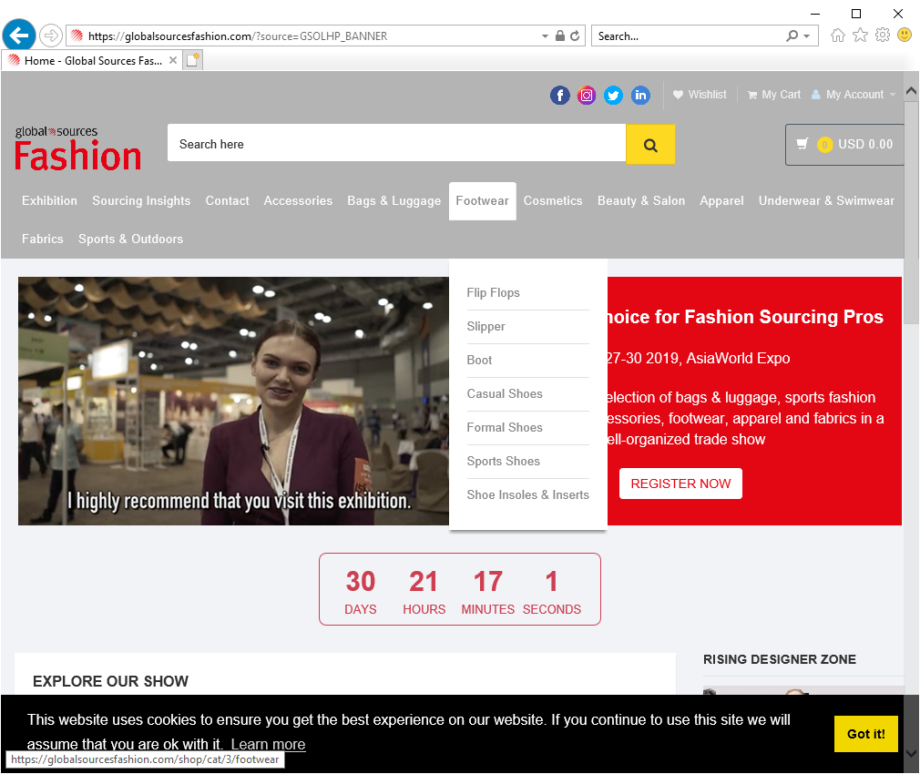

ELECTRONICS:



Shop.nordstrom.com: I like it that you can hover to see categories, and only when you click on the top level does it put you into that category. You can also make a selection from the hover. Both nice features.

At first, only the top level selections are showing (#1). When you hover, it shows selections by category – you can make a choice directly from the hover (either bolded heading or individual caegory) (#2). If you click on the top level, it moves these categories to the left (#3). I liked the feel of this site better than the site above:

#1:

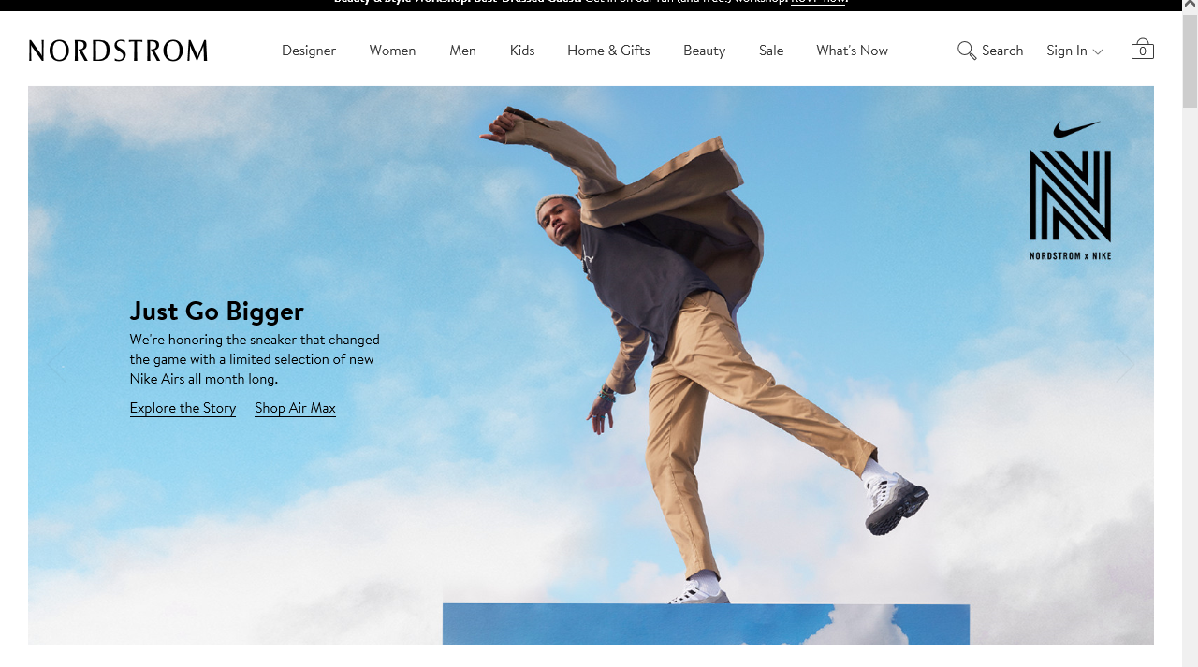

#2: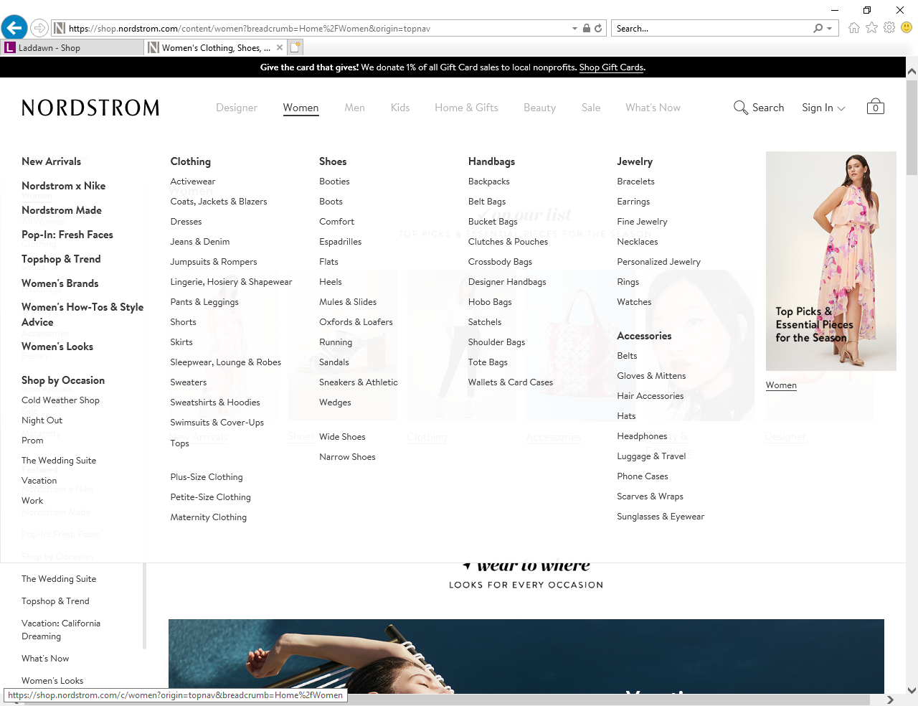

#3:

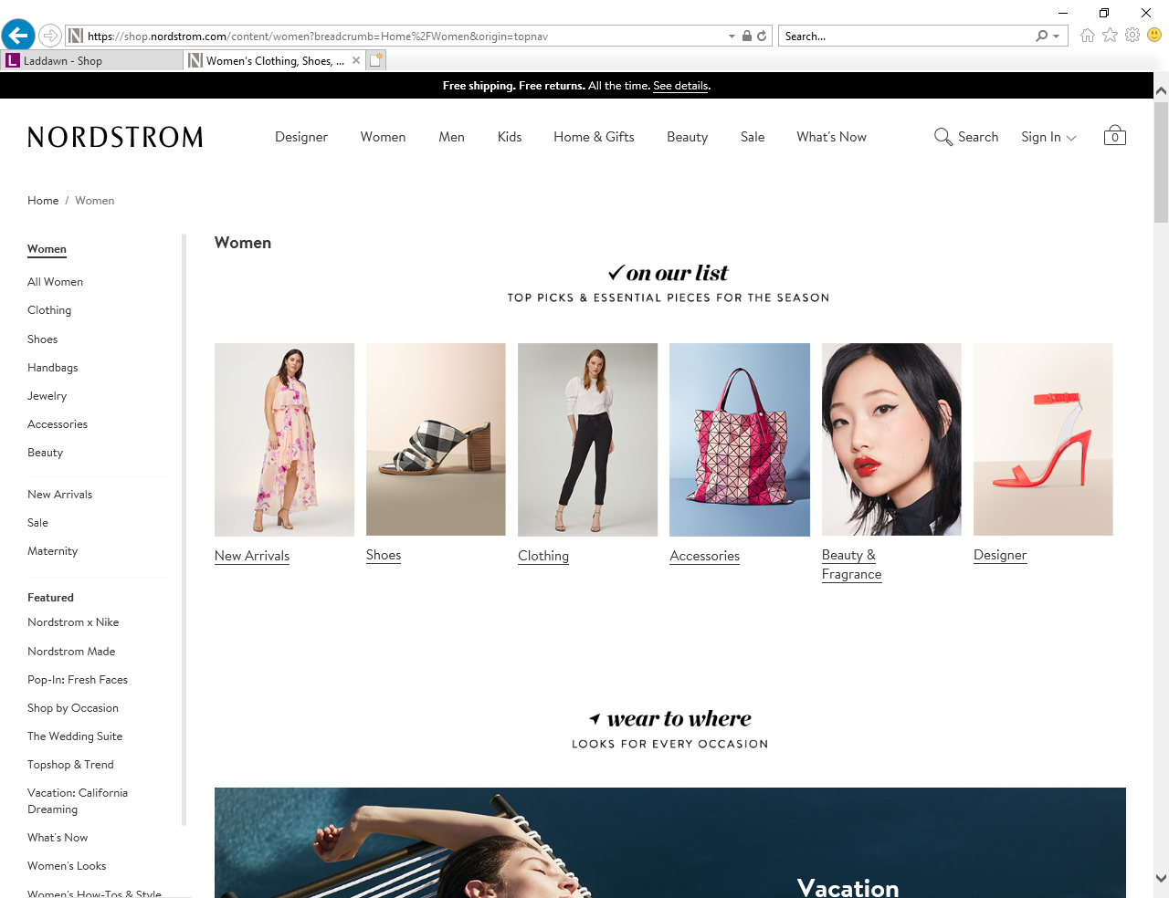

From hover, I chose Dresses under Clothing category. The filters are on the left, including length, size, etc. :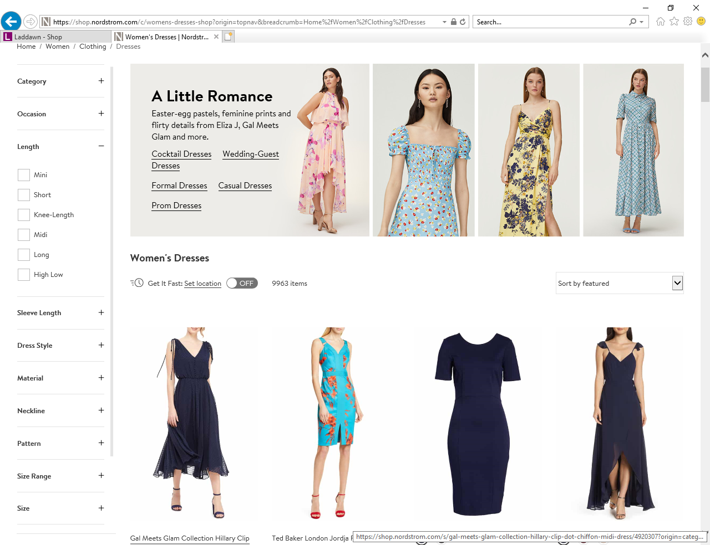

As I chose the filters, they displayed at the top left of screen, and the items changed to reflect my choices:

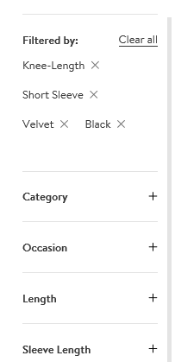

Choosing a different top level category and sub-category shows different filters/questions. I like the fact that the filters are different by category, but not how they are shown vertical on the side. I prefer the way our widget has the filters shown horizontally above the results:

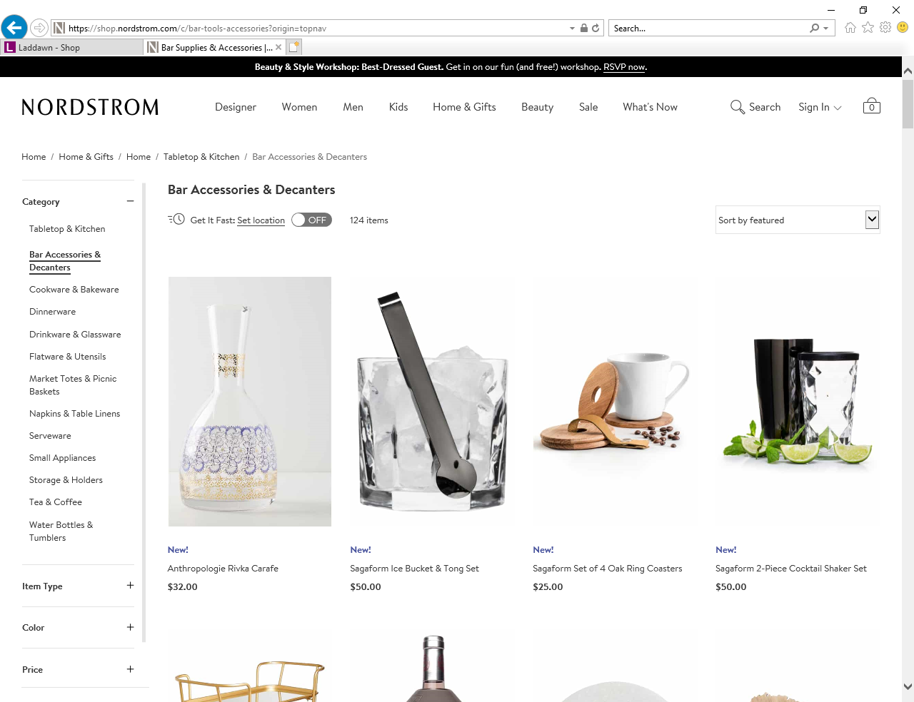

Possibilities for laddawn.com:

* The Level 1 area stays horizontal with smaller text and icons
* Hover over Level 1 shows a single ‘at a glance’ page of all Major categories with sub-categories. Because you are seeing all of the sub-categories, we could remove some of the duplication that we currently have (SUPs in food service and by itself).

For example, Reclosables could look something like:

**Zip Tops:** **Food Service:** Slider Top

Zip Top Polypro w/Hang Hole

w/Hang Hole Saddle Pack Deli

Polypro w/Hang Hole Dispenser Case Sandwich

w/White Block Saddle Pack Sandwich

Amber Tamper Evident

Bubble

Clean Room Class 200

Parts Bags

Anti Static

Static Shielding

**Healthcare**: **Stand Up Pouches:**

Amber Zip Top Clear

Biohazard Specimen Silver

Chemotherapy White Foil

Clear+Silver

Selecting one of these would populate the Category field, then display the appropriate widget questions for that category.