Test test testfffff chrome

MS Edge

Test save again

Internet explorer

IE test 2

After our 5/17 meeting, we began working with a single prototype and incorporated the changes we discussed – for example, bringing you right to the designer after choosing Reg. v. RRP; embedding a “get started” block in the designer (fig 1); removing Reg/RRP buttons and RRP spacer button from toolbar (and embedding a spacer tool right in the designer).

*Figure 1: Get started*

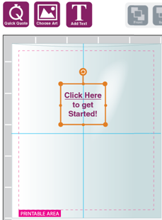

From 5/19 – 5/24 Jeff, Jay and I tested it with 7 CE/CR reps (ranging from novice to expert), and 2 customers, Jen Stillman and Bob Seiple. (One other customer from Agawam canceled at the last minute.)

Our testing employed 8 scenarios to address the most common quoting situations, as well as a couple of challenging ones. Because users tend to learn as they go, we varied the order in which the scenarios were carried out from test to tester.

Testing validated much of our design; for instance …

* No one had difficulty choosing registered or random repeat printing options.
* Some people took advantage of the “Get started” link, whereas others gravitated immediately to the corresponding quick quote/choose art/add text buttons within the toolbar.
* Regardless of how they started, most had no difficulty choosing the right tool for the scenario (quick quote, choose artwork, or text). There were a few wrinkles though with the quick quote button – see below.
* Most people understood their options for resizing and moving images.

… But it also uncovered several opportunities for fine tuning. Just a few examples:

* In scenarios involving customer or Laddawn artwork – most struggled after selecting “choose artwork” – they were simply not seeing the tabbed options on the left (fig 2); so they interpreted the first tab (Laddawn stock art) as a presentation of all their choices including uploading artwork. We will present 1-2 visual designs to address this.

*Figure 2 – Tabbed options for choosing artwork, initial screen*  
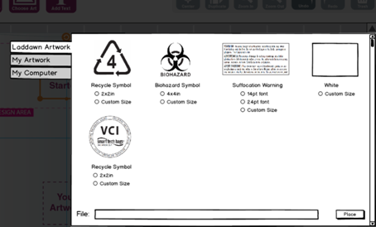

* Nearly all testers had difficulty telling us how they’d change the color of text, but did not have this difficulty with images. We’ll make the tool for selecting color for text similar to that for images.
* A couple of people gravitated to the quick quote button even though their scenarios involved using Laddawn stock art. A couple of others mistook the quick quote button for the button they’d click to finish the bag and get their results and pricing (Find). Folks in IT observed that everywhere else on the site we’ve avoided use of the term “quote.” We may want to consider repositioning this to make its purpose clearer, and to be more consistent with the rest of the site. (“Price without artwork”?)